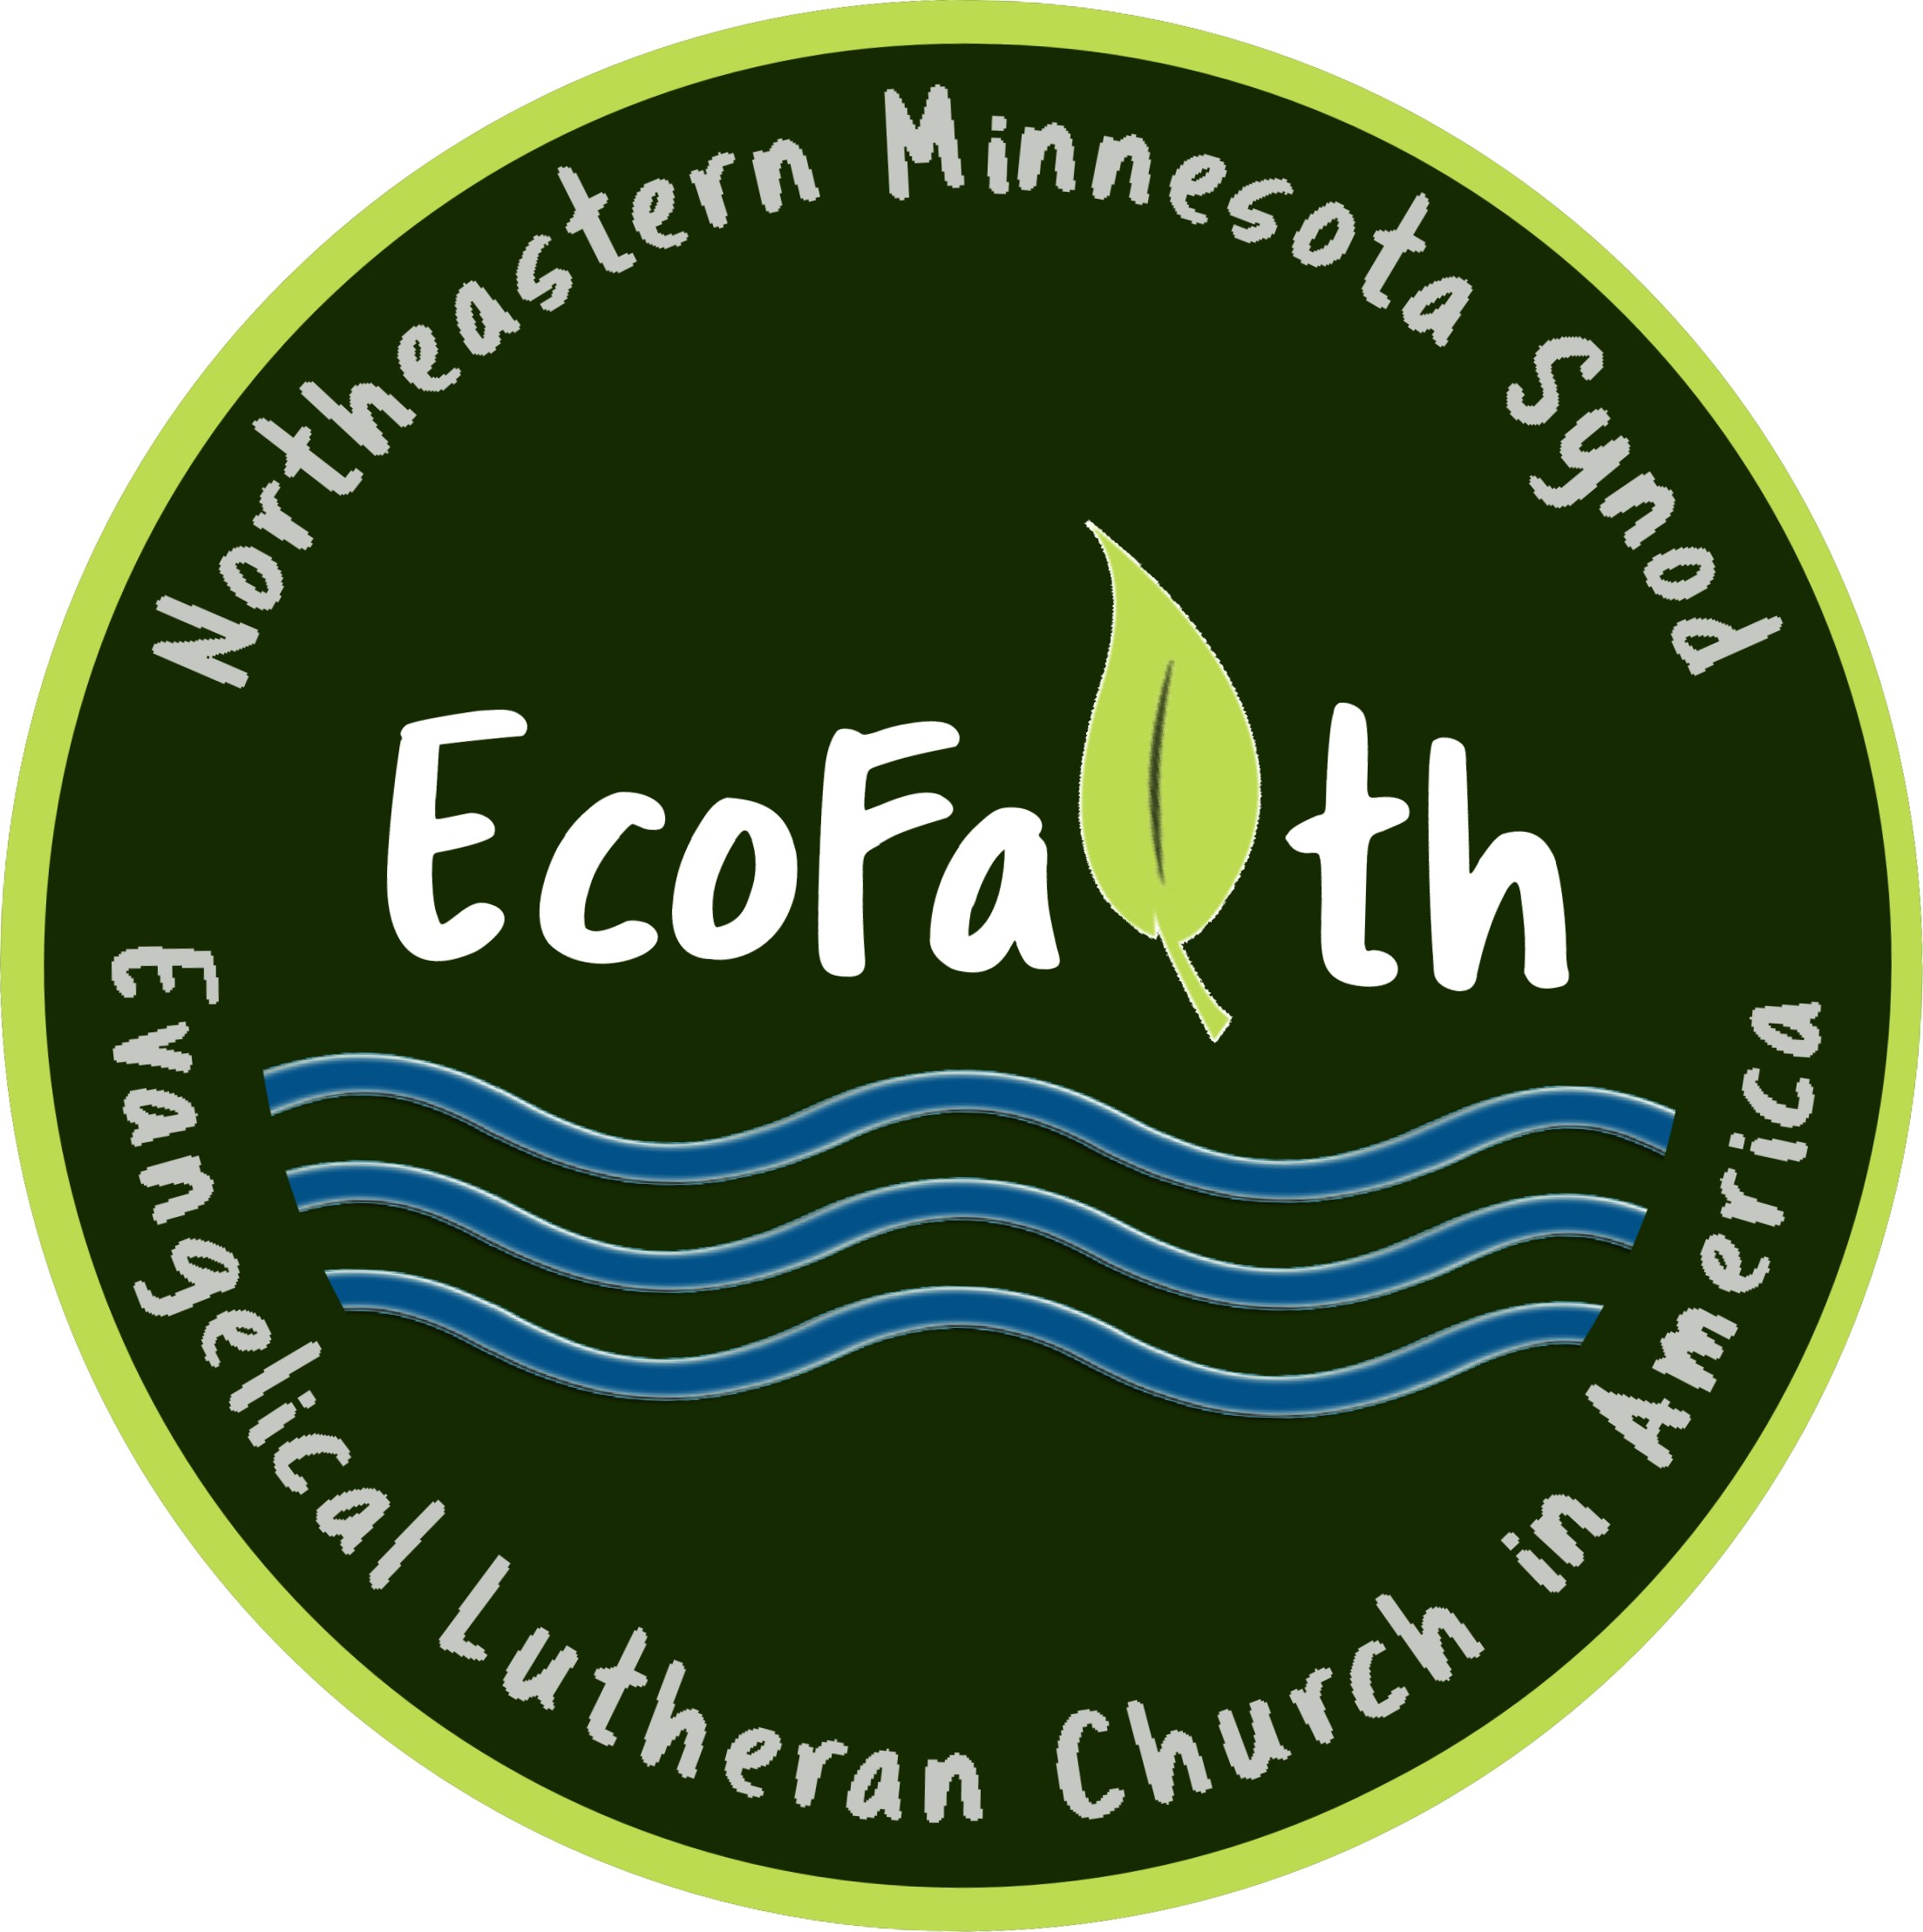 EcoFaith Microgrant Projects
2021 – present

Butterfly Sanctuary Church and Community Collaboration
Church of the Cross, Nisswa

Community Garden Start-Up
First, Duluth

Creation Care Bags Neighborhood Outreach
Spirit of God, Duluth

Exploring Your Environment at VLM
Voyageurs Lutheran Ministry

God’s Goats for Creation Care
Bethlehem, Brainerd

Lil Gardeners VBS and Community Garden Outreach
Immanuel, Princeton

Pollinator Project Pilot Congregations (2022)
Bethesda, Malmo
Bethlehem, Twig
French River Lutheran, French River
Our Redeemer Lutheran--Pine City
Our Savior’s, Outing
St. Andrew’s, Grand Rapids

Stewardship of Building and Grounds
French River, French River

Tote Bags for Plastic Reduction and Education
First, Aitken

Will Steger Community Event
Church of the Cross, Nisswa

Want to learn more about these projects?
Email ecofaith@nemnsynod.org
We will send you their grant application or put you in touch with the recipients.

