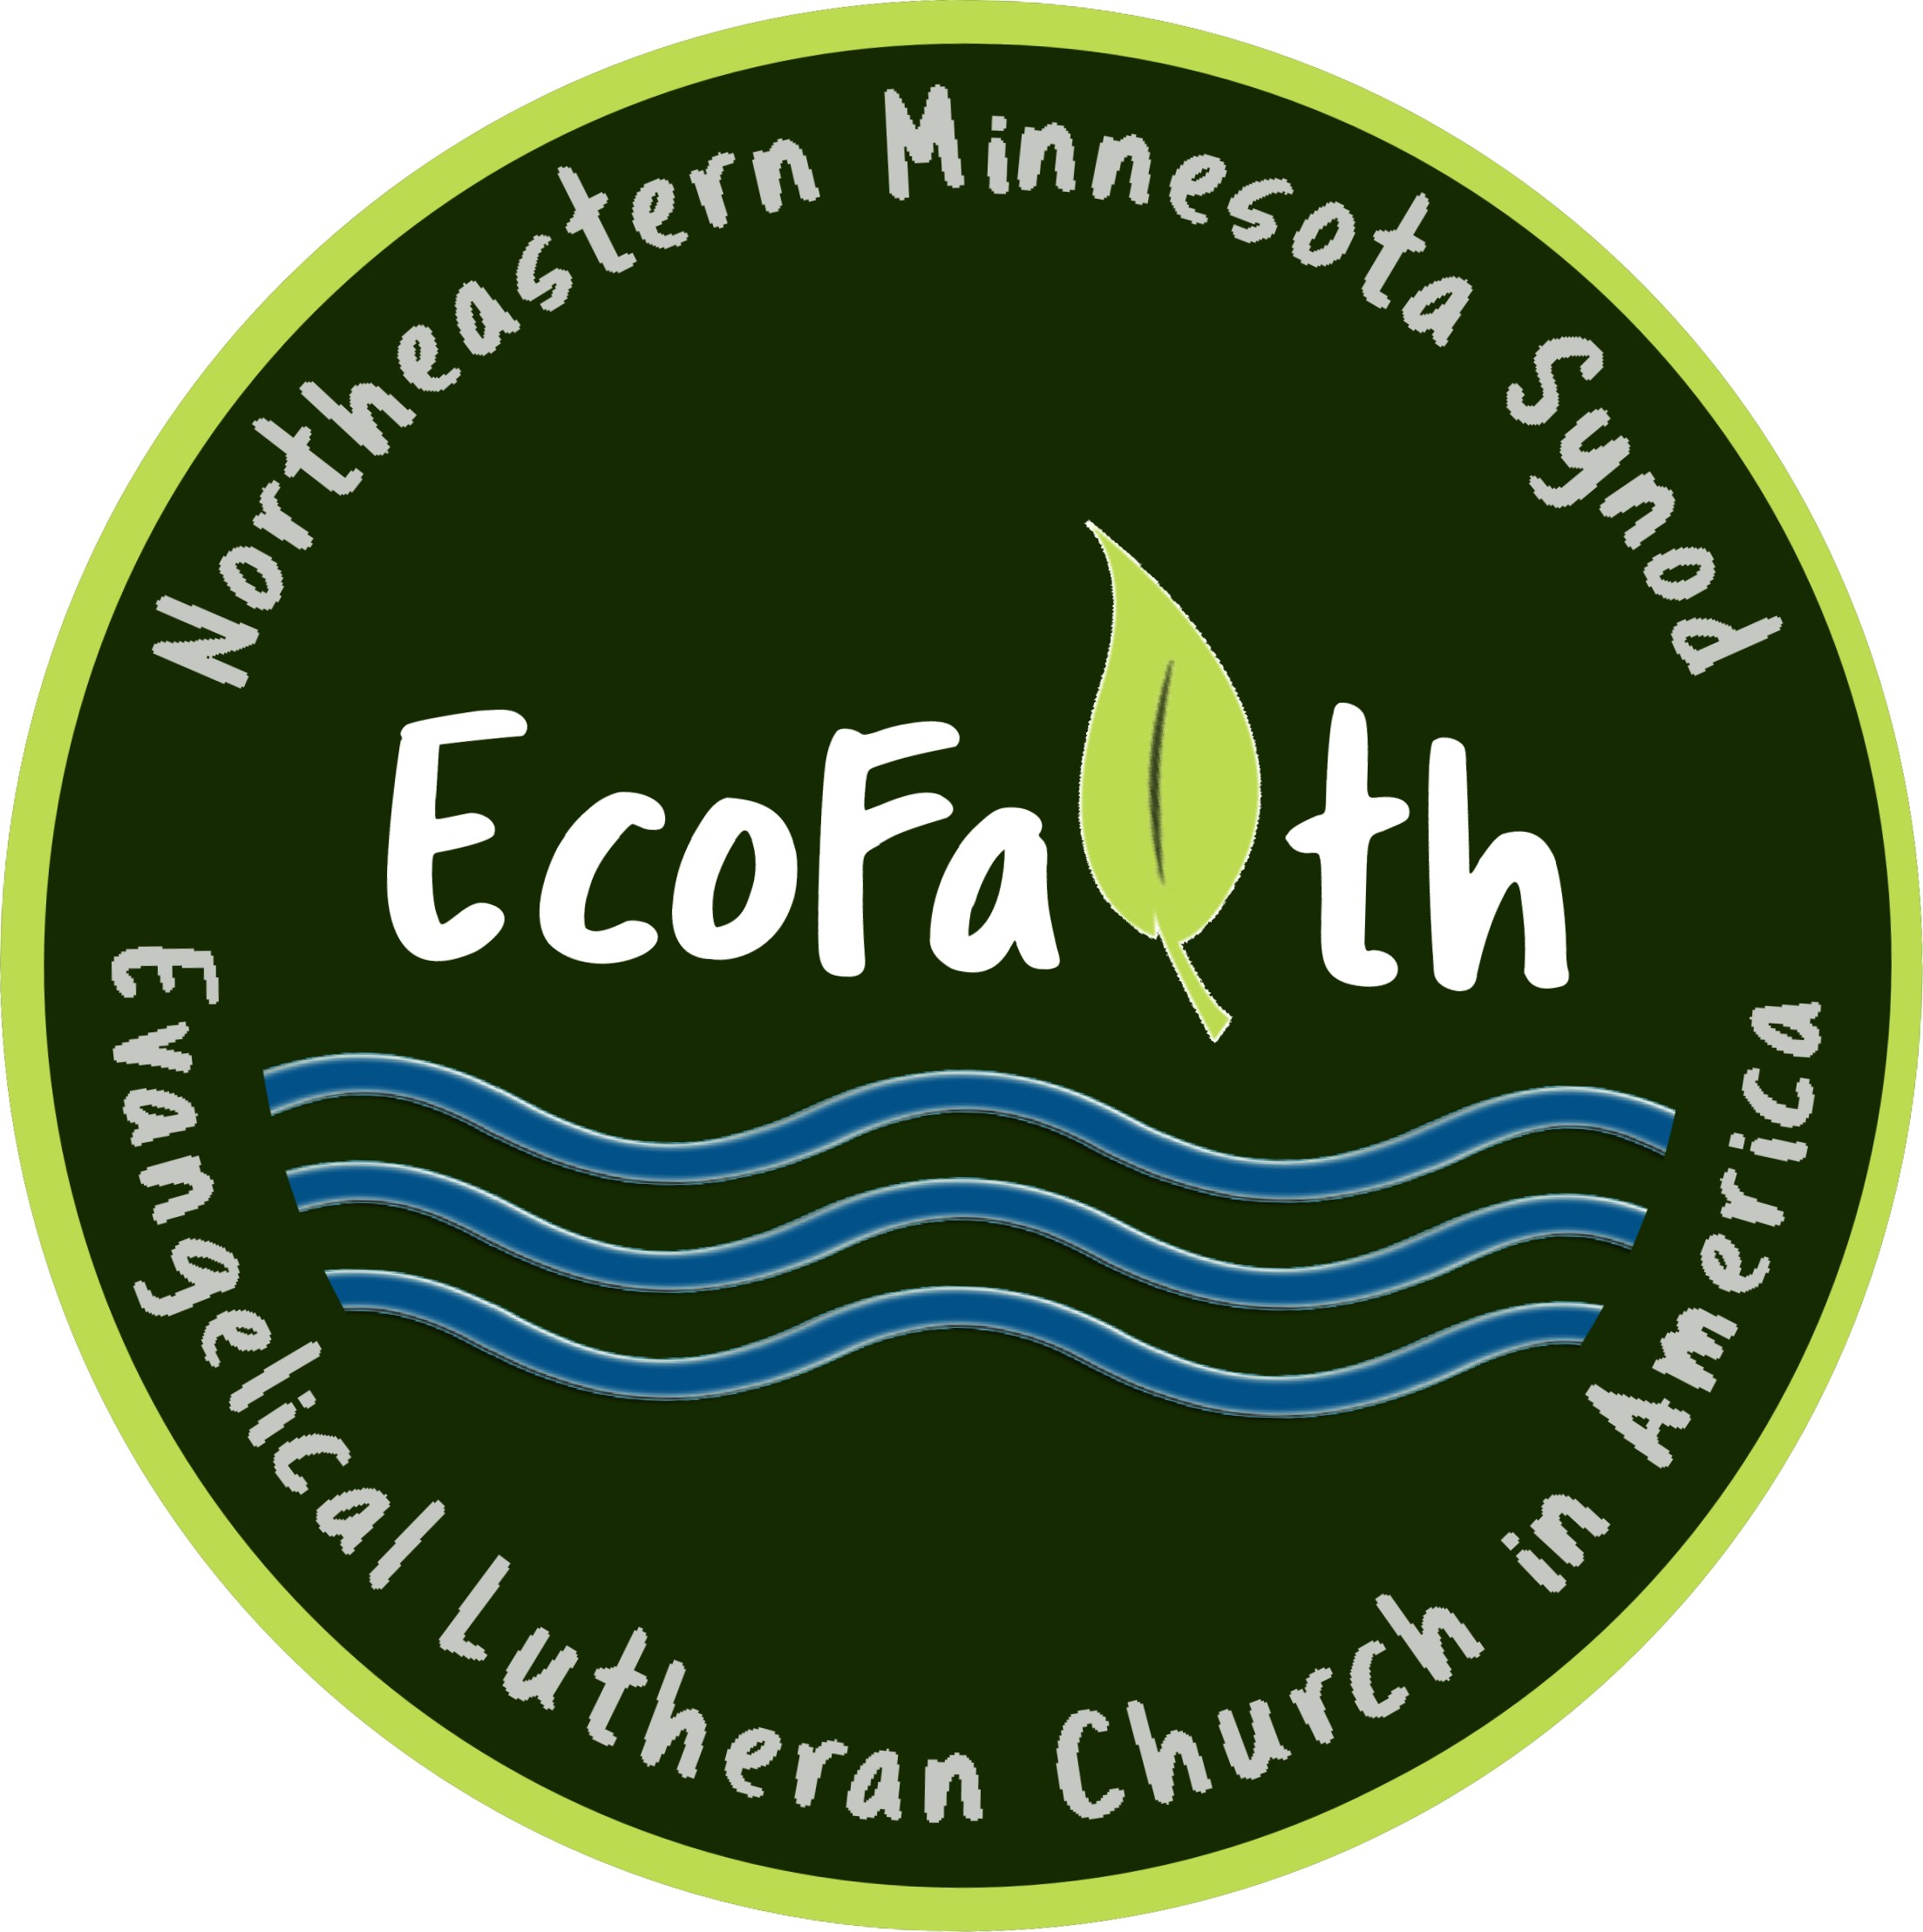

Sample template press release to announce micro-grant award

For immediate release

Name, town awarded an EcoFaith Network micro-grant from the Northeastern Minnesota Synod EcoFaith Network

Or Name, town to undertake innovative environmental ministry project with special funding from the NE MN Synod EcoFaith Network

Photo of your church/organization or of the site of the project should be included.

Name, location has recently been awarded an EcoFaith micro-grant by the EcoFaith Network of the Northeastern Minnesota Synod, ELCA. The grant for $_______ will provide funding for name, location to initiate a/the title of project initiative. Describe project here. This project is a direct expression of the mission of name which is to ______________. If you are doing other forms of creation care, and/or a creation care team, you could identify them here.

You could insert a quote here about the project from the pastoral leader or someone directly involved.

The EcoFaith Network of the Northeastern Minnesota Synod of the ELCA is a growing network of congregations and other companion partners, living out God’s call to be stewards of the earth for the sake of the whole creation. The Northeastern Minnesota Synod has named the care of creation as integral to worship and ministry, especially in this time of ecological and climate crisis. EcoFaith Network micro-grants are awarded each year to NE MN Synod congregations and other church-related organizations to support innovative new initiatives in the care of creation.

Name, location plans to celebrate the results of this project with our neighbors. The date and specifics of this celebration will be announced.

For more information about name, location and its creation care ministry, go to (website), email ____________, or call __________________.

For more information about the EcoFaith Network’s activity, or to receive their monthly newsletter, go to www.ecofaithnetwork.org, or email ecofaith@nemnsynod.org.

Notes:

--The sequence of the press release could be changed. The specific project could be announced and described first, followed by acknowledging the grant awarded with description of the EcoFaith Network.

--A similar article should be included in the church/church organization newsletter and in abbreviated form on your Facebook page.

--We also recommend that you share this on the NE MN Synod Facebook page and Synod On-Line Communications, Contact Monica Brunig monica.bruning@nemnsynod.org.

--The press release can be sent to whatever news outlets are most noticed by your community. If photos and video clips are available, this could also be picked up by KAXE TV or CARE-11, or by MPR.

--If you were awarded this micro-grant earlier, just adjust the press release accordingly, and lead with a description of your project, including the micro-grant acknowledgement later in the body of the press release.

