Summit Information
For Engaging Your Congregation and a Full Generational Arc

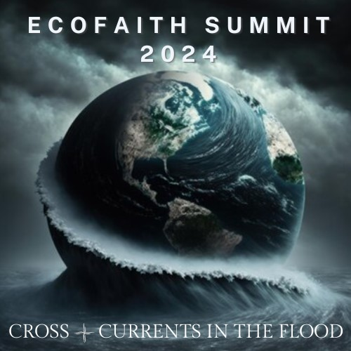

EcoFaith Summit 2024
Cross Currents in the Flood
Building Arcs Together for a Livable Planet

April 6, 2024
First Lutheran, Duluth, Minnesota and Livestream
9:00a.m. – 4:00p.m.
Reception to follow

Presented by
Northeastern Minnesota Synod EcoFaith Network
Northwest Synod of Wisconsin Creation Care
St. Paul Area Synod Care of Creation

Confront the reality of the climate crisis.
Listen for God’s call through the cries of the world.
Conspire for life across generations.
Equip communities for action.

Summit Highlights
Keynote Speaker: Larry Rasmussen
Next generation respondents: 7th grade student and recent college grad
8 Arc Building Sessions, including child-friendly options
Summit Worship featuring original hymn by Paul Jacobsona
Singalong with Duluth Singer-Songwriter Sarah Thompson
Explore table displays from Partners
Book display
Letter writing table
Lunch by Chef’s Marketplace, Cloquet

Registration: $25 (scholarships also available)
Free registration for anyone under 30
Free childcare

Register and download Summit posters at https://ecofaithnetwork.org/ecofaithsummit-2024
For regular Summit updates, https://www.ecofaithnetwork.org/subscribe
Facebook: https://www.facebook.com/events/743527824549578/?ref=newsfeed

The Summit Theme
The year 2023 was the hottest year on record. The climate crisis is no longer a future we are trying to avert. This crisis is upon us like a flood. We feel caught up in its cross currents that threaten to sweep us away and pull us under. We are overwhelmed by myriad floods: literal floods and other disasters that threaten our existence, floods of information and misinformation, as well as debilitating floods of anxiety and hopelessness.

At the same time, we are being carried forward on the Spirit-led cross currents toward new possibilities and new life. As in the waters of baptism, this journey involves both death and resurrection. By acting together with an ever-expanding circle of companions, we discover signs of hope.

As we build these relationships, we are building arcs that become the Ark necessary for survival. We build arcs of relationship connecting generations, crossing boundaries, and healing divisions. We build arcs that lead us to Indigenous ways and wisdom. We repair the broken arc between us and the whole community of creation. We build arcs together from problems to solutions, from fossil fuels to sustainable energy, from extractive economy to regenerative economy. As we build these arcs, we look to the rainbow – the arc of promise.

Throughout this journey, questions abound: How can we unite in the face of this flood? How can we listen more closely to the cries of creation and to the promises of God? How do we respond in life-sustaining ways? What other questions do we bring?

During the Summit, we will join together to address our many questions. We will listen and learn from our keynote speaker, Christian environmental ethicist and author Larry Rasmussen, and from inspiring young respondents. We will sing and worship. And we will engage our bodies in arc-building actions and conversations, as together we conspire to embody God’s vision for our life together.

About the Keynote Speaker Larry Rasmussen
Larry L. Rasmussen is Reinhold Niebuhr Professor Emeritus of Social Ethics, Union Theological Seminary, New York City. His most recent book, The Planet You Inherit: Letters to My Grandchildren When Uncertainty’s a Sure Thing (Broadleaf Books, 2022), is the winner of the 2023 Nautilus Gold Prize for best 2022 book in Ecology and Environment. His book, Earth-Honoring Faith: Religious Ethics in a New Key (Oxford University Press, 2013), received the Nautilus Gold Prize for Ecology/Environment and also the Nautilus Grand Prize for best 2014 book overall (27 categories). An earlier volume, Earth Community, Earth Ethics (Maryknoll: Orbis Books, 1996), won the prestigious Grawemeyer Award. He served as a member of the Science, Ethics, and Religion Advisory Committee of the AAAS (American Association for the Advancement of Science) and was a recipient of the Distinguished Alumnus Award from Union Theological Seminary, New York. From 1990-2000 he served as co-moderator of the World Council of Churches unit, Justice, Peace, Creation. In the Spring Semester 2018 he was guest professor at Union Theological Seminary and Yale University Divinity School. In the summer session of 2019, he taught in Cambridge University, England. In 2021 he was granted the Lifetime Achievement Award of the Society of Christian Ethics.

Arc Building Session Options
Energy Transitions and the IRA: Building Arcs to Renewable Energy
Graceful Conversations: Building Arcs across Divided Perspectives
Joining the Pollinator Plot: Building a Regional Arc of Pollinator Sanctuaries
Letters to My Body of Water: Rediscovering our Spiritual Arc with Water
Building Arcs between Generations: Conversation with keynote speaker and Next Gen responders
Climate Grief and Mental Health: Building Arcs of Awareness and Wellness in Anxious Times
Political Advocacy and Action: Building Arcs of Necessary, Public Change
Zero Waste Kids: Building Arcs with Our Youngest Generation

Schedule for the Day

8:30 - 9:30a.m. Check-in, refreshments, explore table displays
9:30 - 9:45a.m. Summit Opening, Welcome, and Worship
9:45 - 10:30a.m. Keynote Session 1
10:30 - 10:45a.m. Next Generation respondents, followed by Q & A
10:45 - 11:00a.m. Break
11:00 - 11:45a.m. Keynote Session 2
11:45a.m. - 12:00p.m. Next Generation respondents, followed by Q & A
12:00 - 1:15p.m. Lunch and explore table displays
1:15p.m. Summit Worship
2:00 - 2:50p.m. Arc Building Session 1 (4 options)
3:00 - 3:50p.m. Arc Building Session 2 (4 options)
3:50p.m. Sending (within each Arc building group)
4:00p.m. Reception and explore table displays

Livestream schedule

Morning Plenary: 9:30a.m. – 12:00p.m.
Summit Worship: 1:15 – 1:45p.m.
Arc Building Sessions: One hybrid session at 2:00p.m. and at 3:00p.m.

Summit Partners (as of 3/1/24)
Luther Seminary
Augsburg University
St. Olaf College
United Theological Seminary of the Twin Cities
Lutheran Advocacy-Minnesota
Minneapolis Area Synod EcoFaith
Northwestern Minnesota Synod
Southwestern Minnesota Synod
Minnesota Interfaith Power and Light
The Ministry Lab
Together Here Ministries
Voyageurs Lutheran Ministry, Minnesota
Luther Park Bible Camp, Chetek-Danbury, Wisconsin
Lutheran Campus Ministry – Bemidji State – Community Called Grace
Lutheran Campus Ministry – University of Minnesota, Twin Cities
Lutheran Campus Ministry – Duluth

“The destiny of the 21st century will be shaped by the possibility or collapse of a shareable world.” Toni Morrison, as quoted by Larry Rasmussen in The Planet You Inherit

“Coming of age in a climate crisis is like learning to swim in a flood.” Talitha Amedea Aho
Deep Waters: Spiritual Care for Young People in a Climate Crisis

