Green Blades Preaching Roundtable
Second Sunday in Advent, Year A –– December 4, 2022
Melinda Quivik, St. Paul, Minnesota

Isaiah 11:1–10
Psalm 72:1–7, 18–19
Romans 15:4–13
Matthew 3:1–12
________________________

Advent wants us to wake up so that we are ready to take in the promise that, as Isaiah puts it: “the earth will be full of the knowledge of the Lord.” The very Earth will know God.

Faced with a land that holds “the knowledge of the Lord,” that knows God, that exudes who God is, what else would we want to do than treat with compassion all people, all plants and creatures, the air and soil and water that God has given us?!!!

This is such an enormous idea, it would take eons for us to understand what it means, but at least the church calendar gives us the four weeks of Advent to ponder a world in which “the wolf shall live with the lamb,” led by a little child, the most unlikely of shepherds. Preparing entails listening to John the Baptist: “Repent, for the Dominion of God has come near. . . Bear fruit worthy of repentance.”

This bearing fruit begins with looking around us at an Earth that is full of a knowledge we don’t have. John calls the oblivious of his time a “brood of vipers.” Today he castigates us, as well, because we have also –– as nations, communities, families, and as individuals –– failed to prepare the way of the Lord by repenting of our neglect and our assumption of privilege regarding the gifts of our lands. We have ignored the knowledge Earth has of God.

Earth groans because humanity looks at Earth –– the creatures and landscapes –– as “resources”
we are invited to use up instead of holding them in awe. (We should abolish the word “resources” when used to refer to the gifts of Earth. This is especially true in Intercessions so that we don’t ask God to care for the “resources” but for God to help us care for cormorants and waterways, songbirds and elk, the forests that stand in danger from wildfire, the microbes and the soil and so much more.) Earth is groaning when Earth’s waters scream at us to pay attention, showing us who is boss as the seas submerge islands. Nations and tribes watch the inevitable relocation of their people to higher ground come closer. Venice is sinking. Several-story buildings along the Atlantic Ocean in Florida crumble as the structure of the ground beneath them is undermined by water. Drought, famine, mudslides, and violence are on the increase.

The Baptist comes out of the wilderness knowing where he is standing and where he is going. He directs us to take stock so that we can begin to imagine, as he does, that our context is a marvelous place that includes not only ourselves and all of nature but also the Dominion of God.

If we come to see Earth as a place where God resides, we might begin to imagine turning toward the care of creation with gratitude rather than resentment at having to change our ways. Lutherans know that hearing about the knowledge of God that resides in Earth is the kind of announcement and promise that changes our vision and frees us to bear worthy fruit. The law, the truth about ourselves, neither points to the way we should go nor helps us see how to renew the face of Earth. The law shows us the situation, but the gospel gives us the imagination and energy to want to change our ways and honor God’s creation.

John says two things: 1) Look around you, O People, and see what is true so that you know what it is you need to repent, and then 2) make yourselves worthy of this Earth that is “full of the knowledge of God.” All Earth and beyond Earth is God’s creation and the place of God’s reigning. Considering the origins of things will help us attain enough awe for what is in front of our eyes to live with gratitude.

Some time ago a little article in the New York Times described what existed in the universe before the Big Bang. Astrophysicists know something about what happened in the “first trillionths-of-a-second after the Big Bang,” but they long thought there was nothing before the Bang. Physical evidence has changed that view. Astrophysicists now see a “backdrop of cosmic microwave radiation generated by the Big Bang.” And on top of that backdrop, they see “a pattern of concentric circles” that might be “gravitational waves” from “collisions of superbig black holes before the Big Bang.” This means that our own universe may “be but one aeon in a (perhaps unending) succession of such aeons.” Our universe might just be one universe in a chain of universes each of which had a Big Bang and sent a gravitational wave into the next universe.

And on one tiny dot in that expanse, on our Earth, a voice cried out, urging us to pay attention to what it means to be alive and to care for others. We need the help of figures like John the Baptist to call us to what matters because even though we continue to need to repent and bear fruit worthy, we are still prone to taking even extreme measures to avoid addressing the underlying problems of our time.

Some humans have even spent fortunes building escape housing. “60 Minutes” recently showed escape apartments built in vacated nuclear missile silos. Underground spaces for living and recreating (including a swimming pool) are walled off behind a steel door that weighs many tons. You can’t get in if you are not one of the wealthy owners. The message of those siloed living spaces is that you can’t save yourself from climate change unless you are fabulously wealthy. Even then, what would you find when you opened the very heavy steel door to venture back out into a ruined landscape? Is escape even possible?

With God nothing is impossible.

The God who created universes and set them in motion, who created light and darkness, the heavens and the earth, the creatures and all that breathe, the plants and insects, the leviathan and single cells –– that God knows our need. And it is that God who sent to us something very small in the huge scale of all that is –– a little child… a stump… a branch… a Word… a voice in the wilderness –– to welcome the needy into God’s justice and peace, to call us all to care for what we have been given.

_________________

Hymns to consider:

In ELW:
#434 Jesus Shall Reign
#881 Let all Things Now Living
#771 God, Who Stretched the Spangled Heavens

In the new hymnal supplement to ELW, All Creation Sings:
#1064 Earth is Full of Wit and Wisdom
#1065 Can You Feel the Seasons Turning
#1069 God Bestows on Every Sense
#1070 The Heavens Tell of Your Creative Glory
#1071 In Sacred Manner

Melinda Quivik, an ELCA pastor (who served churches in Montana, Michigan, and Minnesota) and former professor of worship and preaching, is currently the Editor-in-Chief of the quarterly journal Liturgy, a writer, and a preaching mentor with Backstory Preaching at backstory-preaching.mn.co.

Green Blades Preaching Roundtable
Second Sunday of Advent
December 4, 2022
Isaiah 11:1-10 - Romans 15:4-13 - Matthew 3:1-12

Pastor Karen Behling (she/her)
Chippewa Falls, Wisconsin

Since its publication in 1992, my preaching and teaching has benefitted from Manna and Mercy by Daniel Erlander, and I am now appreciating the many related materials available through Augsburg Fortress.

https://www.augsburgfortress.org/store/category/287225/Daniel-Erlander

Erlander helps us to recognize the overarching themes of the biblical story which he describes as a “long story - a story of friendship, passion, promise, disappointment, hope, and self-giving love. It is a story of God mending the universe.”

When John the Baptist appears, calling people to mend their ways, we are called into this larger story of God who is acting to bring reconciliation and who is inviting us to join this effort to mend the universe. As one who has used needle and thread and sewing machine to mend many garments, I know that the best mending considers both utility and aesthetics. I recall many times when one of my children came with a torn article of clothing, often one of their favorites. Occasionally, the tear happened at the seam, and so the repair was as simple as re-stitching that seam, and the garment looked as it did before the tear. More often, however, the mending required some sort of patch which meant that the garment would look different after the repair. With some creative use of color and a bit of imaginative flair, however, I learned to mend garments that brought delight to my children with their whimsy and beauty. In many cases, the mended garment became more cherished than the original. And no two patches ever looked the same.

Repentance is all about assessing where relationships have become torn and then creatively imagining how to mend that tear so that joy can flourish. Or as John the Baptist urges us, “Bear fruit.” Fruit is pleasant to behold, it nourishes, and from its seeds, it produces more fruit which promotes more life which brings greater blessings.

As we look around at our world today and consider the state of our relationships with each other and with the waterways and with the land and with all the creatures of this planet, it is so very obvious that the fabric of our life together has ripped and torn apart. So much is out of balance. And as unsettling as things may be for us, in many parts of this world, the situation is truly alarming. To do nothing is to consent to this scary downward slope. To repent is to name the tears in the fabric of our life together and then to find ways to work together to mend these many tears. It will not be easy. There is no quick fix, nor can we go back to what once was. But with some imagination and some innovation, we can find ways to mend these tears and discover the life that could be, the life that God envisions for all of us together.

All three of today’s readings invite us to look to the future, to embrace God’s vision for harmonious life together, to recognize that change is necessary if we are to thrive and flourish, and ultimately, to acknowledge that change is necessary for the survival of so much life on this planet.

John the Baptist’s call for repentance is a call for change. Our lives need mending. Our relationships need mending. Our planet needs mending. The tone of urgency that we hear in John’s message is similar to the tone that we hear from many climate scientists. We simply cannot continue to live like we have all the time in the world to get our act together, because we do not have much time at all. The fabric of our life together is tearing apart. We see gaping holes where forests have been cleared and where machines have dug deep to extract resources and where there are dead zones in bodies of water and where toxic spills have wiped out plant and animal life.

We can act before it is too late. We can mend our ways by acting to change our habits and practices in our homes, in our church buildings, in our communities, in our policies for how we use this earth’s resources, and in our commitment to act in ways that benefit all of this earth’s creatures - plants and animals and yes, people in all of our wonderful diversity, living throughout the world.

Throughout scripture and in all three of our readings for this day, God persists in pursuing God’s vision for this planet. It is a vision of shalom where all can dwell in peace. It is a vision of relationships bridged beyond differences. It is a vision for action that brings life and bears fruit.

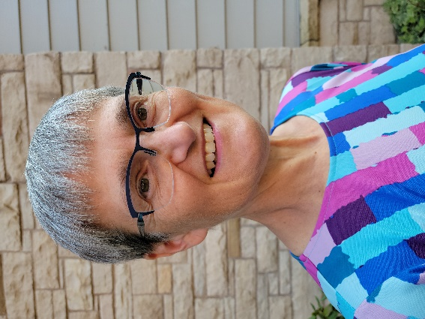
Pastor Karen Behling (she/her) lives within a mile of the congregation she serves - Our Saviour’s Lutheran Church in Chippewa Falls, WI - which means that most days, she enjoys walking as her primary mode of transportation. Previous calls have been in Minnesota, Iowa, and North Dakota in congregations small to large, with and without staff. Her primary creative outlet is quilting, and a perfect day includes time with family as well as time for yoga, gardening and a good book. Those children whose clothing she mended are now 26, 28 and 33.

Green Blades Preaching Roundtable
- Year A: Advent III
- Isaiah 35:1-10 ~ Psalm 145:5-10(or Luke 1:46b-55) ~ James 5:7-10 ~ Matthew 11:2-11

- December 11, 2022

Pastor Lisa Buchanen, Deer River, Minnesota

Is Jesus the one? John’s purpose in life was to prepare the way for the one – the Messiah who would redeem Israel. Already in prison, it’s not looking good for John, but can he die knowing the Messiah has come? Will everything be okay now? John sends messengers to ask Jesus directly. Jesus, classically, does not answer directly.

Rather, as a response, Jesus names the salvation others have already experienced in his presence: sight is restored, people can walk again, diseases are healed. The disciples are to tell what they “hear and see” as experiential proof of Jesus’ credentials. Jesus will not name himself as the Messiah but focuses more on the works of “kingdom of heaven” and his role in launching such a reality (Matt. 4:17b).

My attention today is drawn to the popular desire for a Messiah who would fix everything, and Jesus showing the reality that everything cannot get fixed at once with a cosmic finger snap, but through the intentional and persistent unfolding of the kingdom of heaven.

I know that we can all get frustrated at the enormity of the environmental crisis and wish someone would just do something about it already. Didn’t Jeff Bezos say he was going to give away most of his wealth!? There we go! Easy and done. Whew. For a moment there, I thought I would have to change. We want the easy fix, and yet, begrudgingly, we are beginning to realize that we all have a part in creating a sustainable future starting with our actions in day to day living. Everyday we keep trying.

I am so proud of my congregation for switching over to compostable trash bags (the ones that don’t tear apart, of course) and for moving to LED lightening. The Altar Guild volunteers voiced their concern over using disposable communion cups, so they took it upon themselves to wash glass communion cups instead. Did we try many other solutions first? Yes. And when they didn’t pan out, we kept trying. Does it take more time? You bet. But I have watched these volunteers use that time to visit and giggle with each other, taking pride in their work in the church and knowing they prevented more plastic from ending up in a landfill.

Jesus is doing the hard, time-consuming work of bringing about the kingdom of heaven without needing to fit within the Messianic dream that arose from the inter-testamental period. Anyone can claim they are the Messiah – and my understanding of this time is that a lot of people did. Jesus uses his life and death to work redemption in the present for those who suffer throughout Judea. He keeps at it and keeps trying. It’s not a cosmic finger snap, but it’s relentless, compassionate action in the present that supports Jesus’ ministry proclamation: “the kingdom of heaven has come near” (4:17b).

Jesus will go on to describe the kingdom of heaven as spreading slowly but persistently like a mustard seed (13:31) or yeast (13:33). It will create a new reality with great reversals as Jesus indicates at the end of the gospel passage today regarding John: “No one has arisen greater than John the Baptist; yet the least in the kingdom of heaven is greater than he” (11:11b).

Is Jesus the one? John does not get a direct answer today, but Jesus appears to answer with a wink so that we may find hope in hearing that the lame can walk, the deaf can hear and the poor are sustained with good news. It’s not fast and flashy work, but God is at work. Jesus’ consistent acts of love and compassion point to the unfolding kingdom of heaven among us. And instead of a Messiah who will overthrow an empire, we find a humble servant, a leavening agent who gives us the power to keep going and the power to keep trying.

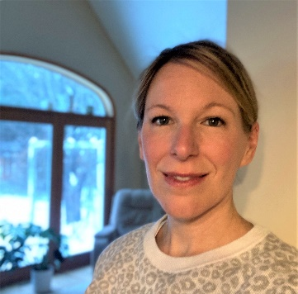
Lisa Buchanan is pastor at Bethany Lutheran Church in Deer River. She shares life with Ben and 6-year-old twins, Alex and Scarlett, in Grand Rapids.

Green Blades Preaching Roundtable
Year A: Advent IV
Isaiah 7:10-16 ~ Psalm 80:1-7, 17-19 ~ Romans 1:1-8 ~ Matthew 1:18-25

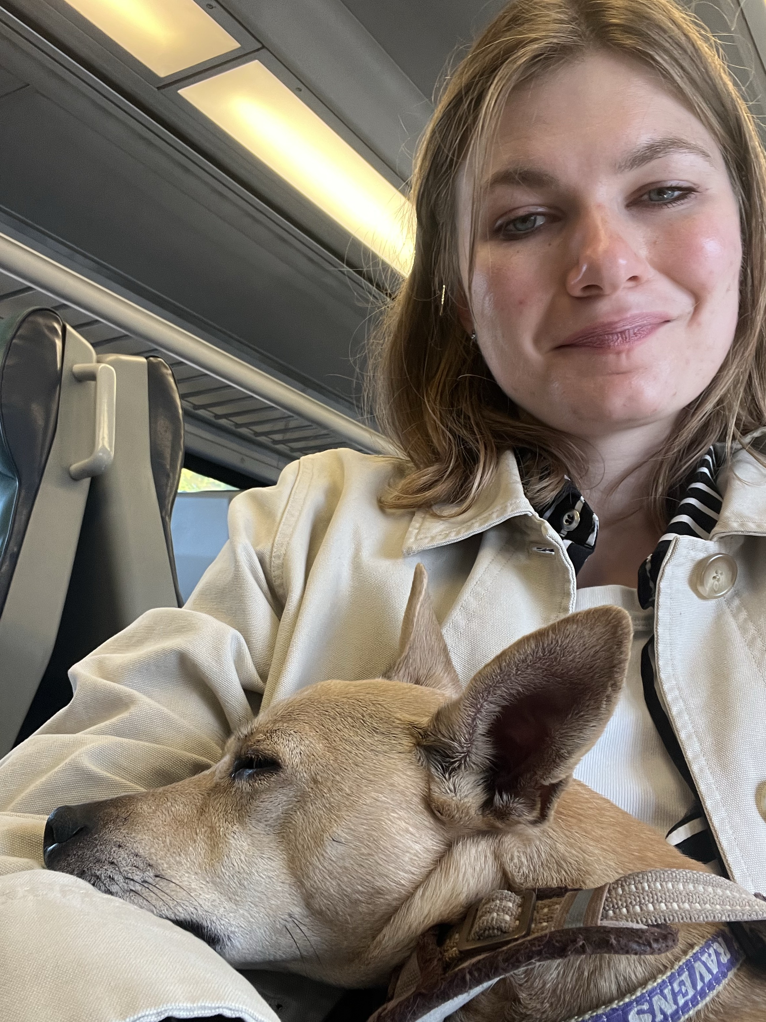
December 18, 2022

Born and raised a Lutheran in Chicagoland, Pastor Claire Repsholdt is currently serving in her first call in a small town suburban church lovingly known as the Lutheran Church of Our Savior in Patchogue, NY on Long Island. She is looking forward to being ordained in January 2023! Outside of work, she enjoys knitting, reading, making frequent train trips in to New York City, and taking her little dog Penelope on grand adventures.

"Look, the virgin shall conceive and bear a son, and they shall name him Emmanuel," which means, "God is with us."

Dearest preachers—

Here we reach the end of the season of Advent, the culmination of all of our anticipation for the birth of our beloved Christ. Even now, as we enter into the mad rush to Christmas that our society loves so much to practice. Even as we explode into a bustle of gift giving in our families and friendships this holiday season, perhaps there is still time to experience the hush of awe that falls on a group—when everyone realizes at the same time that, yes, “God is with us.”

Can you think of the moments of quiet like this in your life? When you’ve stood in front of a sunrise? When you’ve looked at the glistening sea floor that hid beneath the tide?

In the last few weeks, I am sure we have all embraced the traditions of Advent in full festivity. As we have prepared for the coming of Christ, it may have been a little bit like we are kids in the back seat of a car on a long road trip, hating the world as it passes by the window. Struggling to settle down as we are waiting and waiting and waiting for the big arrival. And for a few precious weeks, we have rightly embraced the task of enchanting each other to make the waiting less difficult. We baked cookies, wore colorful clothes, lit candles, and sang some of our most familiar hymns.

In these last few days, though, perhaps, after all of this amazing enchantment has been done, we have enough courage to look out the window at the world around us. Perhaps we have enough time to let what is unadorned in this season speak. To look out at the world and let the cold wind, the black skies, the bare trees whisper to us that something new is about to arrive.

I know that sometimes, as adults, it can seem impossible to let the wild joy of Christmas sweep us off our feet. And yet, I know it is always there in the quiet fields around us, waiting for us to slow down and let it.

On Christmas Day, 2020, I was working as the only chaplain on-call at Yale New Haven Hospital. I decided it was the least I could do, since I could not travel home to Chicago to be with my family, and all of my colleagues had families near by to see. Plus, I admit, I was excited to hear that the chaplain on call that day got to plan a Christmas service for the entire hospital.

I put on my favorite Christmas cardigan for the occasion—blue with white beaded snowflakes. I strung together a simple liturgy, featuring Christmas prayers, poems, and, most importantly, a boom box that would play the best hymns imaginable. And as I sat in the chapel, filled with beautiful poinsettias and lit candles, checking my watch…no one came.

But as I stood there after I had done so much set up and looked out at the empty room, the unadorned message of Christmas began to speak. I realized that I believed in the healing love of Christ so much that it was worth it to do the whole service alone, just in case someone showed up who needed to hear some good news.

So I proclaimed to the empty chapel that Christ is born to save us all and hold us close as we make our way to glorious eternity. That’s that funny way God has about God… of filling untouched wombs—creating life exactly wherever everyone has heartily agreed lies a bare landscape. As I preached to that empty chapel, I did not feel alone at all. I cried, as I read the story of Christmas and sang, Christ is born today. I knew without a doubt that God was with me there. The Christmas story promises that God is with us always! I knew that one day I would celebrate Christmas again in a full church.

This year, I did, indeed, make it to a full church. I am celebrating in an amazingly full church as I approach my first Christmas in my first call. And yet, I am doing so with the wisdom that in the most barren landscapes of our lives—the deep breaths we take at dawn, the tacit prayers we utter when we face an empty road home, the thoughts that fill our minds as we bend to shovel another heap of snow. God is with us even in these moments—preparing us to rejoice when we see each other again.

I hope you find ways in these last days before Christmas to look out the window at the world around you—to drink in the emptiness of nature, the huge room of your heart, the biggest silence of your day. Let yourself hear in those bare landscapes that God is with us. Let yourself live into the softness of these final days of Advent. Let them be a huge womb where you can nurture your sweet love of Jesus Christ.

See how this will prepare you to stand in the crowd, if that’s your thing, on Christmas Eve. See, then, who you can wink at with the sweetness of how good it is to have traversed so much cold and quiet ground to be together. See how lucky we are to be able to celebrate Christ’s birth unabashedly in a full church.

Your friend—
Claire

Green Blades Preaching Roundtable
Christmas Eve and Christmas Day
December 24 and 25, 2022

Luke 2:1-14[15-20], John 1:1-14

Pastor Dick Bruesehoff
Minocqua, Wisconsin

Preacher, on the Feast of the Nativity, less is more! The time will come to explore, perhaps even to argue the case for the Incarnation. Days will follow, plenty of them, for diving into every nook and cranny of the duties and delights of discipleship. Even then we will never fully know and understand the mystery of the Incarnation. Today it is enough to celebrate the beginnings, to ponder convergences, to reflect on the Incarnation as the glue that connects us to God and God’s beloved world, to ruminate on the mysteries of Word and Flesh.

You know the story. Many of your hearers are at least acquainted with it—a baby, a barn, shepherds, songs of angels. Perhaps less familiar is a story of the first Word, the in-the-beginning-was-the-Word word.

Perhaps because of the way the ecumenical creeds were structured, we are inclined to proclaim Christmas stories as the beginning of the story of salvation. When we do, we can miss and dismiss the stories of salvation, healing, restoration and reconciliation that fill the Hebrew scriptures. And we’re as likely to gloss over the stories of creation and new creation in the Christian scriptures, echoing those we know from the Hebrew scriptures.

How do the Christmas stories resonate when we hear them, these stories of creation and beginning, under the winter sky, listening for the voices that are still singing? What do they sound like in the places where our nostrils are filled with scents of life—humus, blood, sweat, milk, straw, manure? Where do they transport us when we stand in the places where nothing but a gritty, earthy spirituality will do?

I believe we can (and indeed must) always read the Gospels from the very places where we stand. As I’ve read and contemplated Luke 2 and John 1 in 2022, I am struck by how these two tellings of the story of Incarnation speak now. The Gospel of Luke reflects the heart of Christmas, filled with the pathos, the longing of the earth, the poor, and (stay with me!) women, BIPOC (black, indigenous, people of color)—in short all those who yearn for the all-shall-be-well world of God’s promised shalom.

If we were staging a performance of Luke 2, I can imagine a kind of split backdrop—the palatial palaces of the powerful on one side and the dank, dark depression in the rocky ground that housed the animals at the inn on the other. Can you sense that both can be alien, foreign worlds? Now douse the lights and enter the night world of sheep farmers. Here in a darkness deeper than any barn, a song: Glory to God in the highest places and peace on earth. Singing moves us! And this song takes the farmers to the barn where they see the child. Birth! Beginning. Life, new life before our very eyes. And for those with eyes to see, this is the beginning of the New Age (as Frederick Danker names it in his commentary on Luke, Jesus and the New Age).

John, the mystical poet, the delver-into-the-depths, writes in the language of logic and reason about this creative Word that is now becoming flesh. Here all takes place in the light. We are moved from the world of theories, hypotheses, and observing-at-a-distance. We are drawn away from denying creation and hating the world, because! Because the Word is, right here, right now, among us, becoming flesh. The light which cannot and will not be overcome is shining. It’s as if it is all beginning fresh and new. Creation, like a seed, ripe-to-bursting with life, grace and truth.

John Philip Newell in his The Rebirthing of God: Christianity’s Struggle for New Beginnings says it this way. “We find this same connection at the heart of the Christian household, looking to the Glory at the center of life in such a way that the whole of life is seen to be suffused with that same Light. This is what the story of the nativity of the Christ Child does. The sacredness of the Christ Child, born of the marriage between heaven and earth, reveals the sacredness of the universe, conceived by the union of spirit and matter.” (p. 46)

Robin Wall Kimmerer in Braiding Sweetgrass writes: “The problem with these people (us!) is that they don’t have both feet on the shore. One is still on the boat. They don’t seem to know whether they’re staying or not. This same observation is heard from contemporary scholars who see in the social pathologies and relentless materialist culture the fruit of homelessness, a rootless past….But can Americans, as a nation of immigrants, learn to live here as if we were staying? With both feet on the shore? What happens when we truly become native to a place, when we finally make a home? Where are the stories that lead the way?” (p. 207)

We are people of just such stories: the story of Word made flesh! The story of God become human! A gritty, earth-bound story. A story of all creation, planted and nurtured in the rich soil, the humus of the Word made flesh. A story reminding us that we are dust, humus, and to dust we will return.

Again, John Philip Newell in The Rebirthing of God.
Last year I was in Cuba at the beginning of Advent, staying at the Convent of Santa Brigida in Havana. One of the Brigidine sisters had spent days preparing the nativity scene in what historically had been the stable on the ground floor of the convent. Its double doors swing open onto a busy street in Havana. There, hundreds of Cuban families stop every day during the Christmas season to gaze at this life-size representation of the Light of the Christ Child. They gaze with delight not because the nativity scene is pointing them to a foreign figure in a far-off land and age. They gaze because they have recognized something of this Light in the newborn countenance of their own children. And they gaze, I believe, because they are distantly remembering deep within themselves the Light that no darkness on earth can extinguish.
Sister Maria is excited to show me the manger scene and to tell me all about the creativity that goes into preparing it each year; she exudes enthusiasm as she speaks about how Cuban families come from all over the city to stop and stare at this depiction of the Christ Child. But this ties in with the passion she brings to her work year-round among the poorest of Havana. This passion is inextricably linked to the vision of Light that inspires her community to feed the hungry and to welcome strangers as if they were feeding and welcoming Christ. It is no coincidence that, in the thirteenth century, St. Francis first introduced the tradition of the nativity scene. It brought into focus for him the Light that he saw in the earth and in every creature, the light of “Brother Sun” and “Sister Moon,” as he called them in his Canticle of the Sun, or “Sister Water” and “Brother Fire.” (p. 47

Preacher, echoing the words of the Psalms, “Let the words of my mouth and the meditation of my heart be acceptable to you, O Lord, my rock and my redeemer.” Amen. May it be so.

Pastor Dick Bruesehoff and his wife, Naomi, live on Anishinaabe (the Lac du Flambeau band of Lake Superior Ojibwe) land in northcentral Wisconsin. In retirement Dick is serving as a spiritual director and retreat leader. A major vocation is loving and learning to live well with five acres of mixed hardwood and pine forest on the shores of Broken Bow lake, land that Naomi’s family has tended for over a century. They have feet in two worshipping communities: St. Matthias Episcopal Church in Minocqua, Wisconsin and Christ Church Lutheran in Minneapolis, Minnesota.

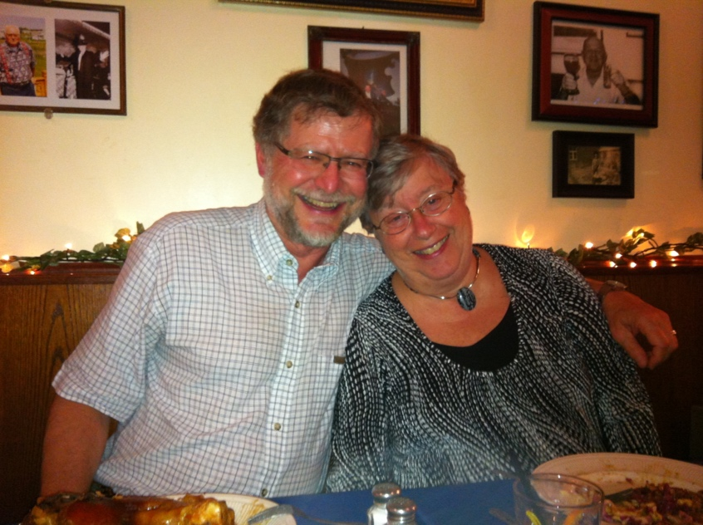

Green Blades Preaching Roundtable
- Year A: First Sunday of Christmas
- January 1, 2023

Isaiah 63:7-9; Psalm 148, Heb 2:10-18; Matt 2:13-23

Pastor Amanda Kossow, Cass Lake, Minnesota

As I started reading Hebrews, I was struck by the author’s sidenote assertion in verse 10, “…God, for whom…all things exist.” I exist for God. You exist for God. The black squirrel exists for God. The tall red pine exists for God. The sparkling snow exists for God. The gray sky exists for God. You get the idea. I can’t really say where I’m going with this necessarily, but it affirmed for me the purpose of all of creation. This then, for me at least, contested the prevailing notion in some cultures, mine included, that the sole reason for other-than-human life is to serve us humans.
I then came across the author’s good news: “so that through death he [Jesus] might destroy the one who has the power of death…and free those who all their lives were held in slavery by the fear of death.” Fear of physical death has a stronghold on many of our lives. I started to wonder though, what other types of death do we fear and hold us captive? Death of our theological and/or scriptural stances? Death of our viselike grip on self-serving power? Death of our consumptive way of life?
Then the Spirit blew this seed down another winding path. Reading the gospel, I was immediately flooded with images of our undocumented neighbors, many of whom are climate crisis refugees. Some of us here in the U.S. greatly fear the influx. Some are infuriated to the point of violent action. How are we reacting to news that threatens us and our lives as we are currently living them? How is our reactive fury killing innocent lives? Relationships? Faith?
As these questions churned in my mind, I moved on to the Isaiah and Psalm readings. As I tried to conjure up how the moon praises the Lord, I was brought back to a detail I had overlooked in the gospel. Often times night is associated with and used metaphorically to represent grappling, turmoil, torment, fear, secrecy, and evil. I don’t know about you, but I have always assumed that nighttime was when Herod’s unchecked rage fomented the horrific tragedy. But the text doesn’t really say. We don’t know for sure the time he was made aware of the wise men’s redirection and violation of his orders. What we do know is that it was the blanket of night that provided refuge for Joseph, Mary and infant Jesus as they fled to a foreign land where they were undocumented refugees for an unknown length of time.
Back to the psalm I go. Whatever the intention of the lectionary folks for this particular Sunday, I cannot help but be jarred by the juxtaposition of the psalmist’s effusive call to praise the Lord and the very sobering, heart-wrenching narrative from Matthew. Yes, we could focus solely on the holy family’s escape as a praiseworthy act of God, and ignore the wailing and loud lamentation over the children who are no more. However, that would be easy and convenient, and faith is, most of the time, neither. This truth transferred, for me, to one of our current realities. It is demoralizing to think about the billions of songbirds that have died or gone extinct due to climate change, habitat destruction and use of harmful chemicals. I lament this distressing truth. And yet. And yet, as I sit typing this reflection, I know there are chickadees chirping away in my front yard. Doing what they were created to do. Praising the name of the Lord who fashioned their tiny black, white, and gray bodies.
“…he himself likewise shared the same things [flesh and blood], so that through death he might destroy the one who has the power of death, that is, the devil, and free those who all their lives were held in slavery by the fear of death.” The One who shares the same flesh and blood as those murdered by fear and the one whose fear erupted in slaughter daily frees you and me in water and the Word from captivity. Frees us to be transformed. Frees us to work for change. And frees us to praise, alongside the chickadees and all of creation, the Lord. Even and especially amidst the suffering.

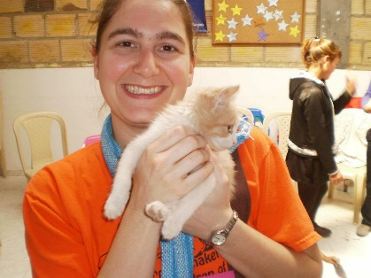 (This photo is taken from the building of Luz Y Vida, the companion church in Colombia to the congregation I previously served) My name is Amanda and I currently serve as pastor at Trinity Lutheran Church in Cass Lake, MN. There is a t-shirt from Grand Island, MI which describes me to a “T.” It states, “Into the woods I go to lose my mind and find my soul.” I am an avid animal and nature lover who hikes, kayaks, and snowshoes as often as possible. Growing up in the Upper Peninsula of Michigan, I feel a strong kinship with creation, particularly trees. During my time in seminary and in both my first and now second calls, I’ve also been gaining a deeper appreciation for and learning from my bond with human neighbors whose culture differs from mine.

Green Blades Preaching Roundtable
First Sunday after Christmas
January 1, 2023
- Isaiah 63:7-9 • Psalm 148 • Hebrews 2:10-18 • Matthew 2:13-23

Emily Meyer, Minneapolis

Like Ramah before them, and Bethlehem in today’s Matthew reading, many of our communities find themselves in a paradoxical position of weeping and lamenting, while quietly carrying the (unacknowledged?) additional weight of complicity in either their own suffering, or the suffering of other communities.

In preparation for this First Sunday after Christmas, it is worthwhile to attend to Matthew 2:3, in which ‘King Herod… and all Jerusalem with him’ are frightened by the news of a new king being born. ‘All Jerusalem’ has good reason to be afraid - not because a new king has been born, but because Herod is afraid. There is nothing more frightening for a population than a frightened despot. Frightened authoritarian leaders do frightening things. Unfortunately, frightened populations often allow frightening things to happen - either to themselves, or to a scapegoat population they are willing to sacrifice for their own preservation.

So the wailing of Ramah during Babylonian captivity, echoed in Herod’s despotic slaughter of the innocents in and around Bethlehem, serve as precursors to the countless ways political, corporate, and social leaders, with the endorsement of fearful populations continue to torture families and slaughter the innocents in cages at our borders; in school shootings; on our streets; in sex and drug trafficking; in traffic stops and school-to-prison pipelines; in climate-change-induced drought, famine, disease, inflation, war, and economic distress; in Afghan coal mines and Midwestern meat packing houses; and, of course, Covid-19 - anywhere and everywhere fearful populations sanction the slaughter of innocents, political, corporate, and institutional leaders will oblige.

To avoid our culpability, many of us read this text and see only Herod’s fear and action. But a fearful populace is also responsible for allowing atrocities to occur - decidedly more so now than in Herod’s day.

Rather than avoid culpability, perhaps this New Years Day reading can function for Christians as Rosh Hashanah, the Jewish New Year, functions for our Jewish siblings: as “a time to celebrate the completion of another year while also taking stock of one’s life… [moving from two days of celebration to] the Ten Days of Repentance, also known as the Days of Awe, which culminate in the major fast day of Yom Kippur, the Day of Atonement”, the end of which is preparation for Sukkot. This ritualized round of celebration, followed by penitence, followed by celebration provides a healing cycle which highlights the joys of the past year, recognizes both personal and communal culpability in the past year’s grief and loss, and then celebrates God’s grace dissolving sins and washing them away.

Key concepts in the Rosh Hashanah and Yom Kippur celebrations are the intentionality and distinction between repentance for personal and communal sins. Christians - and ironically, Lutherans - have moved into a very individualized understanding of repentance, emphasizing ‘personal relationship’ over a communal one. But our Lutheran liturgy provides an opportunity, in preparation for every worship gathering, to confess corporately, that is, as a body: ‘We confess that we are in bondage to sin…’ We are complicit and apathetic to the wailing and lamentation in Ramah not only as individuals, but as a community. Could our communal repentance and enacted atonement, then, meet the communal wailing of Ramah, with at least the comfort of hope for a better future together?

The other essential lens for our Matthew text is that of the grieving community - and what clergy person is not serving a community steeped in lament, these days? For all the reasons listed above and more, our communities are weeping and lamenting deeply felt loss and grief.

The jubilant praise of all creation repeated over and over again in Psalm 148 then may be jarring.

But into this grief, the Prophet Isaiah (63:9) speaks words of comfort with the reminder: “It was no messenger or angel but God’s presence that saved them; in God’s love and pity God redeemed them; God lifted them up and carried them all the days of old.”

How have you seen God carrying your community in these past days, weeks, months, years? How has grief been carried by the community as a whole, lightening the load for individuals? How has creation supported your grief process? How has God used nature to help move the community toward healing?

According to the Association of Nature & Forest Therapy, “Physical activity in the form of a 40 minute walk in the forest was associated with improved mood and feelings of health and robustness.“ When individuals share their grief with the community, their individual burden is lightened. When communities share their grief with the landscape around them, might their burden, too, be lightened?

In some communities these questions will be easier to answer than in others. The praise and thanksgiving of Psalm 148 may remain elusive and something of a mystery in the face of communal sorrow. Yet biblically, emotionally, and psychologically, entering into creation’s rejoicing and praise are sound responses to grief.

We learn this and experience this with our siblings who grieve in New Orleans second line funerals. These brilliant, colorful, flamboyant celebrations of life begin with wailing and lament - then build into a celebration that is jubilant, exuberant, and exhaustively expressive of joy and thanksgiving. And these are not by chance or happenstance. Nicole Young, writing for Vox, quotes Cherice Harrison-Nelson, co-founder of the Mardi Gras Indian Hall of Fame and a leader of the Guardians of the Flame Maroon Society, saying, ‘“...cultural traditions don’t bubble up from the street like Jack and the Beanstalk…We go into our communities and we decide that we’re going to do something, a cultural expression that comes from our deep places to share in our community.” For Harrison-Nelson, “Culture is a language, cultural expression is a language. [My mother] said that people grieve in their mother tongue. The culture is our mother tongue.” So while second line funerals may be particular to New Orleans - and therefore not the ‘mother tongue’ in which all of us grieve - Young asserts that, “A regular celebration of this kind in communities across the country could serve as a reminder that while grief is persistent and cannot be diminished, it can be carried together. Communal grieving, funeral processions, collective altars and artwork allow us the time needed to pause and honor both the sadness and the light.”

How has God carried your community? How has God used nature to help move the community toward healing?

This past October I joined my Luther College classmates for Homecoming in Decorah, IA. Our 30th Reunion coincided with the celebration of the 75th Anniversary of Luther’s Nordic Choir, for which choir alumni were invited to sing in a reunion choir. The piece chosen for this festival celebration was also observing an anniversary - the 100th year of F. Melius Christiansen’s Psalm 50. There we learned this story:

Dr. F. Melius Christiansen established the band and choral tradition at St. Olaf College - and the Lutheran a cappella choral tradition in America - by 1912. In 1922, his son, Carl, was killed in a tragic automobile accident, in which his wife was also severely burned. Christiansen fell into deep grief and absented himself from the St. Olaf campus completely for several weeks. The choirs began to wonder if this was the end of the fledgling choral experience. Then one day, out of the blue, choir members were all summoned to the rehearsal hall, where Christiansen introduced them to Psalm 50, composed in the weeks of his grief and isolation. The first movement is somber, but movements two and three are exultant, jubilant, glorifying and praising God, repeating the refrain, “Offer unto God a sacrifice of thanksgiving…”, then culminating in a rousing rendition of the Doxology (“Praise God from whom all blessings flow. Praise God all creatures here below…”), echoing Psalm 148 in both style and substance.

Somehow, in the weeks of his despair, F. Melius Christiansen had moved from a most horrible state of grief - the wailing and loud lamentation of Ramah - to offering unto God a sacrifice of thanksgiving and inviting all creation to join in praise for God’s abundant, flowing blessings. I believe it was by putting his grief into the voices of his community - his choir - that he could move through that grief to a sense of thanksgiving and then praise. In writing this piece of music, F. Melius Christiansen placed the burden of his grief into the safe and loving keeping of the choir that he loved - and which loved and grieved with him. In that safekeeping, Christiansen found such comfort that he was turned to profound gratitude and even joy.

When our grief is immense and experienced and felt as a community, it is perhaps too great for even our community to hold. Psalm 148 provides an opportunity to invite all of creation to be our choir, our jubilant parade. All of creation can hold the immense grief of these past years. All of creation will uphold our communities as we wail and lament. All of creation will sing and dance, rejoice and give praise and thanksgiving.

And if we are able to turn our grief over to the loving, sustaining embrace of the sun, moon, and stars, the waters and the sea monsters, the fire, wind, snow and frost, the mountains and the hills, the forests and the trees, the wild animals and the domesticated companions, the creeping things and flying birds - their unending chorus of miraculous praise - miraculous because creation, too, has known years of grief and lamentation at the slaughter of its own innocents - if we can let that eternal song of praise and thanksgiving hold us, embrace us, remind us that God is carrying us, then perhaps - like our Jewish siblings moving from Rosh Hashanah through Yom Kippur to Sukkot, like New Orleans second line funerals, like F. Melius Christiansen - somewhere in there we’ll find our own cultural language to express our own collective grief, and it will be turned by the song of creation from weeping and lamentation into praise and thanksgiving.

Thanks to be to God, we do not carry our grief alone. We are surrounded by creation’s praise, which will hold us and carry us into this blessed New Year.

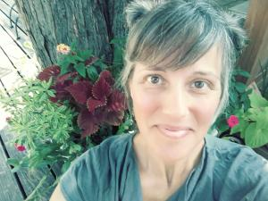Rev. Emily Meyer (she/her), Executive Director of The Ministry Lab
As an ordained pastor in the ELCA, Emily interned in Seaside, OR, served as pastor, liturgical artist, and faith formation leader in suburban, ex-urban and rural Minnesota congregations, created and directed the multi-congregational affirmation of baptism program, Confirmation Reformation, and was pastor of Fullness of God Lutheran Church in the retreat center, Holden Village. She currently serves as executive director of The Ministry Lab (St Paul, MN), where she consults and curates and creates resources for progressive UCC, UMC, and PC(USA) congregations throughout Minnesota and the United Theological Seminary community. Rev. Meyer leads contemplative and creative retreats and small groups. Between pastoral gigs, she has enjoyed costume designing, choreographing, and performing. She lives in Minneapolis, MN, with spouse Brian, daughter Natasha, and two Wirehaired Pointing Griffons, Kiko and Zip.

Ordoñez, Franco. NPR/MPRNews: Deaths of Migrant Children Haunt Former Official As Border Surge Increases: 03.17.21. Accessed 11.19.22. (https://www.npr.org/2021/03/17/977978891/deaths-of-migrant-children-haunt-former-official-as-border-surge-increases)
See Naval Postgraduate School’s Center for Homeland Defense and Security Data Map for Shooting Incidents at K-12 Schools (Jan 1970-June 2022): (https://www.chds.us/ssdb/data-map/).
See Contemporary Pediatrics (https://www.contemporarypediatrics.com/view/a-sobering-look-at-children-and-gun-violence-in-the-united-states); The Journal of the American Medical Association (JAMA) Pediatrics (https://www.usnews.com/news/health-news/articles/2021-11-23/study-youth-in-poor-areas-more-likely-to-die-from-gun-violence); Gun Violence Archive (https://www.gunviolencearchive.org/reports/child-injured-killed); and Severson, Gordon. Kare 11: Children and Parents Host March to End Gun Violence in Minneapolis; 10.16.21. (https://www.kare11.com/article/news/crime/children-and-parents-host-march-to-end-gun-violence/89-76018784-3762-4160-9370-0e996fb33231)
Collective Liberty: Human Trafficking Victims: Indigenous Women Vulnerabilities. (https://collectiveliberty.org/blog/human-trafficking-indigenous-women-vulnerabilities/)
See Statista (https://www.statista.com/statistics/585152/people-shot-to-death-by-us-police-by-race/).
ACLU (https://www.aclu.org/issues/juvenile-justice)
Fadel, Leila (host). NPR/MPRNews: Coal Mining Is a Dangerous Job. In Afghanistan, Kids Often Do Much of the Work: 11.18.22. Accessed 11.18.22. (https://www.npr.org/2022/11/18/1137604222/coal-mining-is-a-dangerous-job-in-afghanistan-kids-often-do-much-of-the-work)
Sepic, Matt; MPRNews: Teens Hired to Work Overnight as Slaughterhouse Cleaners, Regulators Allege: 11.11.22. Accessed 11.18.22. (https://www.mprnews.org/story/2022/11/11/teens-hired-to-work-overnight-as-slaughterhouse-cleaners-regulators-allege)
NPR/MPRNews: How Many Of America's One Million COVID Deaths Were Preventable? 05.17.22. Accessed 11.19.22. (https://www.npr.org/2022/05/16/1099290062/how-many-of-americas-one-million-covid-deaths-were-preventable)
See My Jewish Learning (https://www.myjewishlearning.com/article/rosh-hashanah-faq-all-about-the-jewish-new-year/).
See Chabad.org (https://www.chabad.org/library/article_cdo/aid/177886/jewish/What-Is-Yom-Kippur.htm)
My Jewish Learning (https://www.myjewishlearning.com/article/rosh-hashanah-101/): “Among the popular traditions associated with the holiday is a ceremony performed on the afternoon of the first day of Rosh Hashanah called Tashlich, when people throw crumbs or pieces of bread, symbolizing their sins, into flowing water.”
https://www.natureandforesttherapy.earth/about/the-science
Young, Nicole, “The New Orleans funeral reminds us that grief is a burden that can be shared”; Vox; 01.28.22. (https://www.vox.com/the-highlight/22876551/mourning-grief-second-line-new-orleans-jazz-funeral)
See MNOPEDIA for a chronology of Christiansen’s life (https://www.mnopedia.org/person/christiansen-f-melius-1871-1955).
Listen to Luther College’s Nordic Choir performing Psalm 50 here (https://www.youtube.com/watch?v=0_OoRm1nN44)

