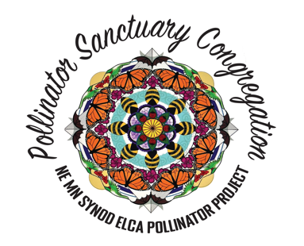
Guidelines for becoming a Pollinator Sanctuary Congregation

Welcome to the Pollinator Project of the Northeastern Minnesota Synod ELCA
Sponsored by the NE MN Synod EcoFaith Network

Pollinators are endangered by the loss natural habitat.
They need us and we need them.
Here’s how your congregation can join the plot.
- Seek the support of your church council or creation care team. Let your congregation know that they will be participating in a synod wide project. Do some basic education of why this matters.
- Let the EcoFaith Network know so that we can add you to the growing list of Pollinator Sanctuary congregations! Email ecofaith@nemnsynod.org or steering committee chairperson Tom Uecker @ tomuecker1946@gmail.com.
- Establish a place for your pollinator sanctuary. Find out what site preparation may be needed for the pollinator plot you have selected.
- Commit to pollinator friendly practices on your church grounds, such as no pesticides, no herbicides, no lawn chemicals.
- In the designated pollinator habitat area, there are other best practices too, such as leaving stalks and leaf cover.
- Plant and/or seed with regionally native plants that have not been grown in or exposed to Neonicotinoids. Prioritize good nectar plants.
- Do a blessing or commissioning of your pollinator sanctuary, either indoors in worship or outdoors next to the pollinator plot.
- Consider writing an article for your church newsletter and local newspaper.
- Place the Pollinator Sanctuary yard sign in or next to your pollinator plot during the growing season. Yard signs and posters are available at the synod office. Call 218-724-4424 or email rollie.bockbrader@nemnsynod.org to pick them up.
- Display the Pollinator Sanctuary Poster in your church building or door.
- Spread the word! Put the Pollinator Sanctuary Mandala on your church's website, worship material, and Facebook page.
- Join the Pollinator Project – NE MN Synod Facebook Group https://www.facebook.com/groups/636061001764314/
- Encourage congregation members to develop pollinator sanctuaries at home
Monarchs need us too! Plant milkweed and become a Monarch Way Station! Get info from Tom Uecker, tomuecker1946@gmail.com
For more information, go to ecofaith@nemnsynod.org/Get Involved/ Pollinator Project

