Green Blades Preaching Roundtable
Reflections on the Texts
The Second Sunday in Lent
March 5, 2023
Genesis 12:1-4a; Psalms 121; Romans 4:1-5, 13-17, John 3:1-17

Rev. Gary Hedding, Chippewa Falls, Wisconsin

There will be thousands of sermons preached this Sunday about a searching Nicodemus and a righteous Abraham - both of whom will be examples for people in their relationships with God. This is not inappropriate nor unworthy of the texts. What often goes unnoticed is the place of “world” and “land” in these texts, which extends the passion of God for grace and redemption to all of creation, and cements the connections between our interests for redemption and the interests of redemption for all that God has brought into being.

“Now the LORD said to Abram, ‘Go from your country and your kindred and your father’s house to the land that I will show you.’” So, what is so wrong with Abram’s family and the land of Haram that Abram needs to abandon them in order to establish this blessed new nation? I can see how the old gods and traditions of Abram’s kindred could be a distraction, but the land itself? Is it just an invitation to invade someone else’s home and make it yours, or is God establishing a promise to the land in partnership with the people? The land becomes a sign of the covenant as much as Abram’s and Sarai’s offspring. Just as Isaac is all they receive as a hint of the promise of God for descendants as the stars in the sky, a cemetery plot is all they own of the promise of a land. Still, even this is enough to trust in God’s promise. God’s covenant with the chosen people includes care for the land as well as care for people. Leviticus is full of expectations that the land will have a sabbath. The land is tied to promise in such a way that it cannot be sold forever, but must be returned to its people in the year of Jubilee. When the people develop a long history of breaking their part of the covenant, they finally go into exile in Babylon. Exile from what? Not God, but exile from the land, which is a sign of God’s presence and blessing.

Psalm 121 also focuses on land. “I lift my eyes to the hills. From whence does my help come? My help comes from the LORD, who made heaven and earth.” The bit about my help comes from the LORD does not contradict the lifting up of the eyes of God’s people to the hills. There are too many references to God coming to God’s people on hills and mountains. Holy Places are such because people have found a Holy Presence there. The Ark’s grounding, Sinai, Zion, Jesus’ sermon on the mount, Transfiguration, the mountain in Galilee to which Jesus directed them for his ascension. The psalmist is not foolish or superstitious in lifting eyes up to the hills. It is where God’s people have found God before. It is the God “who made heaven and earth” who has the power and desire to be a help to those who are in “distress”. (See Psalm 120, which is the first of the couplets in this collection of Songs of Ascent and without which Psalm 121 is without context.) The psalmist must look to the hills because “too long have I had my dwelling among those who hate peace”(Ps 120:6). God, by God’s own covenant, is tied to land just as God is tied to people.

Jesus’ conversation with Nicodemus is full of earthiness. Jesus’ picture of what it takes to “see the kingdom of God” is a new birth from above/anew. Nicodemus stumbles on the impossibility of him returning to a woman’s uterus. Jesus invites Nicodemus into the realm of mystery by comparing the movement of the Holy Spirit to bring this birth of grace and faith to life with mystery of the wind, “you do not know where it comes from or where it goes” yet the wind is real, experienced as force either gentle or strong. It moves ships and blows chaff away from the grain. Wind may be mysterious, but it makes things happen, so don’t worry so much about how faith comes, but receive the way it makes things happen in your life, Nicodemus.

The claim of Jesus that all creation matters and is included and essential to God’s work of redemption is revealed in verse 3:17. God really loves the world and so intends not to condemn the world but sent the Son “in order that the world might be saved through him”. In John’s gospel the world (cosmos) is broken and often at odds with the good news Jesus is, but all that means is that it needs redemption just like the subset of people do. So, just as Christians witness to this good news to people to give them hope and lives of promise, Christians witness to this good news to creation to give the creation a sign of God’s hope and promise. Just as the most inspiring witness to people is listening to them with respect and honor and caring for them in ways that are meaningful to them, so we join in inspiring witness to creation by listening to it with respect and honor and caring for creation in ways that are meaningful to the creation. We seek to protect the health and beauty of creation. We respect the land by caring for it more than selfishly or thoughtlessly demanding from it for our own luxury. We honor creation by constantly acknowledging and valuing its presence just because God loves it. We make use of creation as a partner, not as a possession. We give back to creation more than we take from it, because that is what we do with a partner we respect. So, we listen to creation as the Columbia River dries up, as the earth heats up way too fast, and as toxic chemicals from railway cars, mines, and factories burn it. We must act to show the promise of God’s redemption for creation by restoring it, and not demanding from it what it cannot give and remain healthy. We do this so that the mystery of the wind remains a mystery of birth from above/anew rather than a mystery of death.

An idea for a hymn this week is ELW 450, “I Bind unto Myself Today”. The music might be a bit spritely for Lent, but the words reflect Celtic theology’s love for creation as a revelation of God. Verse 3 - “I bind unto myself today the virtues of the starlit heaven, the glorious sin’s life-giving ray, the whiteness of the moon at even, the flashing of the lightning free, the whirling wind’s tempestuous shocks, the stable earth, the deep salt sea, around the old eternal rocks.” Verse 2 is all about binding ourselves to Jesus’ incarnation, baptism, cross, resurrection, ascension, and return. You could do worse.

******
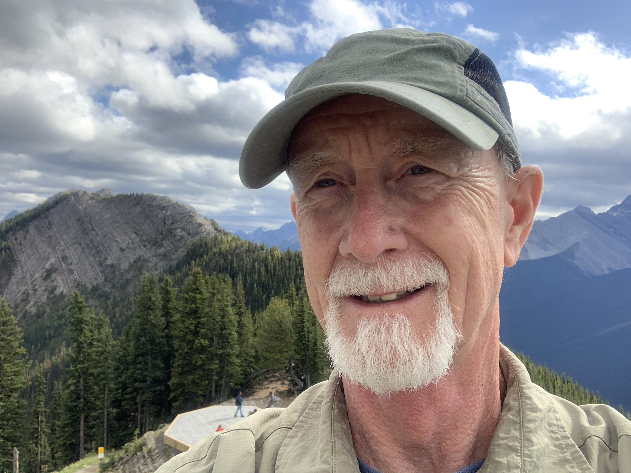
Gary Hedding is a retired pastor who graduated from Luther Seminary in 1978. He served his internship in Brooklyn, NY. His first call was Prince of Peace Lutheran Church in Coloma, WI; then as associate pastor and later lead pastor at Faith Lutheran Church in Marshfield, WI; followed by serving six years as assistant to the bishop in the Northwest Synod of WI; then as pastor of Bethlehem Lutheran Church in Cedar Falls, IA. Gary has been retired since 2018. Gary is married to Linda and they live in Chippewa Falls, WI with their dog, Strider. Their daughter, son-in-law and two grandsons live in the Fort Worth, TX and their son and daughter-in-law and one granddaughter live in Eau Claire, WI. Gary enjoys wilderness canoe tripping, sprint triathlons, fishing and hunting, reading science fiction and urban fantasy, and vegetable gardening.

Green Blades Preaching Roundtable
Reflections on the texts
Third Sunday in Lent, March 12, 2023

Exodus 17:1-7; Psalm 95; Romans 5:1-11
Gospel: John 4:5-42 (Jesus’ encounter with the Samaritan woman at the well)

The Rev. John Hanson, Turtle Lake, Minnesota

The Samaritan woman came to the well for water to nourish the body. Jesus came to the well to offer her spiritual water that nourishes the soul and brings eternal life. Can there be a connection to, a bridge, to earth’s water and the spiritual water Jesus offers to us? The lake I live on may offer some insight into that connection.
I live on a pristine lake in the Chippewa National Forest in northern Minnesota. As a member of the lake association, I monitor the water quality by sending samples to a lab in Detroit Lakes. I do this to fulfill one of the mandates of the association mission statement: “...To retain and preserve for future generations the existing high quality water,...” Why is this such an important mandate for those of us who live on the lake? It is to maintain water quality to allow residents and visitors to enjoy fishing, swimming, and boating. That’s obvious and important.
But why do the majority of cabin owners, who are summer residents only, flock to the shores of Turtle Lake every summer to find enjoyment, relaxation and renewal? Beyond the physical activities that people engage in, I believe there is a spiritual dimension to why so many people seek time ‘at the lake’ in northern Minnesota. For many it is a profound connection with the natural world that reminds us that we are more than physical creatures, but also spiritual beings that find personal renewal, connection with family and friends, and time to contemplate the presence of God in whatever form that takes for people. Thus the lake I live on is “living water” because it offers me recreation, reflection, and renewal of body and spirit. I find connecting with God while sitting at the end of the dock to be a profound, renewing experience.
In his 2009 Nobel Conference lecture, Larry Rasmussen put it this way: “And finally, there is the problem of larger frameworks of meaning: Is water properly an object of merely economic calculation and manipulation? Or is it an object of awe, calling forth from us the deep respect and love that we owe to its Creator?”
For people of faith, the natural world is the home or environment that allows us to live and flourish. But there is a deeper purpose for our lives than physical existence, such as relationships to one another, and to God based on love as revealed in Jesus. Water helps bridge nature and spirit. It is, as Raymond Brown suggests, simply water that bears “the Spirit communicated by Jesus” (Raymond E. Brown, The Gospel According to John I-XII, New York: Doubleday, 1996, p. 179). “After uncovering the truth about her life, Jesus disclosed the truth about himself as well: “I am he,” he says, the one about whom, as she expects, ‘”when he comes, he will proclaim all things to us” (4:25-26). The evangelist has made his point: Not only does Jesus give water as a sign of God’s presence in the land, Jesus is himself that presence (the I AM) (4:26).”

Another approach could be reference to eco-justice issues surrounding water. Native Americans protested an oil pipeline (Dakota Access Pipeline) proposed to go under the Missouri River and across reservation land. Many protesters were “water protectors” who were alarmed about the potential contamination of water and the environment around the pipeline. Communities like Flint, Michigan have to battle in court just to make water safe to drink in their communities. The oceans, making up over two thirds of the earth’s surface, are being acidified by carbon build up and polluted by tons of plastics accumulating in certain areas of the oceans. In fact, the water bottle many of you are holding in your hand takes more water to manufacture than it holds. It is obvious that our human behaviors worldwide are causing the pollution of and the scarcity of water globally. Only as we begin regarding water as the source of life, physically and spiritually, will we understand God’s loving purpose for the gift of creation.
Psalm 95 reminds us of the spiritual connection to water (verse 5) “The sea is yours, for you made it, and your hands have molded the dry land.” If God is the creator of and owner of the water and the earth, and we are to be caretakers, reflecting God’s purpose for creation and life, we are doing a poor job of showing our appreciation for such a wonderful gift.
Exodus 17:1-7 gives us another sense of God being the author of life, provider of water for life, and revealing the spiritual dimension of water. God brings Israel out of the abundance of water in Egypt to a desert lacking water. Grumbling ensues, revealing a lack of faith in God’s intentions. God does provide water, in a miraculous way, out of a rock. It is an example that Israel can and must rely on God’s loving presence for life to be lived graciously and lovingly.

John Hanson is a retired pastor living 37 miles north of Grand Rapids, MN on Turtle Lake, with his wife, Linda. After serving many congregations, he is now a member of Suomi Evangelical Lutheran Church. He is a member of the EcoFaith Network Leadership Team of the Northeastern Minnesota Synod of the ELCA, and is a book reviewer for Green Blades Rising.

Hymn suggestions:
Gathering: “Come, Thou Font of Every Blessing,” ELW, 807
Hymn of the Day: “As the Deer Runs to the River,” ELW, 331
Sending: “Lord, Dismiss Us with Your Blessing,” ELW, 545
Also a hymn written by Norman Habel (see below)

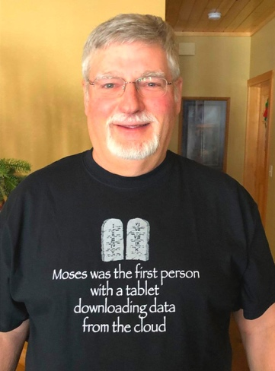
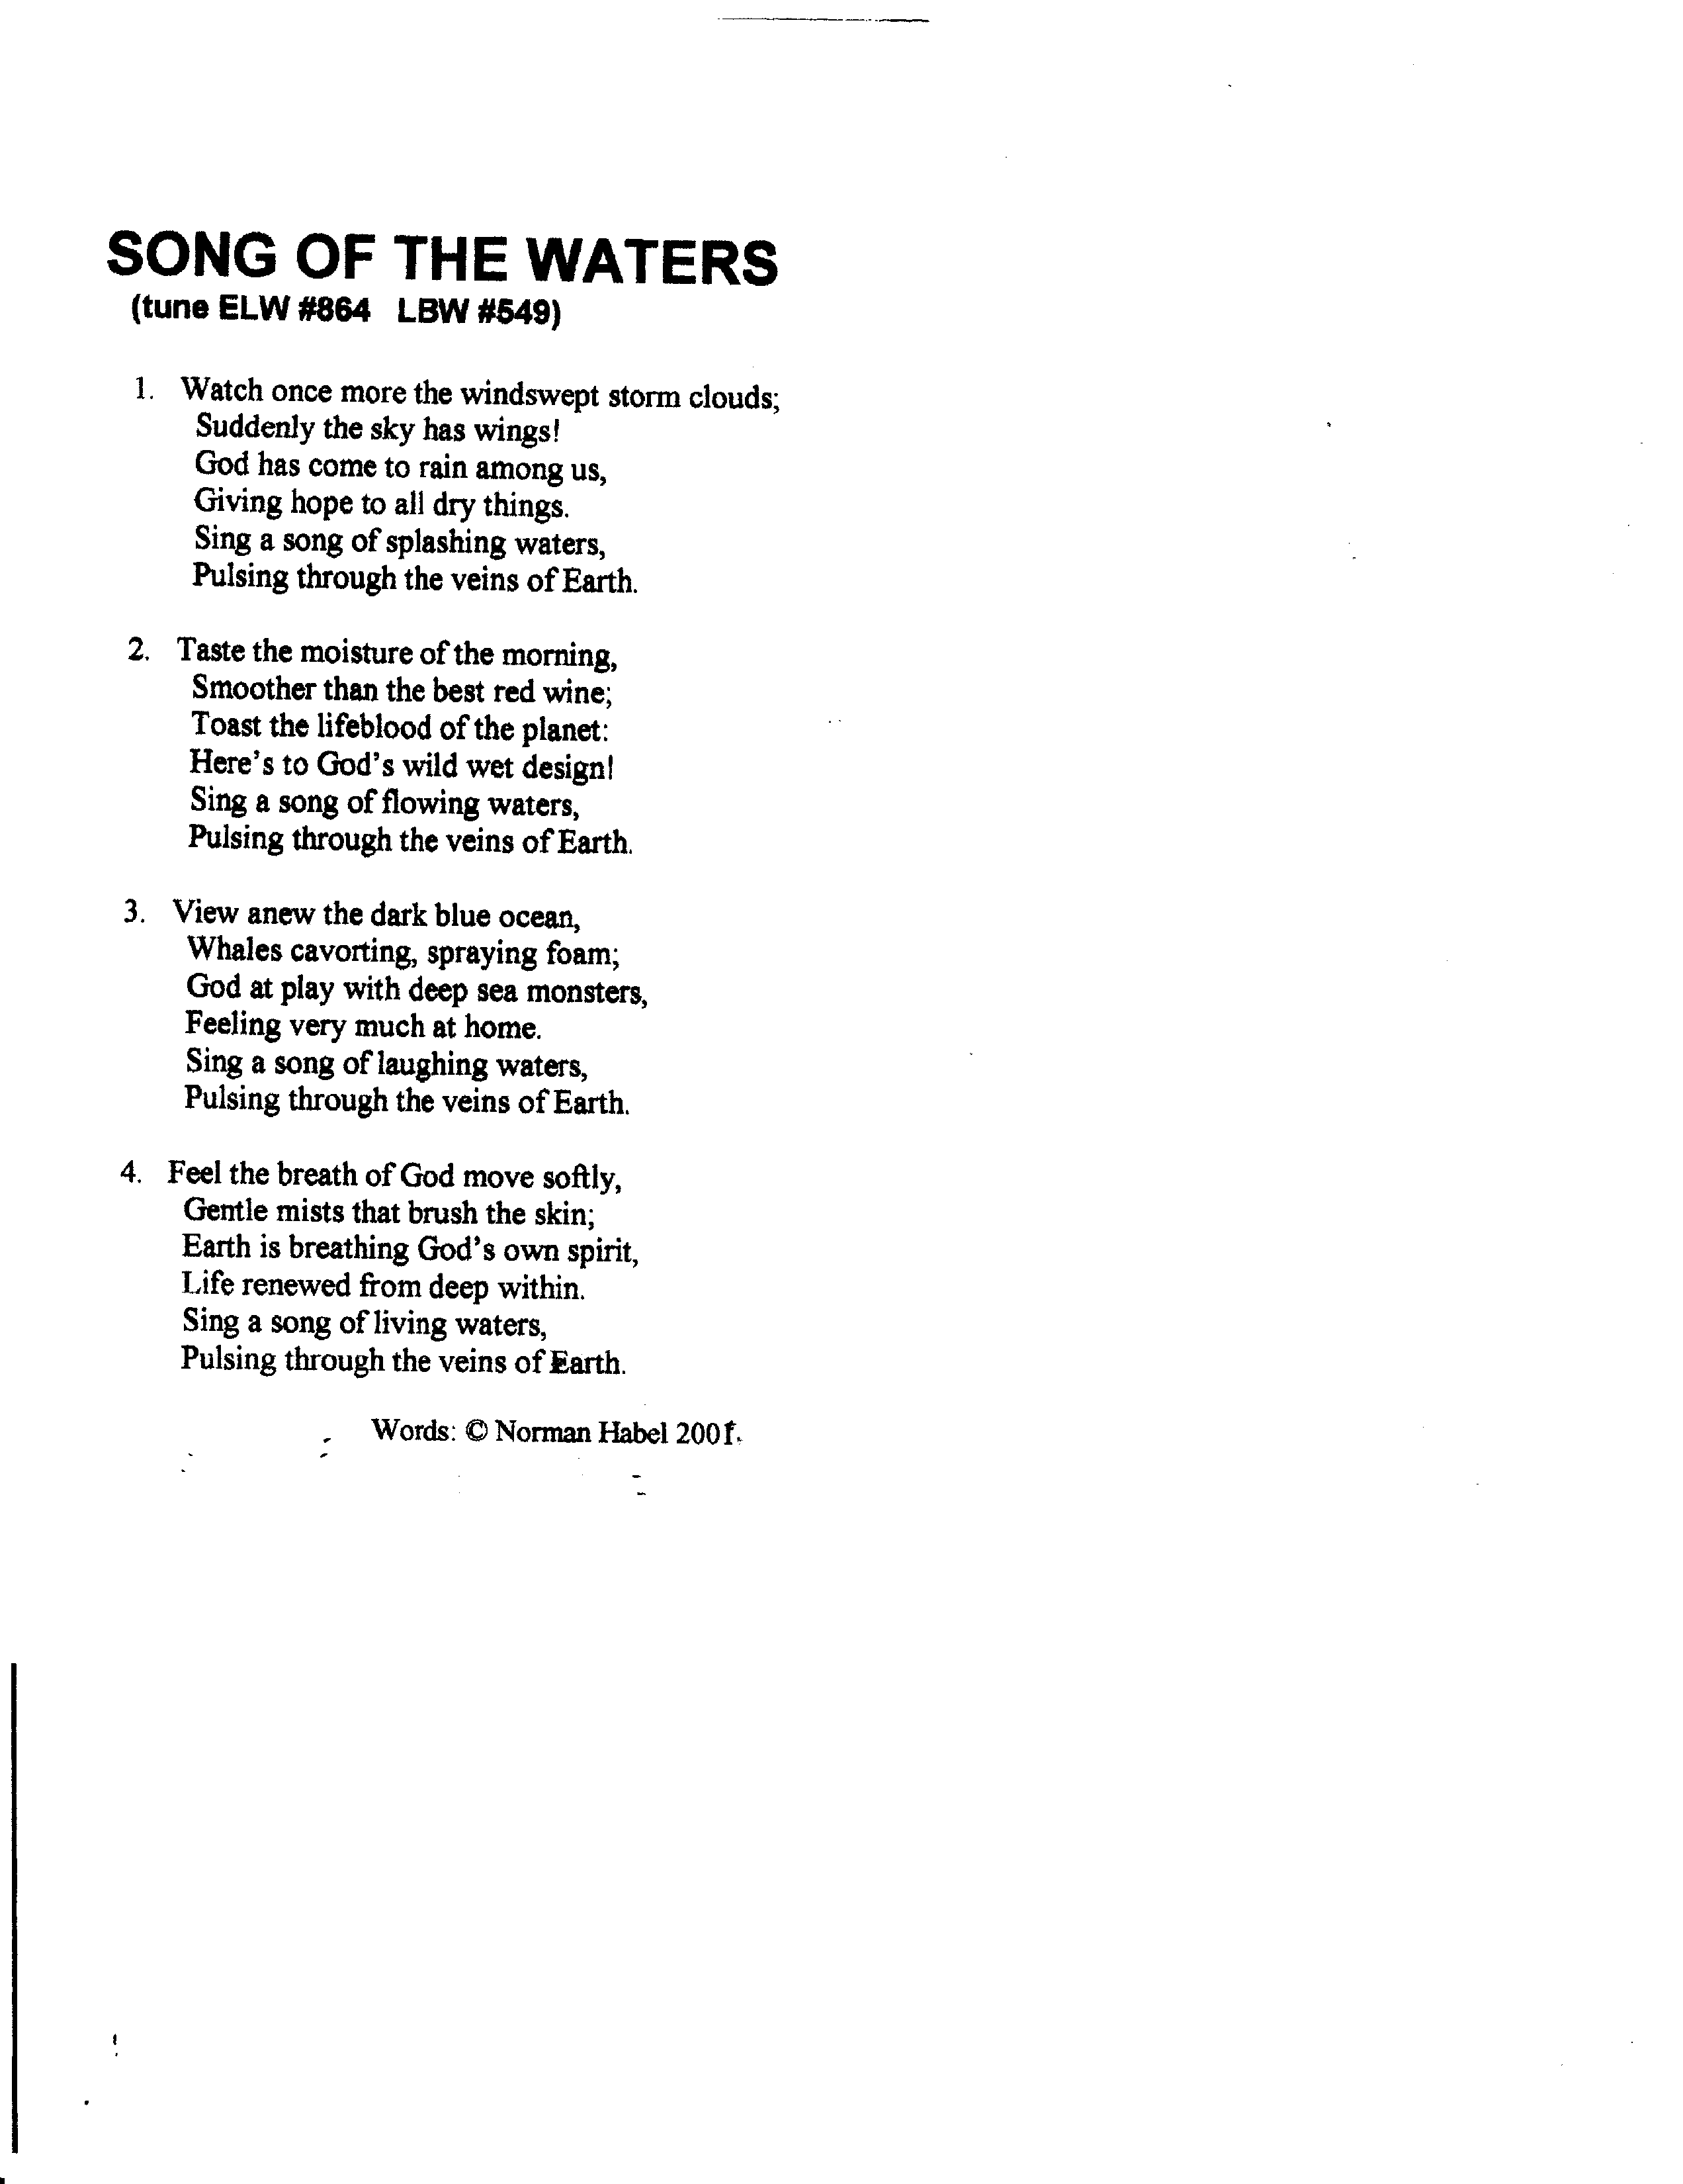

Green Blades Preaching Roundtable
Fourth Sunday in Lent
March 19, 2023
1 Samuel 16:1-13; Psalm 23; Ephesians 5:8-14; John 9:1-41
Hymn suggestion: As the Sun with Longer Journey, ELW #329

Rev. Emily Meyer, Minneapolis, Minnesota

HERE’S MUD IN YOUR EYE!

‘Here’s mud in your eye!’ was one of my dad’s favorite toasts. As a kid, I thought it was one of the many nonsensical, funny sayings he’d made up.

Turns out, other people do actually use this phrase - though no one really knows where it comes from. Some people reckon it stems from today’s Gospel reading: Jesus uses mud to heal, so ‘mud in your eye’ is a toast to good health.

What if we could toast everyone, or maybe even put some mud in every eye (including our own), so that we could all, collectively, simultaneously, see clearly the glorious gift of creation - and life - God has entrusted to our care?

What if climate care became a norm, rather than a daily concern and global crisis?

Writing from the perspective of cultural organizing, Puerto Rico-born, Minneapolis-based protest artist and activist, Ricardo Levins Morales reminds us that ‘the soil is more important than the seeds’ and ‘it’s hard to get anything to grow if the soil is barren, toxic and won’t hold moisture.’ Reflecting on recent social justice losses and reversals, Levins Morales observes that climate-deniers and others have, ‘for forty years… devoted themselves largely to preparing the soil’ with toxic messages - including ‘stuff that sounds ridiculous, fighting for things that aren’t winnable yet, because they’re investing in the future and ten years later it won’t sound ridiculous and they’ll win’. He wonders, ‘What stories, what narratives, what beliefs - if they were widely disseminated in the soil of our communities - would make it easy to win? …What would make victories easy if everyone believed it? We’re the only ones who can plant the seed of the tree that one day we want to live under. We need to be preparing the soil in which that tree can grow.’

Today’s readings are clearly an exhortation to open our eyes to new and seemingly impossible ideas. If we can see those impossible visions, we can share them; if we can share them, we can fertilize new soil; we can create the soil from which God’s desired future will root and grow.

We first need to see.

If what we see is not New Life for all of God’s beloved creation, including all of humanity - let’s check that the mud we’re wiping from our eyes contains Jesus’ spit and not someone else’s. Then, let’s look with renewed sight toward God’s preferred future, join Jesus and others in disseminating stories affirming and preparing for that future, and see if we can’t mix up some more mud and start spreading it around: things may get a little messy, but messy is far better than toxic.

And the spring / vernal equinox is the time.

According to the Farmer’s Almanac, ‘Vernal translates to “new” and “fresh,” and equinox [derives] from the Latin aequus (equal) and nox (night)... [O]ur hours of daylight… have been growing slightly longer each day since the winter solstice… The vernal equinox marks the turning point when daylight begins to win out over darkness.’

It’s time to wake up, to open our eyes.

For our pagan, druidic, and many Indigenous siblings, the spring equinox is a celebration of the return of spring: a time for planting - both literally in gardens and for the soul’s well-being; it’s a time of ‘raw possibility’ (‘when Oestra’s egg of pure potential cracks open’), a time to set new intentions; it’s considered the New Year in some cultures. The spring equinox is also a time of ‘holy equality’, when dark and light/night and day are equal in length; it is a time of extraordinary balance, out of which many find courage, joy, and renewal - even as ‘the winds of change and uncertainty gust’ - because it is also a time of synergy with all creation and intimacy with ‘kindreds - human and non-human’.

Without further appropriating Earth-centered spiritualities’ spring equinox celebrations, the Season of Lent - as so many of our Lenten texts reveal - is the perfect time to take off the blinders, reconsider our perspective, and cast a new vision so we can ‘prepare the soil’ to receive seeds of hope and flourishing for creation and all humanity.

What might God be urging us to see or experience in this spring equinox? Where is God’s new life already springing into being as we move through these three days of balance and regeneration?

Today’s Gospel reading is a primer on the multiple and varied forms of human blindness - and the extraordinary lengths we’ll go to to remain blind, while perennially, generationally stigmatizing, shaming, and blaming those we see as blind. (See Ash Wednesday, Isaiah 58:9 for God’s opinion of, ‘the pointing of the finger’.)

Here’s an intergenerational ‘game’: set John 9 side-by-side with Dr. Tema Okun’s 15 Characteristics of White Supremacy Culture and see who can find the most connections the most quickly. The lines will be a tangle, as so many characteristics intersect, but in John’s narrative, every character exhibits or avoids one or a multitude of Okun’s 15 behaviors.

Okun’s apologetics for divorcing white supremacy culture sound much of like Jesus’ teaching in today’s Gospel: we have been hoodwinked, all of us, about what is really important’; ‘any attempt to be perfect is in fact a fool's errand (not that we are fools) because learning from our mistakes is how we grow and learn and lean into our glorious and flawed humanity. We can never be perfect when perfection is defined by others, particularly by institutions and cultures that do not care about or for us. We are, in fact, already perfect. We were born perfect. No striving necessary.’

All of this is to say, supremacy culture lies at the heart of immense damage - to our individual selves and our individual human neighbors, to our neighborhoods and communities and society and culture; and to the planet as a whole. All this accepted blindness leads to generational traumas and catastrophic climactic distress.

The spring equinox is a cosmic moment of balance: an opportunity - embraced by our pagan, Indigenous, and druidic ancestors and contemporaries - to have our eyes opened.

And here’s Jesus with some mud in his hands.
And the waters of baptism lie always at the ready to wash the mud away.

For there is no room to assume that our vision is already clear - that smacks of defensiveness/denial intersecting with power hoarding and perfectionism with a heavy dose of a belief in ‘one’ right way mixed in for good measure.

It’s also exactly what the Pharisees assumed. And we all know what happens when we assume anything: Jesus turns us into a donkey…

#5 of Ricardo Levins Morales’ 8 pearls of wisdom for Tending the Soil is summarized above. Pearl #2 regards Moon Spaces, Sun Spaces & Community Power. Moon Spaces are where power is ‘reflected’, i.e., negotiating tables, court rooms, legislatures: ‘where contending forces try to settle their differences and come up with a decision’. Sun Spaces are where power is generated, i.e., ‘where the people are’: on the streets, in the movement. When ‘we don’t have a lot of leverage’, Levins Morales encourages us to create more alliances, develop broader networks, build up power in the Sun Spaces, so we have ‘more energy at our back’ entering the Moon Space of negotiations.

What if we could get mud into everyone’s eyes, all at the same time? Could we all begin to see the way God sees? Could we all recognize the extraordinary abundance with which God provides us every day? Might narratives of abundance, healing, and joyful collegiality make for more fertile soil, where the seeds of renewal, reparations, restoration, i.e., New Life, might take root and grow?

The Spring Equinox seems a good time to assess - in whatever justice efforts we may endeavor - how to disseminate the Christian (but not unique) narrative of resurrection to broader and broader recipients. Where might we ‘generate more power’? What new alliances might we forge? With what other organizations or individuals might we partner to ‘give us more energy at our back’ so we enter Moon Spaces with a full tank?

In this three-day Equinox Season (that isn’t a coincidence) when the sun passes Earth’s celestial equator, moving northward to bring spring to the Northern Hemisphere and fall to the Southern, we see all sorts of promise (up here in the Northwoods it may take a little longer, but we’ll appreciate it all the more!): birds follow the sun and return North, buds and shoots begin to appear, the snow is melting as the earth and air are warming. Our bleary, snow-glare eyes are newly opened and dazzled by the splendor of New Life. Take your pick of metaphors: birds nesting and dropping eggs, butterflies returning, bunnies, squirrels, chippies and bears coming out of hibernation: the North is waking.

Now is the time to smear some mud on our eyes and let the spring rains wash it away.

Resurrection must be just around the corner - if we can open our eyes to see it.

Here’s mud in your eye!

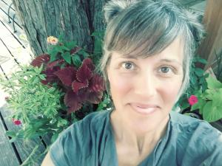Rev. Emily Meyer (she/her), Executive Director of The Ministry Lab
As an ordained pastor in the ELCA, Emily interned in Seaside, OR, served as pastor, liturgical artist, and faith formation leader in suburban, ex-urban and rural Minnesota congregations, created and directed the multi-congregational affirmation of baptism program, Confirmation Reformation, and was pastor of Fullness of God Lutheran Church in the retreat center, Holden Village. She currently serves as executive director of The Ministry Lab (St Paul, MN), where she consults and curates and creates resources for progressive UCC, UMC, and PC(USA) congregations throughout Minnesota and the United Theological Seminary community. Rev. Meyer leads contemplative and creative retreats and small groups. Between pastoral gigs, she has enjoyed costume designing, choreographing, and performing. She lives in Minneapolis, MN, with spouse Brian, daughter Natasha, and two Wirehaired Pointing Griffons, Kiko and Zip.

Green Blades Preaching Roundtable
Reflections on texts
Fifth Sunday in Lent, March 26, 2023
Ezekiel 37:1-14; Psalm 130; Romans 8:6-11; John 11:1-45

Rev. Gary Hedding, Chippewa Falls, Wisconsin

These texts are all about hope in the midst of hopeless situations. The hope is not whistling in the dark, it is not baseless hope because even false hope is better than despair. It is hope based on the power of God, who raises the dead, transforms the living, and enlists God’s people to exercise possible futures when others have given up.

Ezekiel 37:1-14 is a vision of a hopeless scene of death and destruction. Ezekiel sees a valley covered with bones and “there were very many lying in the valley, and they were very dry”. The number of bones suggests a massacre or even a genocide of people. The bones are very dry suggesting that it is a waste of time to hope for any revival for even the moisture has gone out of them. Then, the question comes to the visionary, “Mortal, can these bones live?” Any reasonable person would say, “No, these are too far gone to live”, but when in the presence of God, even through a dream, a person who bases hope on the power of God rather than on what is reasonable is moved to say, “O Lord GOD, you know.” Then the dreamer is called on to be a prophet and speak a word of hope into a hopeless situation. The prophet speaks a word that declares God will work life into this place of death, and, methodically, life is brought about. Bodies are renewed and breath “came into them, and they lived and stood on their feet, a vast multitude.”

Psalm 130 carries on this theme of hope in the midst of hopelessness. “Out of the depths I cry to you, O LORD.” The hope is in God’s forgiveness, and if it doesn’t seem real at once, we wait for it, waiting as long as it takes. The basis, of this hope is the steadfast love of God coupled with the power of God to redeem. Love with the power to make revival happen. The psalm ends with certainty, “It is [God] who will redeem Israel from all its iniquities.

Romans 8:6 starts off with naming the reality of what it is to set our minds on the flesh - death. That mind is hostile to God and cannot change. Then, hope flows in. “But you are not in the flesh, you are in the Spirit, since the Spirit of God dwells in you.” “Since” is a powerful word of hope. It is a word that starts a causal clause in which the cause, in this case the Spirit of God dwelling in us, is not in question. The same word translated “since” is a better translation in verses 10 and 11. “But [since] Christ is in you . . .” and “[Since] the Spirit of him who raised Jesus from the dead dwells in you”. While the word can be translated “if”, starting a causal clause in which the cause is up in the air, that is not certain or settled, given the context here Paul is saying that our hope for life is settled because, by God’s grace, Christ and the Spirit dwell in us.

The John text is the raising of Lazarus. This is another hopeless, lost cause into which Jesus brings life. It is clear, Lazarus is ill, Jesus holds off for two days, guaranteeing that Lazarus will die without him. It must take two more days to get to Bethany because Lazarus has been in the tomb for four days. On top of that people who have gone to the tomb have discovered that the body smells like rotten meat. Mary, Martha, and the crowd all challenge Jesus for not arriving sooner because then there would have been hope for Lazarus, but now all hope is gone. Except it is not. Jesus calls out Lazarus and he comes out; Jesus has him unbound and released. People believe that God sent Jesus.

Ezekiel’s vision is terrible. It reminds me of unreclaimed open pit mines that I have seen. Some of these are huge and the cost of restoring the land is so enormous that no one in their right mind would consider the cost “worth it”. The bones of the earth are laid bare, some scraggly vegetation is trying to get started, but it is clearly a losing battle. I have also seen the mine reclamation at Holden Village and other places in which the enormous cost has been laid at the feet of the mining company which had taken even more enormous amounts of money in copper out of the earth. Those restorations are full of life. Recently, a new federal administration has set a 20 year moratorium on a proposed copper and nickel mine in the region draining into the Boundary Waters Canoe Area Wilderness. Previously, that mining project was advancing rapidly despite fierce opposition. It looked hopeless to many people, some gave up and some persevered no matter how hopeless it looked. An election changed everything and gave those opposing a restoration hope that a mine restoration would never be needed.

Many people have given up hope for slowing human contributions to climate change. It seems people do not have the will to make changes that are necessary and will not hold others accountable for greenhouse gas emissions. Species are dying and the fight has gone out of many. The tipping point has come or will come too soon, so efforts are now focusing on how to enable humans to adapt while polar bears will be relegated to zoos. God says to the visionaries, “Prophesy to these bones”. We do so because our hope is in God’s love for creation and God’s power to redeem the creation. Prophecy is not divine nagging, for God’s words for change empower the change. The reason prophets were killed are not because their words displease people, but because people are afraid that those empowered words will bring about change. Martin Luther King, Jr. was shot not because people didn’t like what was being said, but because they saw his words changing the country. We are a people of hope even when it would be reasonable to give up hope. We do it for the world. We do it to follow Jesus who raised Lazarus and was raised when it looked like he was hopelessly lost. We do it because God is the strong foundation for our hope.

*****
Gary Hedding is a retired pastor who graduated from Luther Seminary in 1978. He served his internship in Brooklyn, NY. His first call was Prince of Peace Lutheran Church in Coloma, WI; then as associate pastor and later lead pastor at Faith Lutheran Church in Marshfield, WI; followed by serving six years as assistant to the bishop in the Northwest Synod of WI; then as pastor of Bethlehem Lutheran Church in Cedar Falls, IA. Gary has been retired since 2018. Gary is married to Linda and they live in Chippewa Falls, WI with their dog, Strider. Their daughter, son-in-law and two grandsons live in the Fort Worth, TX and their son and daughter-in-law and one granddaughter live in Eau Claire, WI. Gary enjoys wilderness canoe tripping, sprint triathlons, fishing and hunting, reading science fiction and urban fantasy, and vegetable gardening.

Levins Morales, Ricardo. Tending the Soil: Lessons for Organizing; pgs. 12-14. Download your free copy of the zine here: https://www.rlmartstudio.com/product/tending-the-soil-lessons-for-organizing-zine-free-pdfs/.
https://www.farmersalmanac.com/spring-equinox-first-day-spring (accessed 02.20.23)
We’Moon; Spring Equinox Rituals and Traditions (https://wemoon.ws/blogs/pagan-holiday-traditions/spring-equinox)
See Baring, Anne, & Jules Cashford. The Myth of the Goddess: Evolution of an Image; London, Arkana: 1991; 566.
Wanting to see ‘like God’ but instead descending into dualism (Gen. 3:5); lifting our eyes to the hills for help (Psalm 121); seeing God’s reign in anew (John 3/Matthew 17; Exodus 17:6) - or not (Psalm 95:9); being fully seen and inviting others to see (John 4); learning to see as God sees (1 Sam. 16:7); being led through shadow and illumination (Psalm 23; Ephesians 5); healing blindness (John 9); prophetic vision (Ezekiel 37); seeing new life (John 11:34ff).
https://www.whitesupremacyculture.info/characteristics.html
https://www.whitesupremacyculture.info/
Ibid.
Levins Morales, Ricardo. Tending the Soil, pgs. 4 & 5.

