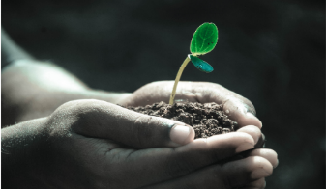
Green Blades Preaching Roundtable
Reflections on the texts
December 3rd, 2023 First Sunday of Advent, Year B

Texts: Isaiah 64:1-9, Psalm 80:1-7, 17-19, 1 Corinthians 1:3-9, Mark 13:24-37

Tyler Bublitz, Bemidji, Minnesota

Happy New Church Year!
As we enter Advent, to me it’s a time of excitement but also a season where I can find myself feeling as if I am not doing enough or doing it right. Don’t get me wrong, I really enjoy Advent and think it is vital to my faith, but I still always have this longing to dig deeper. When looking at the texts that we have for this first Sunday of Advent, there are things that could scare us, but also provide encouragement to keep going.
Take Isaiah for example. We have a text that goes through and reminds us of the power of God in so many ways, like verses 2 and 3 for example. Yet, concluding Isaiah, we are called a vessel made from the hand of God to perform the task we are called to do even if we fall short. The message of falling short and asking for forgiveness is seen in the Psalm, but it is juxtaposed with the 1 Corinthians text of stating that we are not lacking in anything and are equipped for the task at hand. This then leads us to the gospel, where all of these texts come together. We as people struggle to understand how God’s timing and signs work as compared to earthly things. We humans just can’t fully comprehend God’s timing well. This leads us to the parable of the landowner leaving his slaves in charge while telling the doorkeeper to keep watch and to “keep awake”.
How do all these texts come together in a way that we can actually follow?
It is surprising that the word “prepare” never appears in any of these texts. When I think about Advent, I think of it as a season of preparation. These texts remind us of the importance of preparing and equipping ourselves. Do we really prepare? I know that being the midwestern person that I am, I have spent months preparing for the incoming winter that should arrive at any time, but how well do we prepare for something that we struggle to see?
This is where I think that our feathered friends can help us get in the right mindset for these texts. Every year, millions of birds migrate from warmer winter climates to the breeding grounds and then back again in the fall. This is all triggered by the photoreceptors in their brain noticing the differences in the amount of light, which then triggers new flight feathers a larger appetite, and more restlessness at night. These birds then start their preparation for making their long trip. These trips can be thousands of miles, so this preparation is necessary.
For the fall migration, the breeding hormones drop, and you see birds more and more doing training flights together along with finding food sources together to make sure they can make these flights. They find that flying together makes it easier for them to accomplish their huge goal of reaching their end destination. They need to train together, feed together and fly together so that all have the best chance of doing it. In doing so, it is easier for everyone involved. The preparation is necessary for them to fulfill the calling that they must fulfill. There is a lot of building up reserves for the long journey. A lot of muscle building is also necessary. It is difficult to build up the strength and muscle to do it, but they do.
We as people sometimes forget that we have been put in charge and don’t know when the master is returning. That still means that we need to take care of the place where we have been put in charge – the Earth! – to the best of our abilities. We are also reassured that we have gifts given by God to do the jobs that we are called to do, even if it seems difficult. We also can see that we need to work together, like migrating birds who know the season, in order for us to accomplish these goals to which God is calling us.
What are some of the projects we need to work on?
One example would be the current climate crisis with which we are dealing. Our lack of action and our staggering ability to ignore this issue is catching up with us quickly. We need to be able to tackle the difficult tasks of addressing the climate crisis together for all of us to do well. By no means are these easy things for us to solve. It will take all of us working together. Each of us taking small actions, asking challenging questions, and finding and sharing results will help all of us grow and learn together. This will not only draw us closer to each other. During this process, we will also be drawn closer to God. We will then prepare to show the master upon the return that we messed up, but we worked hard to fix it to the best of our ability. The act of seeing our sin and working to reconcile with human and non-human alike is part of us living out the faith as we take care of this place, the Earth. To me, it appears we have some preparation to do, ahead of when the master returns! We know things will not be perfect, but that shouldn’t stop us from trying. This process of trying will help us deepen our faith as we prepare for the season of receiving our gift from God.

References:
https://www.axios.com/2023/09/14/climate-change-paris-accord
https://www.axios.com/2023/11/20/un-climate-change-emissions-gap
https://www.allaboutbirds.org/news/how-do-birds-prepare-for-long-migrations/#
https://abcbirds.org/blog/how-birds-navigate/?gad_source=1&gclid=CjwKCAiAx_GqBhBQEiwAlDNAZj5hBjYgvHmjVDa7pgiA8Dtmegud3ShvCb7lAzMlc6zqK-Gb2BQGXBoCXmAQAvD_BwE
https://www.audubon.org/birds/flyways?ms=digital-acq-ppc-google-x-20190000_google_grant&gad_source=1&gclid=CjwKCAiAx_GqBhBQEiwAlDNAZgLCPq_B0rIVBTPnRUjRHokhtA-8P1qJkRbI_lnfWIDqYRGVGDMCQhoCh_kQAvD_BwE

Tyler Bublitz is the Director of Children, Youth and Family Ministry at First Lutheran Church in Bemidji. He is also the Host and Founder of The Faith and Science Podcast, which is a podcast the follows the Revised Common Lectionary each week and finds a science tie in for each weeks text. He lives in Bemidji with his wonderful wife Sarah.

Green Blades Preaching Roundtable
Reflections on the texts
Second Sunday of Advent
December 10, 2023

Isaiah 40:1-11 - Psalm 85:1-2, 8-13 - 2 Peter 3:8-15a - Mark 1:1-8

Pastor Karen Behling (she/her)
Chippewa Falls, WI

“Ready or not! Here I come!” When that cry comes in a game of Hide-and-Seek, time is up, and a new course of action is about to begin. John the Baptist’s cry in the wilderness has similar intensity. Ready or not, God is coming. Ready or not - and if not, it’s not yet too late, and there’s still time to get ready - but be warned that everything is about to change.

This new course of action starts with Jesus coming to be baptized by John. Creation is involved in this proclamation, as the heavens are torn apart. The Greek word is “skidzo”, and this word will appear again at the end of the story when in 15:38, the curtain of the temple will be torn in two as Jesus on the cross breathes his last. That moment, too, will mark a momentous change in the course of action.

Back to John in the wilderness who roughly quotes Malachi 3:1 and Isaiah 40:3. John preaches in the wilderness, in a place where nature is primary. Mark begins the good news of Jesus in creation, the setting where “in the beginning”, God’s activity brought forth one “good” thing after another in Genesis 1. And specifically, within creation, this good news story begins in the wilderness, where we, who have been paying attention throughout the stories of the Old Testament, have witnessed many great transformations. Most notably, through Moses, God teaches in the wilderness so that God’s people can unlearn past ways of living and learn new ways of living for the future. We in today’s world are still striving to live more fully into these wilderness lessons. God’s vision for all of life on this planet is not yet reality. There is much work yet to be done regarding our care for the earth and its creatures and our responsible sharing of resources.

We need to hear the urgency of John’s call to prepare the way of the Lord. Ready or not, Jesus is coming, and Jesus will have a whole lot to say about how we live – how we live in right relationship with God, how we live in right relationship with all people, how we live in right relationship with all of creation. Our recent text in Matthew for Christ the King challenged us to focus on our human relationships. Today’s texts open the door to a more expansive consideration of living in right relationship with all of creation.

Creation is an important player in God’s transformative work. We hear that from John the Baptist. Our psalm for today celebrates that God’s gifts come first to the land, and then God’s gifts come to us through the land. Faithfulness springs up from earth to people.

And finally, here’s another image for consideration that comes out of this week’s Prayer of the Day. Throughout the season of Advent, each week’s Prayer of the Day begins with the words “stir up”.

When I bake, I stir up the ingredients so that something wonderful can come out of the oven. Baking often begins with stirring together butter and sugar, creaming them so well together that neither is recognizable as what it was. Once the ingredients are stirred together, they become something new and wonderful.

Stirring up a big pot of homemade soup sends out tantalizing aromas that can fill us with anticipation. Each of the ingredients may still be recognizable, but blended together, they create something beyond what any one ingredient could be on its own.

When we speak of someone stirring up the pot, it is rarely intended as a compliment. To many of us “stirring up the pot” implies causing trouble and challenging the norms, and yet, when we think about it, that’s precisely what Jesus will be doing throughout his ministry - stirring up good, holy trouble, as Jesus invites followers to live in contrast to the prevailing ways of the world. Together, with the Holy Spirit leading the way, we work towards something better than any of us could be on our own. It’s an important part of our identity as God’s people. The promises of Baptism and Affirmation of Baptism both include the promise to “strive for justice and peace in all the earth.” Such changes will require plenty of stirring up our current reality. Ready or not, the time is now!
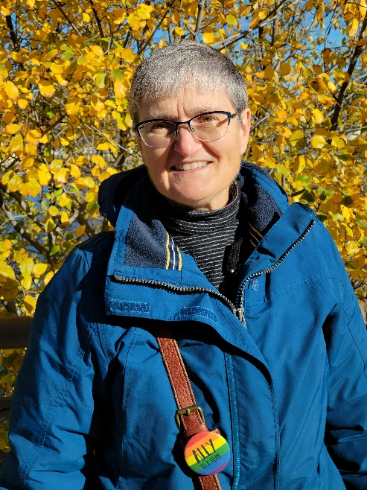
Pastor Karen Behling (she/her) lives within a mile of the congregation she serves - Our Saviour’s Lutheran Church in Chippewa Falls, WI - which means that most days, she enjoys walking as her primary mode of transportation. Previous calls have been in Minnesota, Iowa, and North Dakota in congregations small to large, with and without staff. Her primary creative outlets are quilting and replacing more and more of the front lawn with pollinator plants and stirring up the ingredients for delicious cookies to share with family, friends, and neighbors.

Green Blades Preaching Roundtable

Notes on the Virgin, the Voice, and the Wilderness

Reflections on Third and Fourth Sundays of Advent
Revised Common Lectionary, Year A
December 17 and 24, 2023

Advent 3
Isaiah 61:1-4, 8-11; Psalm 126 or Luke 1:46b-55; I Thessalonians 5:16-24; John 1:6-8, 19-28
Advent 4
2 Samuel 7:1-11, 16; Luke 1:46b-55 or Psalm 89:1-4, 19-26; Romans 16:19=27; Luke 1:26-38

Rev. Kristin Foster, Cook, Minnesota

As I read the texts for the third and fourth Sundays of Advent, I feel an anticipatory sense of loss. The annual Christmas Pageant will displace the texts for Advent 3 in many of our congregations. Advent 4 will likely be lost as it shares a Sunday with Christmas Eve. How many worshipers will hear their sonorities? How many preachers will have the opportunity to prepare to preach them?

According to these very texts, however, counting is not what counts. And sometimes, what begins as a voice that no one hears but the wilderness itself, or as a pregnancy as wildly beyond control as the wilderness – turns out to be conceived by the holy wholly wild Spirit, to grow and be born in some way that stirs us beyond our own imaginations into a new becoming.

And so, whether you prepare to preach on these Sundays or not, whether you are a preacher or not, I offer you some notes, on the Virgin, the voice, and the wilderness.

Note first that the Song of Mary, the Magnificat, is the alternate psalmody for the 3rd Sunday of Advent as well as the psalmody for the 4th Sunday of Advent brings Mary into both Sundays. Apparently, John’s voice crying out in the wilderness and Mary’s voice singing out to Elizabeth have something in common. And Mary, the virgin of Luke 1 and of the Apostles’ Creed, may have more in common with the wilderness itself than we have noticed.

The dominant cultural, historical meanings around virginity tend to cluster around ideas of innocence, of purity, of a girl or woman “saving herself” for marriage. The girl, under her father’s protection and possession, becomes a woman who will be under her husband’s protection and possession. Virginity is a dangerous and fecund period of potential for pregnancy before marriage which must be strictly guarded for the girl to be marriageable. After all, a future husband will not want to take responsibility for another man’s child. The Church has tended to transfer these dominant understandings to the mother of Jesus as virgin. Perpetually pure, perpetually innocent, she becomes the moral symbol for sex as something impure, or at best, something that is good only when owned and guarded by a (male) system. Along with this perpetual purity, the Church extols her submissiveness to the will of God. The Virgin Mary submits, surrenders, to the angel’s message the way ordinary women are expected to submit to men.

Alongside these connotations, though, we typically read the story of Mary’s pregnancy as miraculous in the sense of being supernatural, a divine intervention which contravened nature’s process of procreation. Believing in the virgin birth becomes a warrant for a theology which finds God not in what is natural but in what is supernatural. God acts not through nature itself, but in specific acts of undoing nature, of transcending or contravening it. When we do this, locating God in the supernatural, when we define miracles as supernatural events which disrupt the processes of nature, we drain nature of God. God is not in nature, God is in the supernatural. We consign God to an ever-diminishing arena of what we do not understand, of the unnatural.

In so doing, we miss the miracle, the miracle of nature, and the miracle of the incarnation, the miracle of the gospel.

So this Advent, I am pondering a very different read. What if the first miracle in the gospel is that a male writer in the first century of the Common Era would feature in the first chapter an angel coming to a woman, and would voice the experience of a woman? What if Mary is a virgin in the opening chapter of Luke’s gospel in the same way that we describe wilderness as virgin? Virgin wilderness is wilderness that has not come under human domination. (As we are learning, indigenous peoples interact with wilderness, tend wilderness such that the wilderness remains wilderness while providing for them. They do not own or dominate it.) Wilderness exists beyond human ownership. It is not a natural resource. Once we call old growth forests virgin timber, we are already measuring the trees as commodities. They are virgin like a young woman in patriarchal society is virgin, defined for their eventual use. (Read the long history of human civilization, and you will meet the long history of deforestation, of owning wilderness in order to own it.)

John the Baptizer, as forerunner to Jesus, went to the wilderness precisely because the wilderness exists beyond human ownership and exploitation. John, giving new voice to Isaiah, cried out in the wilderness. His voice is a voice only in the wilderness because what he speaks is not exploitable. God meets God’s people outside human norms and control. In the wilderness.

Likewise, God comes to a virgin, Mary, enters into the imagination and being of a virgin, as a young woman who is not under male possession. There is a wild freedom at the heart of her encounter with the angel. Like the virgin wilderness, her capacity to conceive, her full being, is outside the bounds of human civilization and practices. Her pregnancy is not a product of patriarchy.

And please also take note. The only choice in the account of Mary’s conception is her choice. Joseph does not give permission. Her parents do not give permission. Mary, herself and alone, says Yes. In a world where women had no choice of who they would marry or how many children they would have or when and whether and with whom they would have sex, Mary had choice. She could say “Let it be to me according to your word.” Her Yes to the angel was a yes to her own participation in the saving work of God, her own capacity to conceive God. Conceive. God. Give birth. To God. Give birth to God’s own Anointed One. To God’s own way for the world.

Isn’t this the miracle at the heart of the virgin who conceives and bears a Child. Not that God would supersede God’s own natural processes, but that God would supersede, would disrupt, the human (male) hierarchy which claims to own a woman’s body and a woman’s choices --- in the same way that this same social pattern wants to own the forests and the oceans and everything else?

And more. Through the long and looping narrative of the Hebrew scriptures, God meets God’s beloved people and calls them, into the wilderness, out of bounds, beyond human ownership and control. There, the people learn to live, not under societal expectations, but in expectation. Like we used to say of a pregnant woman, she is, they were, expecting.

John, who was also expecting, called people back into the wilderness to meet a God who will not be confined or defined by any empire, any hierarchy, or any temple, a God who offered a re-start, a re-set, a new beginning. A God who frees us from the tyranny of expectations to live in expectation. Perhaps it would not be too far-fetched to say that Mary was not the only one expecting the Messiah. Perhaps everyone who came to the wilderness to hear and be baptized was expecting too. Becoming pregnant. With God and God’s own borning.

Such pregnancy, such expectation, is not safe. We fear what we cannot control. (Note the current global rising of populist authoritarianism. Even in the Netherlands, people are afraid. People are wanting someone to be in control.) In contrast, this announcement of conception from the margins by the Holy Spirit undermines all claims of territory, all territorial disputes. All empires. All wars.

John’s voice in the wilderness and Mary’s great Yes were and are an existential threat to all human hierarchy. John would be beheaded. A sword would pierce Mary’s heart. The Child whom she freely conceived would be executed.

As you know, we are now encountering another existential threat, the existential threat of climate chaos and ecological devastation. Even the financial and fossil fuel industries and their political backers will use those words. They say we must address the existential threat of climate change, even as they turn the Amazon rain forest into pasture and the boreal forest into toilet paper.

As Larry Rasmussen writes in The Planet You Inherit: Letters to My Grandchildren When Uncertainty’s a Sure Thing, the flood is upon us. And we are the flood. We are also the ark.

But hear this promise. The Advent gospel, spoken from the wilderness, conceived by a woman apart from male ownership, is an existential threat to that existential threat.

We meet this gospel in the Indigenous people of the Amazon, defending their wilderness home and our very climate.

We meet this gospel in the Water Protectors, the Indigenous people of Minnesota and the Dakotas and northern Wisconsin, who are challenging pipelines through fragile ecosystems, who, by the way, are often women leaders.

We meet this gospel in Wangari Maathai, who received the Nobel Peace Prize in 2004 for her efforts to lead women in a nonviolent struggle to bring peace and democracy to Africa through its reforestation. (Her organization planted over 30 million trees in thirty years.)

We meet this gospel in people on the Iron Range who are promoting research now that demonstrates that precious metal recycling can replace precious metals mining.

We meet this gospel in congregations across our region who are joining a movement to create a regional network of pollinator sanctuaries.

And we just might meet this gospel in our own season of Advent. Even if these scriptures don’t get heard.

Let’s say your congregation is holding its Christmas pageant on the third Sunday of Advent. The scriptures appointed for the Sunday are being displaced. Neither Mary’s Magnificat or John’s voice may be heard. Let’s say that the children are dressing up as angels and shepherds, as Mary and Joseph and magi. Whether you know it or not, you are inviting them into the wilderness. By clothing them in the story, you are filling them with freedom, with expectancy. You are dressing them in a pregnant promise. As they dress up in this story, they may be coming to expect something different than what they can buy, or earn, or prove, or achieve. Even without you knowing it, an angel may be whispering to them of a birth in which they are participants, of an existential threat to our civilization’s existential threat. Without you knowing it, they may even be whispering Yes.

Without you knowing it, you may be whispering Yes as well.

Kristin Foster serves as co-chair of the EcoFaith Network of the Northeastern Minnesota Synod and editor of the Green Blades Preaching Roundtable. She is chairing the planning team for the 2024 EcoFaith Summit, “Cross Currents in the Flood: Building Arcs Together for a Livable Planet”. Pastor for three decades to a vibrant parish on Minnesota’s Iron Range, she and her congregation gave birth to the Iron Range Partnership for Sustainability, a regional grassroots, non-profit organization that builds partnerships and pathways for environmental, community, and economic sustainability. (Go to irpsmn.org/ewaste-recycling to learn more about the potential of precious metals recycling to provide the precious metals we need for a transition to renewable energy). She and her husband, the Rev. Dr. Frank Davis, live with their 1-year old black lab on a Swede-Finn farmstead near Cook, Minnesota. They have two adult daughters and three grandchildren.

Green Blades Preaching Roundtable
Reflections on the texts
Christmas Eve
Years ABC
December 24, 2023

Isaiah 9:2–7
Psalm 96
Titus 2:11–14
Luke 2:1–14 [15–20]

Melinda Quivik, St. Paul, Minnesota

___________________

On Christmas Eve, of course, we hear the story of the angels coming to the shepherds who are with their flocks of sheep. The shepherds are suddenly terrified –– a very strong word but understandable! –– by the sight of first one angel and then a whole lot of angels. It is a "terrific" scene.
The words terrify (probably something suggesting danger) and terrific (what we normally name something that is good) are linked by their roots in sixteenth and seventeenth century Latin. Experiencing something "terrific," in other words, may be so outside of our normal encounters that it, in fact, frightens us. We behold a new realm of sensibility. We are lifted out of our ordinary expectations and transported to a place that changes us and changes those around us.
The writer of this story in Luke's Gospel builds up a moment of astonishment so filled with oddness and urgency that it seems natural to us that the story expects the shepherds will indeed go to find the baby in the manger. After all, the angel says: "You will find a child..." (They haven't even yet been told to venture into Bethlehem! The angel makes a huge assumption.)
We hear this story so often repeated that we assume the angel is appearing only to the shepherds. But the angel appears to "shepherds living in the fields." The fields hold not only shepherds but sheep. The sheep are right there, seeing the heavens aglow right along with the shepherds.
In an altar painting in a church in Dollar Bay, Michigan, Jesus walks along a path accompanied by sheep. When artists bring the sheep into the picture of Jesus' life, we are invited to think of ourselves as sheep and Jesus as our shepherd, but we might also ponder the relationship between the Risen Lord and nature. One sheep in particular gazes up at the Good Shepherd with an enigmatic expression on its face. What was the artist signaling?

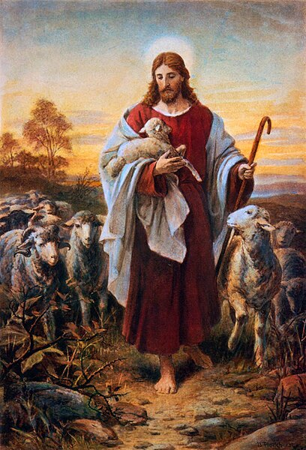

We can see in the face of the sheep who is looking at Jesus either a creature who is appreciating (even adoring) one who would so gently cradle a lamb or a creature who is uncomprehending in the presence of the Good Shepherd. What exactly is the sheep's relationship with God?
Dietrich Bonhoeffer's Christ the Center (HarperOne, 1960)––in a section entitled "Christ as the Centre Between God and Nature"––tells us that both human beings and other creatures of nature are fallen: "nature stands under the curse which God laid upon Adam's ground..." The sheep, let us say, is fallen through the Fall. (Remember the roles played by that apple and that snake in the expulsion of Adam and Eve from the Garden). The natural world, then, "is now dumb, enslaved under the guilt of man. Like history, it suffers from the loss of its meaning and its freedom. It waits expectantly for a new freedom." But Bonhoeffer distinguishes between what that freedom entails for humans and the natural world. "Nature, unlike [humans] and history, will not be reconciled, but it will be set free for a new freedom." (p. 64) Nature will not be reconciled but nature will be redeemed.
This sounds harsh and may be the result of a science that finds only certain intelligences to be worthy of reconciliation with God. Evolutionary theory (fascinating to me but also beyond my skills, to be sure) seems to indicate that there is more to the story of species differentiation than is commonly believed. The apparent "choices" made by creatures over time in various places under differing climates and changed landscapes attest, in the minds of some scientists, to a greater reach of agency than is easily recognized by most humans.
So when Bonhoeffer refers to sheep being redeemed but not reconciled (to pick on the creature in the painting) he could be expressing the thinking of his time. We don't know. At any rate, when we think of the need for God's Son to usher mercy and renewal into our world, we can acknowledge nature standing in need just as do humans. After all, we live in a hawk-eats-mouse world; someone suffers so that others may live. And we humans continue the tradition with wars, denial of health care, disregard for the rights of air and water freely to be themselves and clean. We go along with unequal and unjust living situations for all beings.
The coming of God's Son is the necessary movement toward the "new freedom" Bonhoeffer points to for both humanity and nature. That new freedom might be release from the tyranny of human life thinking first of its own well-being and concerning itself with the welfare of others (sheep, air, water, plants, etc.) only if pressed hard enough. Global climate change is pressing on us now, but we might get the message of our inadequate attention to the non-human creatures with whom we live on the day when we can no longer grow the crops and tend the livestock we have become accustomed to watching over. When at last the shepherds have to abandon their sheep permanently because the grass they need no longer grows in the hills around Bethlehem and the water for irrigation is gone, people all over the world might finally get the message that redemption can mean human turning toward our living-creature neighbors with mercy.
This Christmas Eve when outdoor temperatures might stray from what we expect; when whole nations of people are on the move in search of ways to survive; when we hear rumors of viruses that incessantly morph into varieties we humans cannot fend off; and when uncertainty looms over the natural, social, economic, political, and even religious realms, we may take comfort not only in the angels appearing to shepherds and their sheep. We may take comfort in Isaiah's promise that "a child has been born for us," and Titus pronouncing that God has redeemed us to be "zealous for good deeds." All of life has been redeemed for good. "Christ is truly the centre of human existence, the centre of history and now also the centre of nature." (p.65)
Christ is love. Christ situates love in the heart of our world. Love is freedom. Love is the new thing. Love is the recognition that we all––humans and the creatures of nature––belong to a web that resonates for the good of all.
________________
Hymns to consider:

In ELW:
#280 Midnight Stars Make Bright the Skies
#284 'Twas in the Moon of Wintertime
#292 Love Has Come

In All Creation Sings:
#1067 For the Wholeness of the Earth
#1086 O God, Who Gives Us Life
#1091 Hallelujah! Sing Praise to Your Creator

Melinda Quivik, an ELCA pastor (who served churches in Montana, Michigan, and Minnesota) and former professor of worship and preaching, is currently the Editor-in-Chief of the quarterly journal Liturgy, a writer, and a preaching mentor with Backstory Preaching at backstory-preaching.mn.co. Her most recent book is Worship at a Crossroads: Racism and Segregated Sundays which is a response to Lenny Duncan's Dear Church. She calls all churches to learn why worship ways differ in our various traditions and to ask ourselves how we might better welcome others.

Green Blades Preaching Roundtable

Christmas III
Isaiah 52:7-10
Psalm 98
Hebrews 1:1-12
+ John 1:1-14

He was in the world,
and the world came into being through him;
yet the world did not know him.
John 1:10

Pastor John Dietz, Hibbing, Minnesota

When I was a young and new pastor years ago, I was invited to the home of a parishioner for a meal — more of a dinner party, as it turned out. When I arrived, the host greeted me at the door, took my coat, and brought me into the living room where I was introduced to the other guests. They were already enjoying their drinks and warmly welcomed me into their conversation. Our host then excused herself into the kitchen. After some time had passed, I remember going to the kitchen and asking her if she would like any help, but the offer was refused. I was to go back to the living room and enjoy myself.

Dinner was finally announced and all the guests were given a place at the beautifully set table — china, silver, candles, flowers. Of course, being the pastor, I was asked to pray, and then we sat down and the host popped back into the kitchen to bring out the first course. We had just begun to enjoy what I still recall as a delicious meal, when our host once again disappeared into the kitchen where she stayed preparing the next course. This happened a number of times during the meal; she brought out food — wonderful food — and then retreated back into the kitchen.

At first it was barely noticeable, but over the course of the meal, we all became more and more aware of our host’s absence. She had invited us into her home, she had prepared this excellent food, and yet she wasn’t really part of it at all. It was only after coffee and dessert when she attempted to leave once again for the kitchen sink to start on dishes when the whole company finally requested, and nearly demanded, she stay with us so that we could enjoy her presence as well.

In her efforts to be hospitable and to provide us the best dining experience she could, our host had actually become quite inhospitable, making all of her guests feel quite awkward — as if she were our cook, server, and dishwasher and we were non-paying customers at a restaurant, rather than invited friends in her home.

I think of Saint John’s prologue, which is appointed for Christmas Day and at least encouraged to be read at some other time during the Christmas season. And I hear, beyond the parallels with Genesis and the first story of the beginnings of creation, strong echoes of the canticle from Colossians: “[Christ] is the image of the invisible God, the firstborn of all creation; for in him all things in heaven and on earth were created, things visible and invisible, whether thrones or dominions or rulers or powers—all things have been created through him and for him. He himself is before all things, and in him all things hold together” (Colossians 1:15-17).

The scriptures tell us that all things came into being through the eternal Word of God — everything was created by and for Christ. And the great mystery of our faith is that Christ not only creates it, but then actually comes into this creation, albeit unknown and unaccepted, to live with us and for us. He doesn’t just make an appearance to prove that he exists or perhaps that he cares, but he comes to share our existence in every way. St. Athansius wrote in On the Incarnation: “The Lord did not come to make a display. He came to heal and to teach suffering men. For one who wanted to make a display, the thing would have been just to appear and dazzle the beholders. But for him who came to heal and to teach the way was not merely to dwell here, but to put himself at the disposal of those who needed him, and to be manifested according as they could bear it.”

Too often it seems like, especially in the season of Advent, we focus on welcoming Christ into our world, preparing a place for him, getting ready to receive him … and yet it is Christ who receives us, and from the very beginning, was speaking this world we live in into existence — preparing a home in which to welcome us. Could Christmas remind us that this world is his, it is the home he has prepared, and we are his guests here?

When we celebrate the incarnation of Christ in our own time and place, it becomes more embarrassing than awkward to think of what we have done to this world, considering that we are only guests. We remember our place here, not as the creator, but as creatures and care takers.

Unlike my host of that dinner party so many years ago, Christ does not invite us into this world, into this life, and then disappear from us — back to the kitchen of creation. On Christmas Day, and in this season, we become especially aware that he comes to us to live among us — like one of us, and for all of us. We find him in the living rooms, enjoying the appetizers and conversations; he’s sitting at the kitchen table, dishing out the food family-style so he won’t miss even one story, one laugh, one tear. Christ is here — truly present — and in this incarnate Word we know what Isaiah meant when he told us about the coming Immanuel (Isaiah 7:14): God is with us.

At Christmas, we might look around us: at the church, in our homes, over the winter-frozen landscape, and at each of the people who have joined us — especially the people — these faithful parishioners and once-a-year visitors, our family and friends, and remember the promise that yes, God is with us in all of it, but also that we are called to be with God. The promise we hear on Christmas that God makes to us in “the water of rebirth and renewal by the Holy Spirit” (Titus 3:5) might strengthen and renew our own promises made to God and to the church. In our affirmation of the baptismal covenant, we declare our intention to live among God’s faithful people, and implicit in that communal life of faith is our care of for others and the world God made.

Finally, in the Holy Communion we join our prayers and praise with the angels and saints at all times and in all places for the wonder and mystery of the Word made flesh. We are drawn to worship the God who comes into his own creation, and through that very creation — the bread and wine of the eucharistic feast — feeds his guests with his real presence at a table of grace and mercy, forgiveness and new and everlasting life.

Pastor John Dietz lives in Hibbing where he serves as pastor of First Lutheran Church.

Green Blades Preaching Roundtable

DIAMOND-BRIGHT SWADDLING CLOTHES

Rev. Emily Meyer envisions God wrapping us in snowy robes of healing and right relationships.
….
Reflections on the texts/ Care for Creation Commentary
First Sunday after Christmas, Year B
December 31, 2023

on the Revised Common Lectionary
Isaiah 61:10-62:3
Psalm 148
Galatians 4:4-7
Luke 2:22-40

Rev. Emily Meyer, Minneapolis, Minnesota

Hymn suggestions: In the Bleak Midwinter, ELW #294
Cold December Flies Away, ELW #299
Song: Those Who Dream - The Many

What a beautiful and delightful set of texts - that virtually no one will encounter - on this First Sunday after Christmas (a.k.a. New Year’s Eve Day).
You might focus on the turning of the year. A quick investigation of the institution of the Roman Calendar - the solar calendar that measures our days, weeks, and months - reveals that,
‘By the 1st century BC, the Roman calendar had become hopelessly confused. The year, based on cycles and phases of the moon, totaled 355 days, about 10 1/4 days shorter than the solar year. The occasional intercalation of an extra month of 27 or 28 days, called Mercedonius, kept the calendar in step with the seasons. The confusion was compounded by political maneuvers. The Pontifex Maximus and the College of Pontiffs had the authority to alter the calendar, and they sometimes did so to reduce or extend the term of a particular magistrate or other public official. Finally, in 46 BC, Julius Caesar initiated a thorough reform that resulted in the establishment of a new dating system, the Julian calendar (q.v.). [Britannica; learn more about the Julian Calendar here.]

A reflection on time - and its manipulation - and our measuring of days and seasons may be appropriate on this Sunday.

One final note on the term ‘calendar’ from Thomas Hewitt Key, University College, London (here)

CALENDA′RIUM, or rather KALENDA′RIUM, is the account-book, in which creditors entered the names of their debtors and the sums which they owed. As the interest on borrowed money was due on the Calendae of each month, the name of Calendarium was given to such a book (Senec. De Benef. I.2, VII.10). The word was subsequently used to indicate a register of the days, weeks, and months, thus corresponding to a modern almanac or calendar.

This understanding of the term, ‘calendar’- as debt ledger - corresponds in interesting ways with Paul’s understanding of Christ’s arrival on earth, ‘born of a woman, born under the law, in order to redeem those who were under the law and so we might receive adoption as children.’ The birth of Christ is both sign and promise that we/God’s beloved are no longer debtors or ‘enslaved’ people, but free, redeemed (‘bought back’, ‘bought out of servitude’) children of God.

~~~

If the dogmatic approach of language and history isn’t your thing, the rich imagery of Psalm 148 lends itself beautifully to a video or photo montage - a visual sermon. Invite the congregation to share their own photos and create a local gem. Or borrow the one I created combining photos from around the state of Minnesota. [See more below.]

~~~

The Gospel reading from Luke is a beautiful narrative of a highly intergenerational consecration. It makes me wonder: what if all children’s blessings/baptisms were conducted with at least one elder from the congregation actively and specifically blessing the child? We do this symbolically, with the whole congregation voicing God’s promises and blessings, but the image of both Simeon and Anna laying hands on, lifting up, and embracing this infant - a child they have never met and with whom they have no biological connection: this is what ‘church family’ is intended to do: bless each generation with both predecessors and successors.

~~~

Finally, Isaiah. This is a powerful text of promise and hope that many - if not all - of us need to hear. Tragically, our desperation for it may make it difficult to accept: with climate crises galore, wars raging and threatening to escalate at any moment, with division and depression on the rise locally and globally, God’s words of promise may feel out of touch or even useless.

Where can prophetic promises bring hope to the hopeless and joy to those who grieve losses - personal, communal, and global - time and time again?

61:10 I will greatly rejoice in YHWH, my whole being shall exult in my God; who has clothed me with the garments of salvation, who has covered me with the robe of righteousness, as a bridegroom decks himself with a garland, and as a bride adorns herself with her jewels.

Trauma-informed approaches to ministry encourage us to create safe spaces for those who cannot rejoice in this season. Blue Christmas/The Longest Night provides such a space. This First Sunday after Christmas may also be a time to acknowledge that not everyone is rejoicing; our ‘whole being’ - whether that ‘being’ is each individual, the community as a whole, and/or the whole ‘being’ of creation - may not be capable of exulting. Those of us - or those parts of our individual and collective selves - that are not able to rejoice are likely attuned to the pain of the world.

In the Northwoods the chances are good that by December 31, there is a blanket of snow on the ground. This image may be helpful. As the snow covers the ground, so does God’s healing come to us: sometimes feeling like cold, harsh realities that are weighty and overwhelming - realities we can’t shovel away…

61:11 For as the earth brings forth its shoots, and as a garden causes what is sown in it to spring up, so YAHWEH will cause righteousness and praise to spring up before all the nations.

..Yet somehow, mysteriously, beneath that blanket of snow, the miracles of new life are already germinating: spring’s floral garlands are gathering nutrients; the gems of adornment are hardening and taking on a deeper luster. Somehow, when we lean into the promise that healing is possible, we discover new paths toward reconciliation, reparations, healing of broken relationships. There are seeds beneath the snow that await only our dreaming to take root and grow.

62:1 For Zion's sake I will not keep silent, and for Jerusalem's sake I will not rest, until her vindication shines out like the dawn, and her salvation like a burning torch.

If only God would speak loudly, boldly, prophetically, definitively for the sake of Jerusalem - and everywhere war is actively destroying lives and threatening the planet. Christmas is meant to be a time of peace. Might it be that amidst our celebrations we who follow the Promise of Peace are called to ‘not keep silent’? To actively strive for the Beloved Community’s healing - like a burning torch? The antidote to our despair may very well be to give voice to our fears and take action.

62:2 The nations shall see your vindication, and all the kings your glory; and you shall be called by a new name that the mouth of YAHWEH will give.

It’s easy to read this word ‘vindication’ and equate it with ‘vengeance’. They feel similar. But ‘vindication’ means, ‘absolving someone of blame or suspicion’. God has been angry because Israel has not been living into their covenant with God and so God has dispersed them from the Promised Land into the wild spaces of Babylon.

But God wants to restore the relationship. God is at work to bring about healing. Like Simeon and Anna, God lifts us up and calls us by a new name: beloved.

Will God’s beloved people find the courage to live into God’s will?

62:3 You shall be a crown of beauty in the hand of YAHWEH, and a royal diadem in the hand of your God.

Reconciled relationships - between individuals, between communities, between countries and cultures and religions, between humans and creation - reconciled relationships are the ‘crown of beauty’ and ‘royal diadem’ in the Divine hand. Those jewels forming beneath the blanket of snow are shaped in relationship, re-shaped often to become more clear, more luminous, more beautiful.

The snow is heavy, wet, cold - and beautiful; a blanket of diamonds in its own right. The earth wears it as a garment of joy knowing that without it, spring cannot and will not arrive. Moshieich, the Savior identified in Isaiah 61:1, the Messiah Christians find in the Babe of Bethlehem, has come to heal and restore, renew and reshape God’s beloved people. Even in the midst of pain and suffering - out there in the world and within our troubled hearts and souls - the Christ is being born again, wrapping us in diamond-bright swaddling clothes, inviting us to rest if and when our hearts are weary, but urging us, too, to let that sparkling robe of healing and beloved relationship be a beacon of hope - to ourselves and to the world.

~~~

Recognizing that attendance may be low on this First Sunday after Christmas, and/or that you, dear pastor, will be taking a Sunday out of the pulpit, I humbly offer two resources that may make your life - and celebrations - a bit easier:
I’m creating a Readings and Carols service using Christmas hymn favorites that our congregation won’t yet have sung. It’ll be ready - including at least a few of these texts - somewhere before December 31. If you’d like to borrow it, email me at eplmeyer@gmail.com.
See also the Psalm 148 video mentioned above: Ministry Lab members have free access; non-members can inquire and we’ll figure out something equitable.

Originally written by Rev. Emily P.L. Meyer for Green Blades Rising Preacher’s Roundtable.
ministrylab@unitedseminary.edu
Find more from Emily Meyer at www.theministrylab.org.

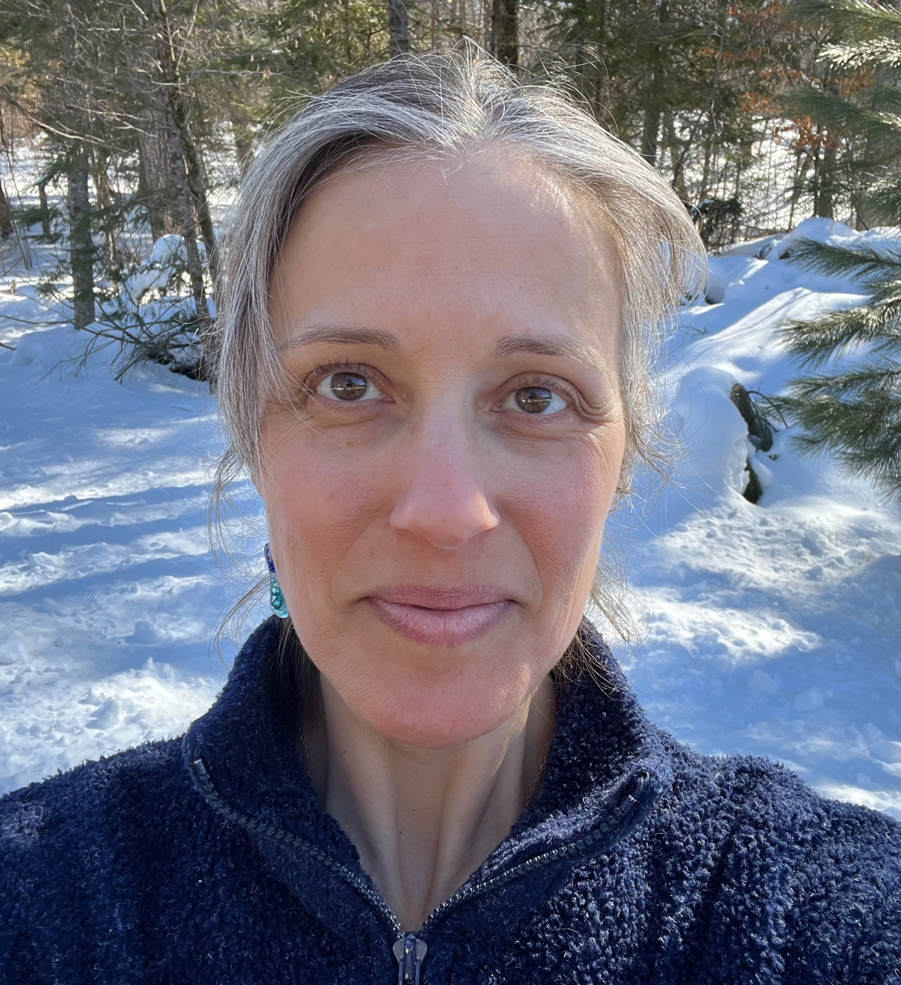

Rev. Emily Meyer creates contemplative retreats, liturgical arts, sermons, costumes, choreography, and performances. Along with contributing to Green Blades Rising and Lutherans Restoring Creation, Emily serves on the St Paul Area Synod’s Care of Creation Team, the ELCA’s Truth-Seeking and Truth-Telling Initiative, and as director of The Ministry Lab.

