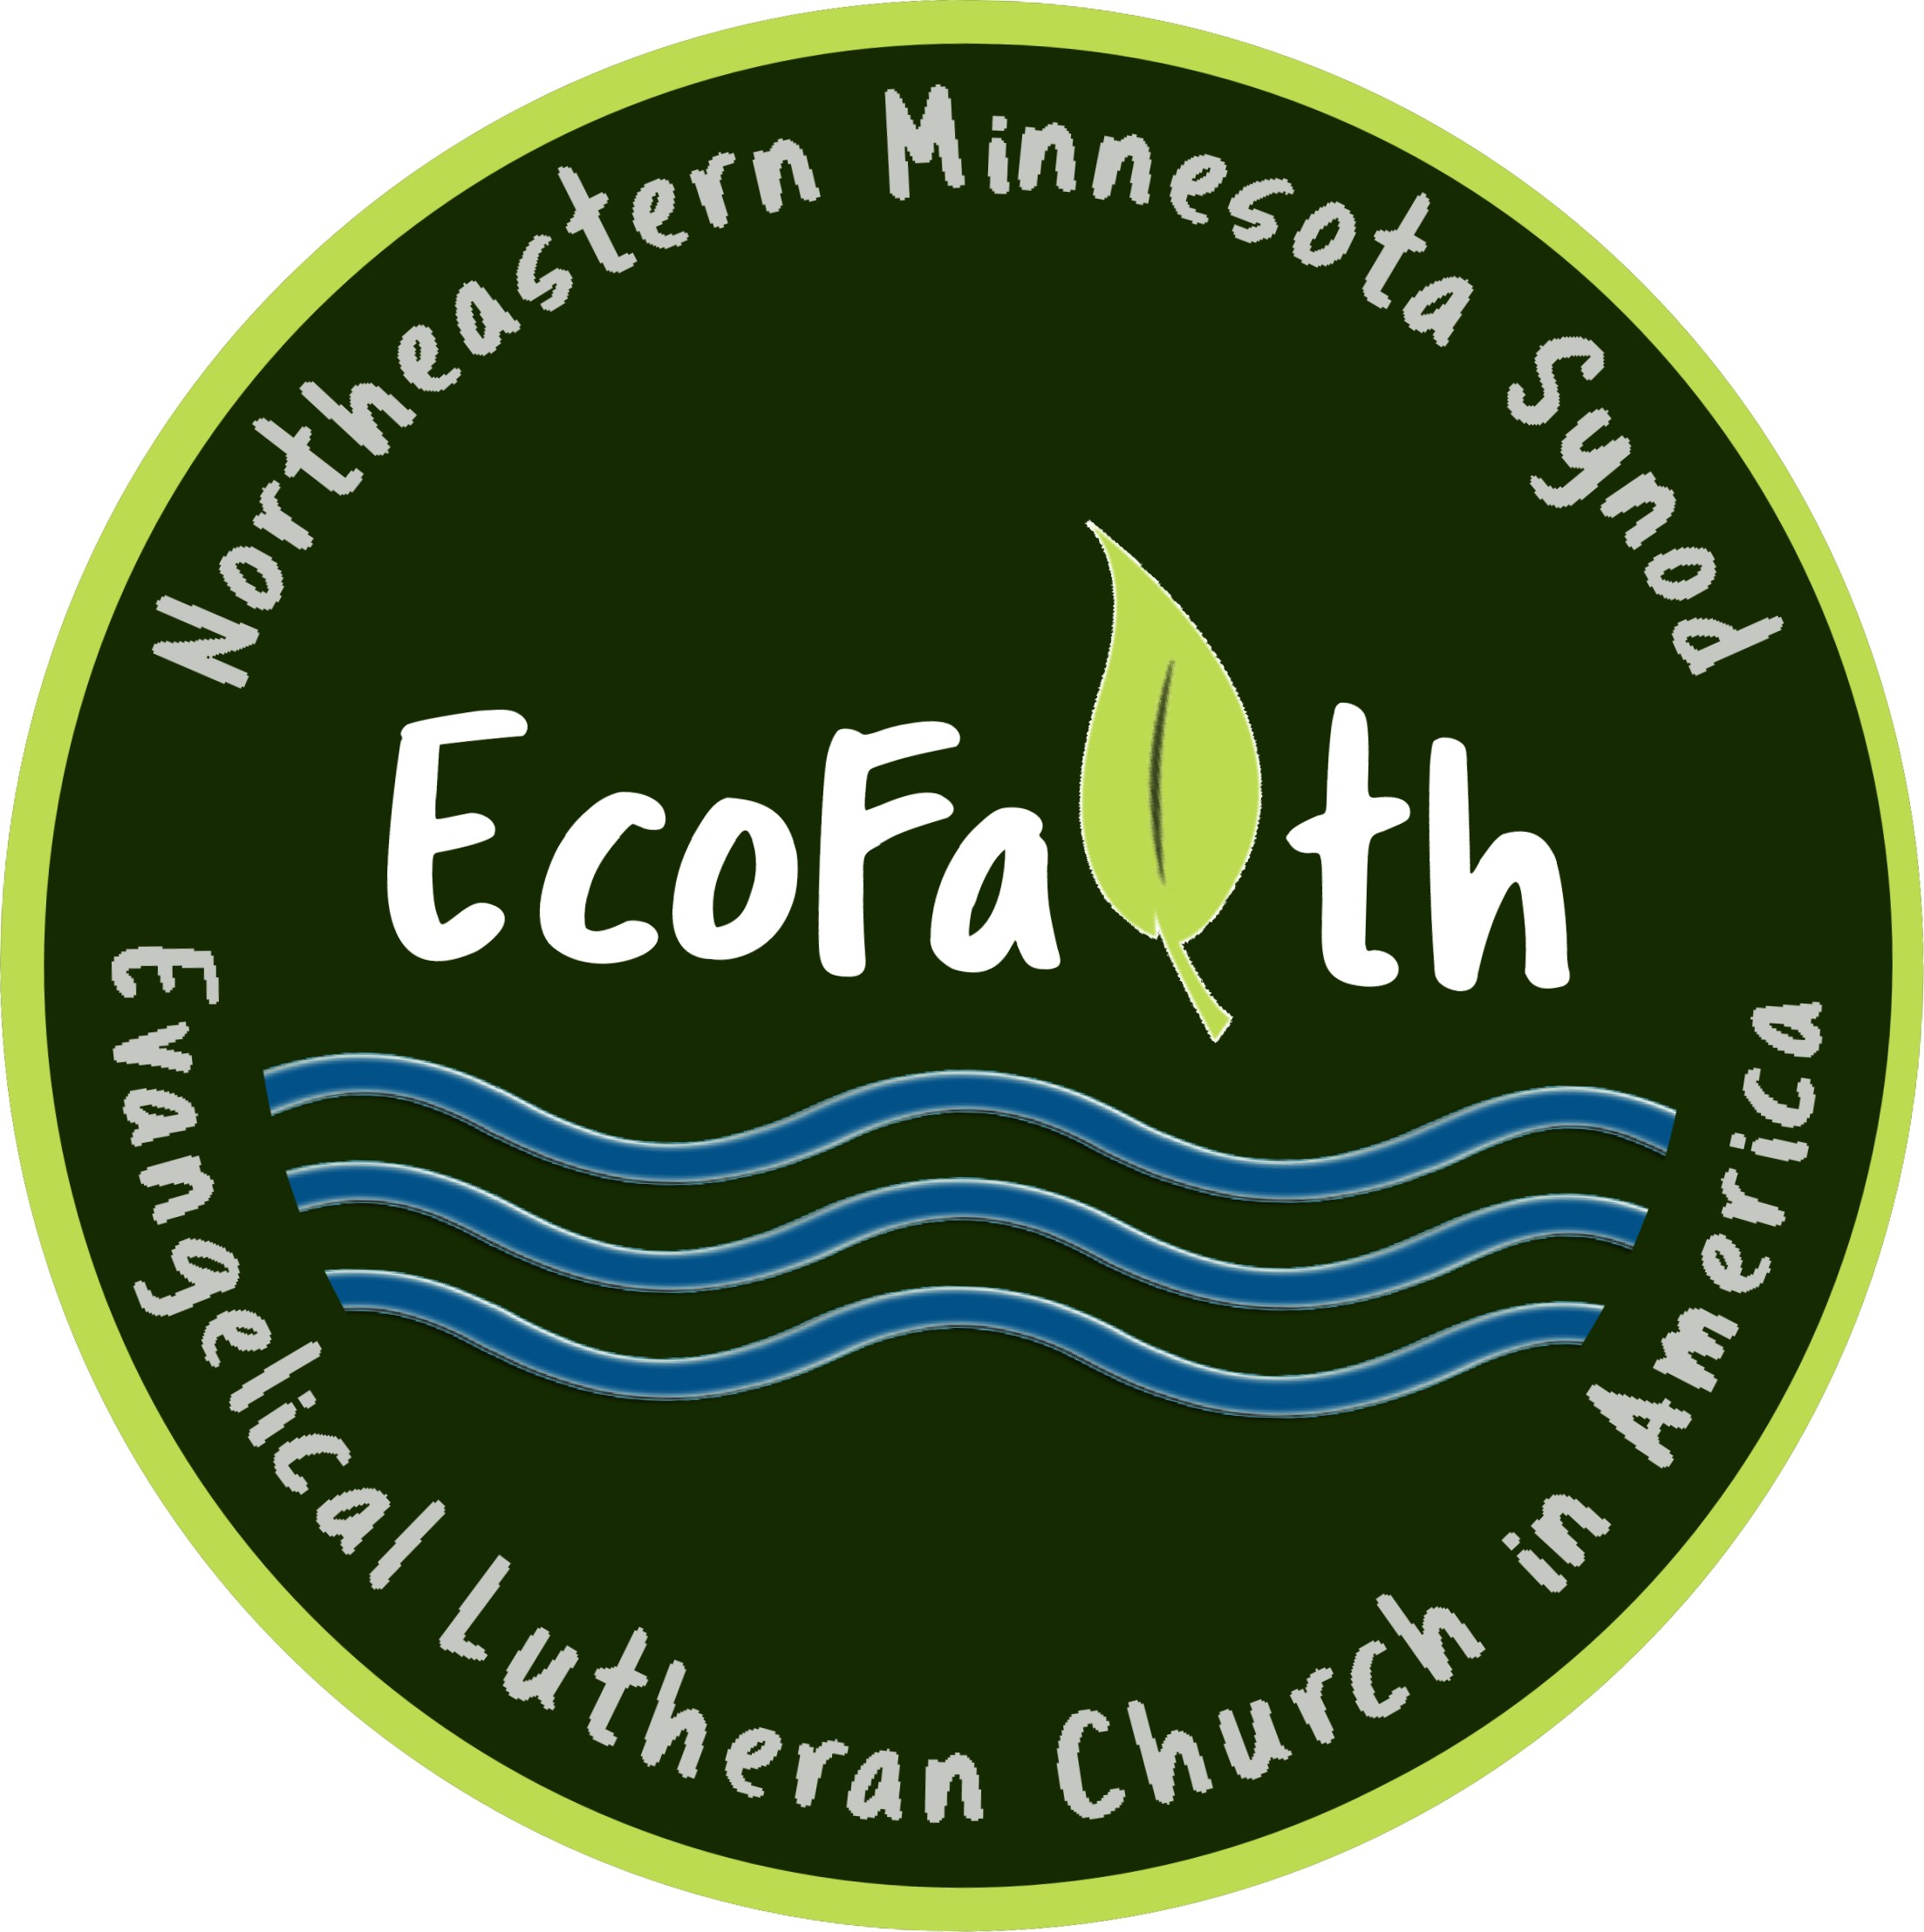About EcoFaith Network Micogrants
EcoFaith Network, NE MN Synod
Nurturing New Initiatives in Care of the Creation

The EcoFaith Network, Northeastern Minnesota Synod is a growing network of congregations and companion partners living out God’s call to be stewards of the earth for the sake of the whole creation. The EcoFaith micro-grant program equips congregations and partners (camps, campus ministries, etc) to live into this calling by providing seed money for specific ministry initiatives.

Grants are available in amounts between $100-$1000.

Projects in a variety of areas are eligible for seed money funding, including but not limited to:

- Art and environment
- Community gardening
- Community engagement and advocacy
- Education
- Energy conservation (e.g. solar panels, off-peak water heaters, etc.)
- Participation in a regional conference
- Pollinator Project initiatives
- Special events and speakers
- Wilderness encounter
- Youth environmental action and exploration

Please send your completed proposal to:
ecofaith@nemnsynod.org

* If awarded, we want to support you and to share your experience with others! We can meet with you once or twice over zoom. We will ask for you to send pictures and let us know what is happening as a result of your grant.

*We want to hear how your project is going! Please feel free to be in touch through the EcoFaith Network NE Minnesota Synod Facebook Page or by contacting any members of the EcoFaith Network NE MN Synod Leadership Team. Even if you do not receive the funding you have requested, we would like to find other ways to support you in your efforts!

Microgrants are made possible by the generous support of EcoFaith Network Partner Congregations and EcoFaith Donors.

For questions, contact EcoFaith Leadership Team Co-Chairs
Rev. David Carlson, pastor@gloriadeiduluth.org
Rev. Kristin Foster, revkristinfoster@gmail.com

The EcoFaith Network Leadership Team will contact you within a month of receiving your proposal.

