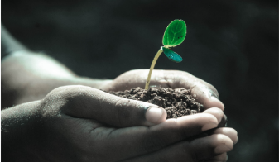
Green Blades Preaching Roundtable
Fifth Sunday of Easter, May 7, 2023
Reflections on the Gospel
John 14:1-14
David R. Warner, McGregor, Minnesota

The Gospel for this Sunday is John 14: 1-14. In that text, Jesus is on his way to the cross. He is accompanied by his motley band of disciples. As usual, they have difficulty understanding what Jesus is talking about, reflecting the human condition. Jesus reaffirms for the disciples that he is, “I AM”. Given how we usually read this gospel, it does not appear to say anything about our concern for EcoFaith. To hear the ecological echoes and implications of this passage, we need to look with a wider scriptural lens, first, to the creation context of the Gospel of John, and then to the creation account that begins the Bible as a whole.
In the gospel’s prologue, John writes “In the beginning was the Word, and the Word was with God, and the Word was God. He was in the beginning with God. All things came into being through him, and without him not one thing came into being. What has come into being in him was life, and the life was the light of all people.” John then goes on for 9 verses and in verse 14, we find the incarnation. John writes “And the Word became flesh and lived among us, and we have seen his glory, the glory as of a father's only son, full of grace and truth.”
In the time span covered by those nine verses at the beginning of John, we have the entirety of cosmic, human and religious development, from the beginning of time to the incarnation. In the first chapter of Genesis, verses 26 and 27, God creates humankind. In verse 28, He gives humankind care of “the fish of the sea and …the birds of the air and... every living thing that moves upon the earth”. All of this activity occurs within the scope of John 1:5- 14.
In our text, verse 2, Jesus tells his disciples “In my Father's house there are many dwelling places”. And Jesus also tells his disciples that he is going to prepare a place for them within those dwelling places and tells his disciples in verse 4, “you know the way to the place where I am going”. The disciples, of course, tell Jesus that they cannot and do not know the way. Jesus then explains to his disciples that he is the I AM. Jesus also extols the benefits of believing in him as the I AM.
I wonder about the dwelling places of which Jesus speaks in this passage. Despite the disciples’ inability to understand, it is clear that Jesus is speaking of his spiritual nature and of a spiritual place. It seems to me that those dwelling places might very well be right outside our windows. We see this flora and fauna every day and think little, if we think at all, of God's injunction in Genesis regarding the care that we are to exercise with respect to what we are seeing and experiencing. Just perhaps, when we step aside from our temporal world and allow ourselves to experience the spiritual, the trees and animals, whether ambulatory or crawling, flying or swimming or in the form of insects, are in fact the dwelling places that Jesus speaks of which have been moved from the spiritual world to the temporal world where we can experience them.
As such we are bound to adhere to God's injunction in Genesis. Jesus tells us in this passage, in verse 12, that those who believe in him “will also do the works that I do and, in fact, will do greater works than these, because I am going to the father”. Perhaps we experience those dwelling places and do works greater than Jesus by abiding in the dwelling places of God all around us, and by abiding by God's injunction in Genesis in caring for creation.

David R. Warner, Jr.
Retired Law Professor.
Member of the Leadership Team for the EcoFaith Network of the NE Minnesota Synod
Affiliated with the Tri United Parish of the NE Minnesota Synod

19507 485th Lane
McGregor, Minnesota 55760
218-838-4972

Green Blades Preaching Roundtable
Reflections on the texts
Sixth Sunday of Easter
May 14, 2023

Acts 17:22-31 - Psalm 66:8-20 -1 Peter 3:13-22 - John 14:15-21

Pastor Liz Davis, Duluth, Minnesota

Today as we gather for worship, many folks will have Mother’s Day on their minds. I typically don’t address Mother’s Day much in worship because it can be complicated. People have all sorts of feelings, experiences, and memories related to mothering and I’m not sure the church has always done a good job in honoring that diversity of experience. You know your congregation and can gauge what they might need to hear and how you can be authentically sensitive to your people. While I don’t tend to focus much on mothering, I was asked to share about these texts in light of my own experience of gestating, birthing, and raising kids.

In Acts, when Paul speaks to the Athenians, he draws on what he has seen around town to help them gain an openness to his (and our) God. This scene shows us that Paul has been paying attention to these people, learning about their values and customs, figuring out how the things that matter to him overlap with the things that matter to them.

In parenting, as in all relationships, noticing and honoring the individual before you is vital. Our children need different things. When my eldest was a baby, I did a lot of baby-wearing, and she always needed to be close by. My youngest would push away from me when she was done eating or playing and ready to go to sleep. As they’re much older now, we still need to anticipate and adapt to their needs. When we go for a walk, my eldest wants only to be able to spend time together and have someone listen to her; she enjoys the exercise. My younger needs something extra to hold her interest in an otherwise “boring” walk: she needs to hold the map or wear a special water pack. Figuring out what they need and providing those things makes our parenting life much easier than if we were to treat them exactly the same.

Paul declares, “The God who made the world and everything in it…gives to all mortals life and breath and all things” (Acts 17: 24a, 25b). God gives us all things, all we need for life. Paul goes on to say, “indeed God is not far from each one of us. For in God we live and move and have our being” (17:27b-28a). We are created and held by God, and this God who knows us so well gives us what we need. As I consider how my spouse and I care for our children out of our knowledge of them, I am awed by a God who does the same for me.

Paul connects this image of a creator who knows and cares for creation with the Athenians’ own imagery, “For we too are his offspring” (28b). Paul sees his own God embracing the Athenians. He makes the claim that they are connected through their common ancestry as children of the creator God. Even as these people are different from him, even as they may have some customs that he does not fully understand, Paul knows that they are all God’s beloved and known children.

As we currently are seeing many states in our nation legislating in ways that are especially harmful to God’s beloved and known children who are transgender, we would do well to remember that this text reveals a God who loves, knows, and provides for each individual in God’s creation in ways that are necessary and personalized to them. Following God’s deep love and care for God’s diverse people, we are called to stand with our transgender siblings, and stand with their human parents, as our nation makes it more difficult for them to obtain what they need to live well.

We are all connected by a common parent. We share a creator not only with our human siblings, but with all that exists. God has brought all things into being. As we live into our vocation as those created in God’s image to tend and care for all creation, even as we are siblings of a sort with every created thing. All of us: humans, animals, rocks, and stars claim our common source in God. How awesome that our parenting God extends care to the cosmos!

Pastor Liz Davis
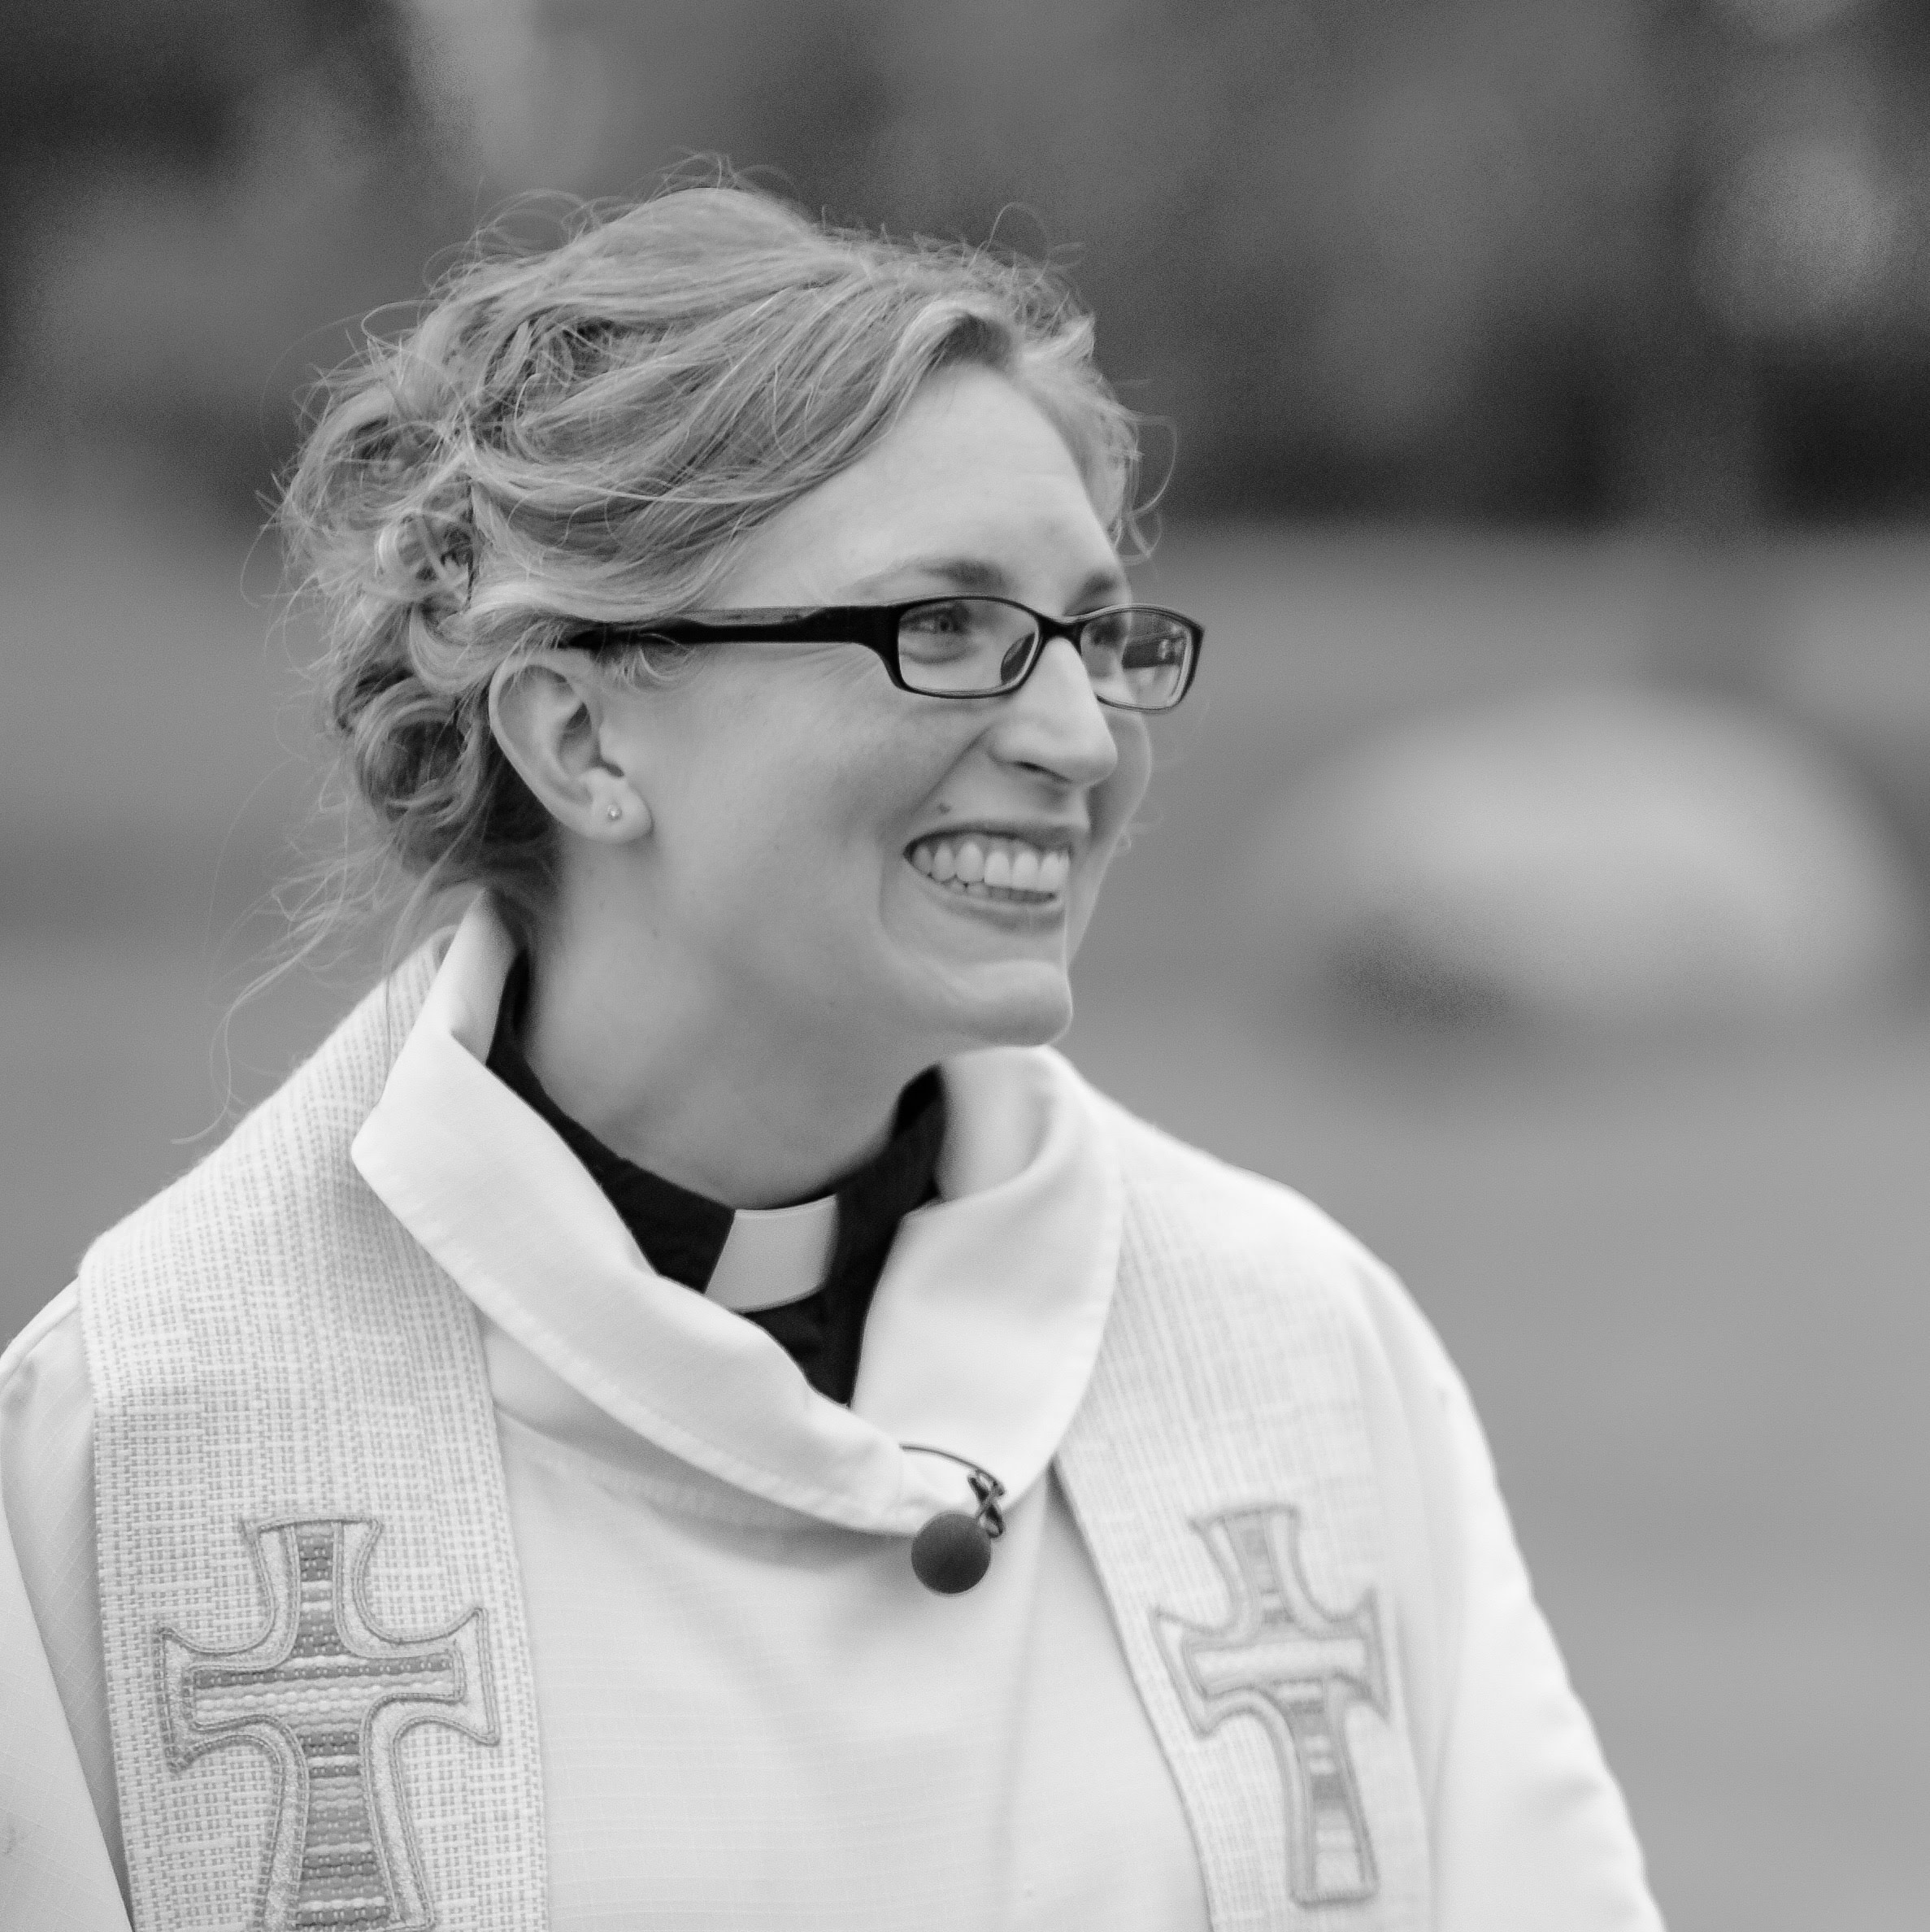
Pr. Liz serves Our Savior’s in Duluth and United in Proctor and the NEMN Synod as Minister for Candidacy Management. She lives in the Duluth countryside, celebrating on every walk the gift of living in this beautiful place of trees and water. With her husband, Pr. Jeff Davis, she parents two children. They share their home and walks with pups Ignatius and Hildegaard.

Green Blades Preaching Roundtable
Reflections on the texts
Seventh Sunday of Easter/Ascension Day
May 21, 2023

- Acts 1:6-14 • Psalm 68:1-10, 32-35 • 1 Peter 4:12-14; 5:6-11 • John 17:1-11

Deacon Colleen Bernu, Fond du Lac/Cloquet, MInnesota

“Norwegian folklore is rich in tales of wonderful happenings from the days of old. One of these stories tells of a young woman’s tireless search for her loved one - - of the assistance she received from two old women as well as from the East Wind, South Wind, West Wind and finally the North Wind. In the process the woman was taken over the seas and across the lands. There was a happy ending; she found her prince somewhere East o’ the Sun and West o’ the Moon…No matter where we are or how separated we have become, we must always remember that we’re family. Only indifference can obscure that knowledge. The family will remain.” -Del Matheson, “Reunion: East O’ The Sun,” 1978, p. xiii

My father’s maternal grandparents were from an island in Nordland, Norway - very near the Arctic Circle. My great-grandfather was the youngest of eight children. He was remembered as being adventurous and kind. He wrote life experiences in the form of poems and would set his poems to music in order to pass on family stories. At some point in his 20s, he heard God’s invitation to serve in rostered ministry. When he was 30-years-old, he sold his bumboat, purchased a suit, a suitcase, a Lutheran book of worship, and a first class ticket to the United States with the goal of earning enough money to return to Norway and pursue a seminary education. On May 21, 1892, he left his home island in order to see major sites on the mainland of Norway before setting sail to America. He boarded a ship named Gallia on May 26th, Ascension Day, bound for Ellis Island in New York. The Gallia skirted a hurricane the entire way. By the time my great-grandfather arrived in Lamberton, MN, on June 15th, he had a new name, a new perspective, and pennies in his pocket. Six years and four months later, his brother’s sister-in-law joined him because his bank account wasn’t growing fast enough for his return. They were married three days after she arrived. Both believed they’d return to Norway within a year or two. They had no way to know that they would never see the land they loved again.

I think of the story of my paternal great-grandparents every year when the Day of Ascension rolls around. I’ve always wondered why my grandfather felt so compelled to tour a land to which he believed he would soon return. His journals and letters to family are filled with stories of the twists and turns that that life took for him (and later his family). Twists and turns that eventually led them to northwest Wisconsin, living in a community of mostly Ojibwe people, on land that reminded my great-grandfather a great deal about the homeland that he could see only in his memories. He went out, to what probably felt like the end of the earth, and found a new way to connect with the people and the land. He wanted to be a pastor, and although the only vocations he ever knew were that of a farmer and a day laborer, his persistent and faithful witness eventually resulted in the planting of a Lutheran congregation in the mostly Catholic community he settled in. Years later during a conversation with Tink Tinker, Tink asked me how I became Lutheran. My answer started with, ‘my dad’s grandpa wanted to be a pastor…’

The story of Christ’s ascension that we read in the book of Acts is a story of near understanding (Acts 1:6), clarifications (Acts 1:7), reassurances and invitations (Acts 1:8), and new beginnings. Just when the disciples thought that their journey with Christ was over (Acts 1:10a), they were reminded that it had simply just begun (Acts 1:11). Without the ascension, the redemptive power of the resurrection could not have been realized. But God would not allow them to simply stand in place with their eyes gazing towards that which was no longer physically with them. God, through God’s representatives, redirected them, refocusing their attention from the heavens towards the land and reconnecting them to the earth through their feet as they walked back to Jerusalem in order to be witnesses there, “in all Judea and Samaria, and to the ends of the earth” (Acts 1:8).

Connection to land is important. We are spiritual beings living in the power of the Holy Spirit yet existing in human bodies that were derived from the land (Genesis 2:7). We need the land to remind us of who we are. We need the land to keep us humble. We are the land, and the land is us. Perhaps, this is why my great-grandparents chose to build their new home somewhere that reminded them of the place they’d left behind. Perhaps, this is why so many immigrant families relocate to places resembling their homelands. At some point, as followers of the way of Jesus, we all realize that God sends us out to be witnesses to all that God does in this world, and at the center of that witness is the liminal space between the resurrection and the ascension, the intersection of the spiritual and the temporal, the horizon line between the land and sky, that place somewhere East o’ the Sun and West o’ the Moon.

“No matter where we are or how separated we have become, we must always remember that we’re family. Only indifference can obscure that knowledge. The family will remain.” - Del Matheson, grandson of my paternal great-grandparents; my dad’s cousin.

Deacon Colleen Bernu

Colleen Bernu is a Minister of Word and Service in the ELCA where she serves as Director for Evangelical Mission and Synod Minister for Diversity, Equity and Inclusion in Northeastern Minnesota Synod. Colleen, a descendant first generation of the Fond Du Lac Band of Lake Superior Chippewa, lives on the Fond Du Lac Indian Reservation with her family and considers Solon Springs, Wisconsin, on the traditional lands of her Ojibwe community, home. Colleen is a former teacher and is dedicated to using her training and experience to expand diversity, equity, inclusion and belonging through a process of truth-telling that promotes the formation of a common memory so that communal healing may begin. Prior to her call to synod staff, Colleen served as mission developer for Together Here Ministries – a ministry that creates space for transformational change by engaging in learning, listening and relationship building between diverse people groups and communities within the Northeastern Minnesota Synod.

Green Blades Preaching Roundtable
Pentecost Sunday, May 28, 2023

Reflections on the texts

Acts 2:1-121 ~ Psalm 104:24-34, 35b ~ John 20:19-23 (alternate: John 7:37-39)

The Rev. Dr. Benjamin Stewart, Two Harbors, Minnesota

Pentecost is the fiery exclamation point on Easter. The entire season is an uprising: the early church set aside all fifty days from Easter to Pentecost as a season in which there was to be nothing that could look like groveling: no kneeling and no fasting on any day of the week. It is a green-blades-rising season. As the green blades rise at Easter, so too do the sparks and flames of Pentecost.

Both the beginning and end of the fifty days are originally rooted in the earth. (The name of the festival comes from the Greek word for “fifty,” referring to the fifty days after Passover/Easter.) Passover, as we noted in the Easter preaching reflections, is a festival that “has roots in an early barley harvest and in a migration to spring pastures, with both events proclaiming the goodness of the earth both here (barley harvest) and there (migration to spring pastures).” Pentecost, fifty days later, was a wheat-harvest festival, Shavuot, the Feast of Weeks, which also commemorated the giving of the law at Sinai.

The earthy and elemental themes are poured out over us on this day:

Fire
If Pentecost had long commemorated that Moses went up on the fiery mountain to receive the law, then in the event in Acts it is as if each believer is a holy mountain, each of them crowned with flame, joined together in the Spirit’s power. I once heard a child say after a mass action for justice, “I felt like a spark in a bonfire – so tiny and yet so powerful.”

Linda Gibler, in her wonderful book, From the Beginning to Baptism: Scientific and Sacred Stories of Water, Oil, and Fire (Liturgical Press 2010), offers a mystical-scientific-ecological account of fire:

﻿ As a consequence of human domestication of fire, the light of the Sun, which is impossible to look at directly, shines in the single flame of a candle that draws our gaze. Early humans never knew, and scientists only learned a few generations ago, that we also glow like candles. The same processes that cause a candle to burn enable respiration within our cells and the cells of all living beings. The air we breathe and the food we eat mix in our cells and release energy. Like a candle flame, we radiate light every moment. (76-77)
﻿Humans and other mammals are not the only beings that glow with respiration. All beings with nucleated cells have mitochondria, which oxidize sugars and release energy. Even plants respire. The sugars they produce through photosynthesis are later oxidized to provide energy for the plant. Not only humans, but all living beings share in the same luminous process as the flame of a candle. (85)

Water
Psalm 104 is a panorama that stretches from the rains coming down from heaven finally out into the sea and into the depths, celebrating the Spirit that renews the face of the earth. The psalm imagines the entire earth as a watershed flowing with God’s goodness, with humans taking a modest place in the system. With all the other creatures we recognize our nature: “All [creatures] look to you to give them their food in due season. You give it to them; they gather it; you open your hand, and they are filled with good things. When you hide your face, they are terrified; when you take away their breath, they die and return to their dust. You send forth your Spirit, and they are created; and so you renew the face of the earth.” (Ps 104:27-30)

We might typically think of the Spirit as breath upon the water, but the alternate Gospel text of John 7:37-39 images the Spirit as water. Jesus – referring to the Spirit – promises that “rivers of living water” will flow from the believer’s heart (though the Greek is probably better translated “belly” or “womb”). Living water for the thirsty: an ecological image for reimagining ourselves at Pentecost.

Wind-spirit-breath
The Acts account of Pentecost describes how “suddenly from heaven there came a sound like a rush of a violent wind, and it filled the entire house where they were sitting.” In the primary gospel text, “Jesus breathed on the disciples and said to them, ‘Receive the Holy Spirit.’” The concept of breath in Hebrew scriptures joins humans together with creation: “everything that has breath.” The Spirit that renews the face of the earth in Psalm 104 is the same Spirit that first hovered over the water in Genesis, that Jesus breathes on the disciples, that fills the lungs of diverse creatures, and that rushes through our assemblies with power. On today’s festival of the Spirit, the linguistic and textual connections that make wind-Spirit-breath into one overlapping, organic conceptual family should not be missed by preachers.

All things: Pentecost economics
Finally, we should be honest about where this is all headed: not only to shared testimonies and hymns of praise, but to shared possessions in a revolutionary economic change. The economic conclusion to Peter’s Pentecost sermon, not included in the lectionary texts this Sunday, nevertheless is part of the renewal of the earth still so fiercely needed today: “Awe came upon everyone, because many wonders and signs were being done by the apostles. All who believed were together and had all things in common; they would sell their possessions and goods and distribute the proceeds to all, as any had need” (Acts 2:43-45).

Blessings in your proclamation at Pentecost – may it be part of the sending of the Spirit to renew the face of the earth!

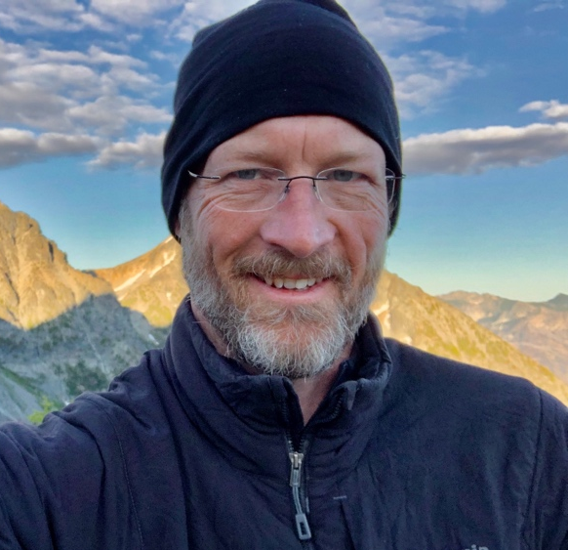

Rev. Dr. Benjamin M. Stewart serves as Pastor to Emmanuel Lutheran Church, Two Harbors, Minnesota, and as Distinguished Affiliate Faculty at the Lutheran School of Theology at Chicago. A recent migrant to Duluth, Minnesota, Ben is a member of the North American Academy of Liturgy and contributes to its Ecology and Liturgy Seminar. He is author of A Watered Garden: Christian Worship and Earth’s Ecology (2011). A former village pastor to Holden, he now serves on the Holden Village Board of Directors.

