Green Blades Preaching Roundtable

Reflections on the texts
22nd Sunday in Ordinary Time, Year A.
14th Sunday after Pentecost
September 3, 2023

Gospel: Matthew 16-21-28

John Dietz, First Lutheran, Hibbing, Minnesota

As I consider the task of preaching on Matthew 16:21-28, I have decided to offer several thoughts on parts of the appointed gospel reading rather than one piece in hopes that one or more of them might serve as starting points for your own reflection as to how this gospel is good news for all of us and for all of creation.

²¹From that time on, [after Peter confessed that Jesus was the Messiah,] Jesus began to show his disciples that he must go to Jerusalem and undergo great suffering at the hands of the elders and chief priests and scribes, and be killed, and on the third day be raised.

In the first verse, we might be drawn to the phrase: “… suffering at the hands of …” As Jesus seemed to know that he would suffer at the hands of the religious leaders of his time, we also know that God’s creation is suffering at the hands of God’s very own creatures. At this point, you would have to go to great lengths to convince yourself that humans are not somehow complicit in the current climate crisis. Some to whom we preach and many with whom we share our lives are doing just that; denying either the crisis or our participation in it, or both. Perhaps when we personally recognize and share in the earth’s great suffering will we be able to confess our part in its cause. Then, as part of our repentance, we might begin to seek real ways to be part of the healing of creation.

The good news in this verse is that, although there is great suffering, and even death, there is also the prediction and the promise of resurrection, which we know in Christ, trust for ourselves, and hope for the creation. The good news is that, in recognizing the suffering and death of creation, the Spirit might move us to repent of the ways we are complicit in it and move us to amend our self-indulgent appetites and ways.

²²And Peter took him aside and began to rebuke him, saying, “God forbid it, Lord! This must never happen to you.” ²³But he turned and said to Peter, “Get behind me, Satan! You are a stumbling block to me; for you are setting your mind not on divine things but on human things.”

In the gospel appointed for last week (Ordinary Time 21 A), Jesus asked: “Who do you say that I am?” and Peter answered: “You are the Messiah, the Son of the living God” (Matthew 16:15, 16). Now that Peter and the rest of the disciples know who Jesus really is — that he is the Christ and not just the reincarnation of John the Baptist or Elijah or Jeremiah or one of the other prophets — Jesus begins to show them what that really means for himself, and for them.

And of course, rejection, suffering, and death wasn’t what the disciples had in mind for the Messiah. We can’t blame Peter for disagreeing with or disapproving of Jesus’ passion prediction here. The chosen king who has come to bring peace and freedom to this world should be welcomed and respected by all, and especially by the religious leaders who, of all people, should gladly recognize and receive him as God’s anointed one.

In The Selfless Way of the Cross, Henri Nouwen writes: “The great paradox which scripture reveals to us is that real and total freedom is only found in downward mobility. The Word of God came down to us and lived among us as a slave. The divine way is indeed the downward way.”

The Christ confessed by Peter is the one the early Christians would sing about as the one who “emptied himself, taking the form of a slave, being born in human likeness. And being found in human form, he humbled himself and became obedient to the point of death — even death on a cross” (Philippians 2:7, 8). This downward divinity of Jesus is not the exception, but the example of true humanity he gives to the church, which we in turn can offer as a model for the world. It’s a counter-cultural model where living with less and on less is not only more sustainable for the environment, but for each of us as individuals physically, mentally, and spiritually.

²⁴Then Jesus told his disciples, “If any want to become my followers, let them deny themselves and take up their cross and follow me. ²⁵For those who want to save their life will lose it, and those who lose their life for my sake will find it. ²⁶For what will it profit them if they gain the whole world but forfeit their life? Or what will they give in return for their life? ²⁷For the Son of Man is to come with his angels in the glory of his Father, and then he will repay everyone for what has been done. ²⁸Truly I tell you, there are some standing here who will not taste death before they see the Son of Man coming in his kingdom.”

The good news here is that sometimes what brings us life is painful, until we actually go through it, and the pain is transformed. In the difficult act of letting go of what we think is a good and meaningful life, we finally realize the joy of being set free from what was actually holding us back from experiencing it. The call to discipleship — which is (discere) literally about learning — is not at all an abstract philosophical pursuit. Jesus calls us into discipleship by inviting us to follow him into this downward mobility, this denial of self and cross carrying, so that we will lose our lives to find them.

We learn the way of Jesus by doing it, which is how I see EcoFaith ministry happening in our parish. Until we started doing it, it was at best a council discussion about its merits or for some, just another liberal talking point. But last year some dreams turned into plans for a pollinator plot and a Monarch Way Station and this year the shovels went into an 11’ x 66’ plot of difficult-to-mow grass. Almost overnight, an unremarkable patch of lawn became not just a topic of generative conversation, but it was an opportunity for people to serve in the church in new ways (watering and weeding rather than reading or ushering). This ministry has become a point of pride for our congregation to serve as a demonstration plot for the community. In letting go of what we think it looks like, or should look like, we learn that living out the gospel can look like creating and cultivating a small sanctuary for bugs, butterflies, bees, and birds.

Considering the gospel life of following Jesus into unremarkable acts of service and sacrificial love, it’s quite a contrast with those who, as Jesus says in the gospel, “gain the whole world but forfeit their life.” It’s easy to be confounded by, and critical of, the wealthiest people who control most of the resources and power in a world where so many suffer in poverty. But we know that Jesus wasn’t speaking to that specific group, or even to the extremely wealthy, or even the comfortable of his or any other time. He’s talking to any and all of us who put anything else over following him, and who make excuses for ourselves when we do it. Jesus speaks plainly to all of us who want to preserve our own control or comfort at the expense of others’ suffering, including that of the earth, our common home.

Meta Herrick Carlson wrote a litany of confession for the church in her book, Speak It Plain. It’s almost too honest for use in public liturgy if there is such a thing. But I have used it as a private examination of conscience, and could imagine it being useful as an aid in a group’s intentional discussion of corporate repentance. She writes in part:
“We confess our fear of being changed
by death and resurrection,
our firm grip on our own ways,
our dangerous adoration
for what we have built on earth.
Have mercy on us, O God.

We confess that we prefer
our slow denial and dissolution
and a false sense of control
to the voice of Jesus, who speaks it plain:
If you’re going to follow me,
let go of who you have been,
the power you’ve had,
your definition of success,
your aspirational sense of self.
Gather the things that are real
and come with me.
because if you spend this life
trying to save it, you will lose it.
But if you let go of this life
for my sake, you will finally find it.”

Henri Nouwen; The Selfless Way of Christ: Downward Mobility and the Spiritual Life, pages 29-30. Orbis Books, 2007.
Meta Herrick Carlson; Speak It Plain: Words for Worship and Life Together, pages 91-93. Fortress Press, 2002.

John Dietz serves as the pastor of First Lutheran Church in Hibbing, Minnesota where he lives with his wife Ashley and their two kids, Livia and Jack.
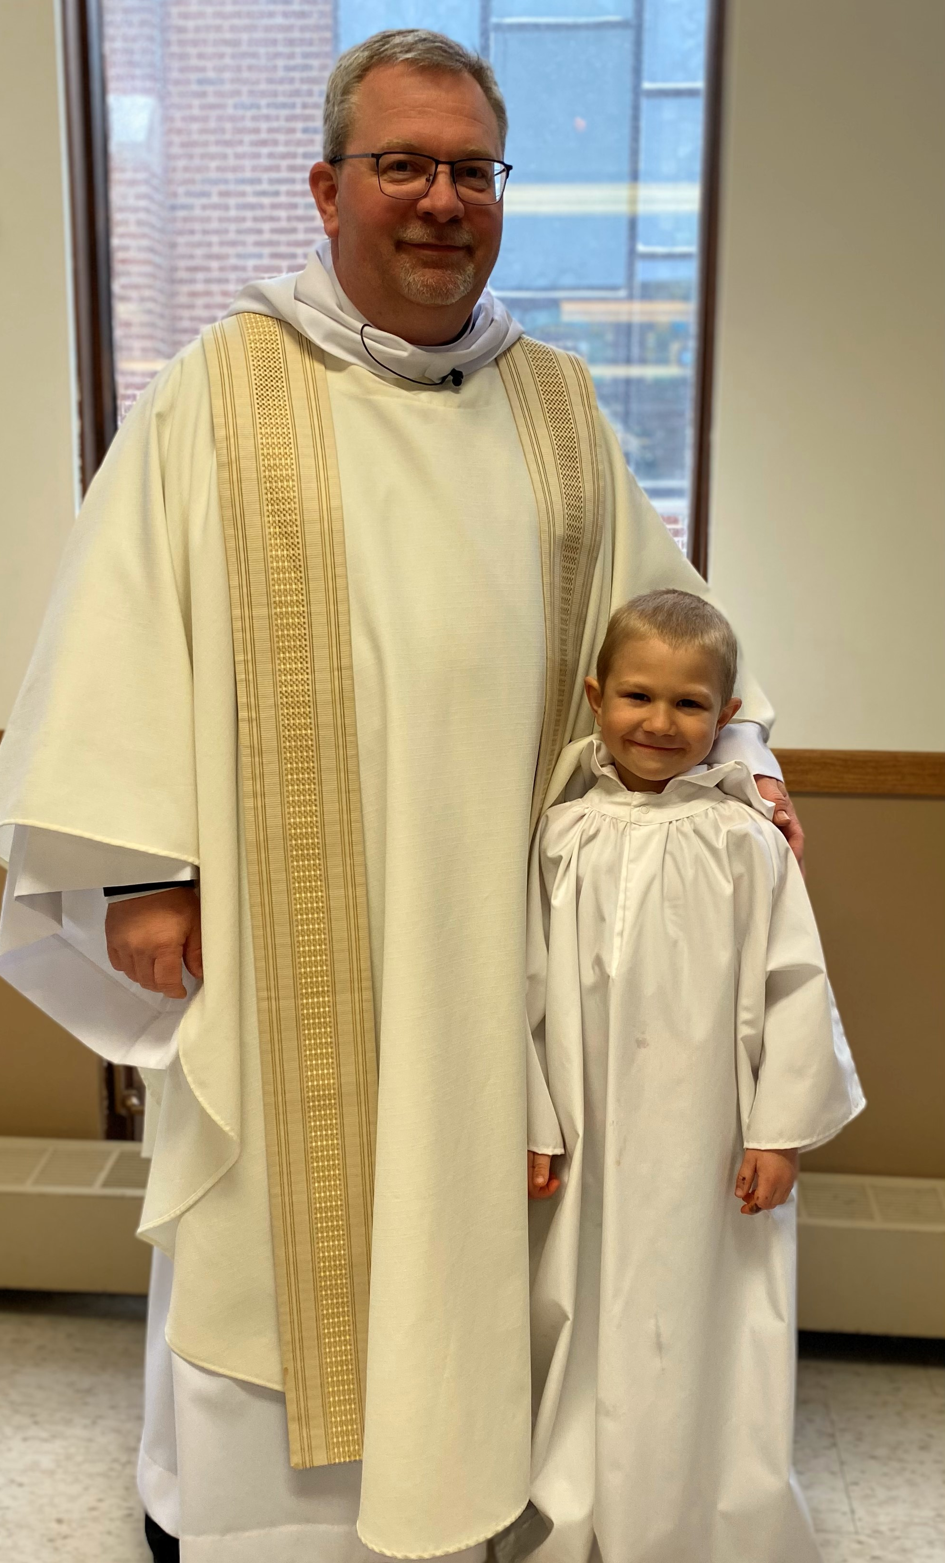

Green Blades Preaching Roundtable
Reflections on the texts
September 10th, 2023 fifteenth Sunday after Pentecost, Year A
Psalm 119:33-40, Romans 13:8-14, Matthew 18:15-20

Pastor Jamie Brieske
Immanuel, Eau Claire, Wisconsin

In our scripture from Matthew today, Jesus is guiding his followers in conflict resolution within the community. This process of truth telling and confronting another member of the community begins individually and then expands to include more witnesses from the group. It is a compassionate response to someone who has made a mistake. There is grace in first responding to this person individually and working to resolve the issue. Then, if this fails, there is still another opportunity, a second chance afforded to that person, now with more people involved. Finally, there are clear boundaries for those who cannot live within the bounds and expectations of the community of love and care that is created in Jesus’ name.

This process follows the values that Jesus teaches. Forgiveness and reconciliation are top priorities in Jesus’ teaching of how to embody the kingdom of heaven right here on earth. Jesus even teaches us to love our enemy and pray for those who hurt us. That is how serious Jesus is about reconciliation and what it should look like in the lives of those who follow him. Perhaps this model for community conflict can also be used on a broader level as well.

I am a Lutheran pastor in the ELCA, and in January, our synod’s Theological Event focused on our relationship with our indigenous neighbors, both through learning our history and examining our actions today. We learned from Barbara Blackdeer-Mackenzie, a member of the Ho-Chunk Nation and community healer and teacher, and Larry Littlegeorge, a member of the Ho-Chunk Nations and a UUC lay minister, among others. There was much truth telling and listening involved in this event, and I think it was very transformative for everyone who participated. I couldn’t help but be overwhelmed by the graciousness that Barbara and Larry and others showed by being willing to share their stories and experiences with us. It was a holy experience, and reconciliation was definitely one of the goals. Yet, before reconciliation can occur I, and others who identify as white Americans (and that includes the Church), have to listen, learn and understand the ways that we have harmed our native neighbors. There has to be confrontation, both of the history and of the very people that live in our communities. There has to be the reckoning and work that leads to true change and restoration of relationships.

As we closed the day, there was a discussion on reparations. In this discussion there were practical suggestions and examples such as: giving land back that was unfairly taken from tribes, paying money for damages, formally acknowledging harm and wrong that was done, advocating for missing indigenous women and teens, and other tangible ways we as Church can participate in the work of justice for tribes.

In addition to this Larry also proposed the following as a method of reparations: care of creation. This really stuck with me. One way we can work to make things right with our tribal neighbors is to stop harming the earth and do our part to be good stewards. Many native American tribes have a long history of sustainability and living on the land with great care and connection. To continue in this tradition is to honor their ancestors and help make a better home for their future descendants. The future of clean water and clean air is being decided right now by our actions. We have the chance to stop the cycle of damage that was done and truly consider how our actions will affect seven generations beyond us, as the Iroquois wisdom saying goes.

“Where two or three are gathered together on earth to represent me, I will be there in spirit to guide you. Then, under my guidance, whatever two or more of you agree upon and ask for will be done by my Father from above.” (Matthew 18, First Nations Version)

Four months after our Theological Event, our synod met at our assembly and passed a resolution that every congregation should have a land acknowledgement and devote one Sunday for education and prayer for Native Heritage Month in November. (We had already passed resolutions repudiating the Doctrine of Discovery and a resolution that every congregation should have a Green Team.) These resolutions are only the first step of course, but the above scripture reminds us that when we come together in Jesus’ name and agree upon something, it is holy work. When we work toward reconciliation, even when it’s hard, we are living into the kingdom of God.

Maybe this teaching from Jesus can inspire us in our public peacemaking as well as peacemaking within our Church communities. We might also imagine how this text could speak to other present-day issues of justice as well. Living into this work of reconciliation, peacemaking, and caring for the earth is one way we love our neighbors. And that love fulfills the law as Paul writes in our Romans text from this week. Here we love our neighbors as ourselves by recognizing our shared humanity and our shared home.

The ‘love your neighbor as yourself teaching' is a very rich theme, one that Jesus of course teaches in Matthew and Paul now reteaches in Romans. It could be a very strong connection between the gospel and first reading. The theme of waking up from the Romans passage could also have a great preaching effect if you are bringing light to ecological issues or other needs of your community. The psalmist also longs to live a good life in the eyes of God and follow the commandments. Therefore these three readings tie together by modeling a life of fulfilling God’s purpose in our lives through being in right relationship with our neighbors, including or more-than-human neighbors, and with God.

I think the good news to be found in this week’s texts is the very practical steps we can take to start loving our human and more-than-human neighbor and loving God right now. We can start really small, by being reconciled to the people closest to us and by taking care of the land right under our feet. Then we can expand that by getting to know our neighbors and hearing about their needs. We are always loved and forgiven in Christ- no matter what the state of the world is. The peace of Christ always reigns in our hearts. Yet, our baptismal identity as beloved children of God calls us to share the love and grace of God with others and work for justice and peace in this precious world, this one, irreplaceable Earth home.There is actually great meaning and transformation found in that work. God’s kingdom comes every time we embody that peace of Christ in public.

Pastor Jamie Brieske
Jamie has been a pastor in the ELCA for 9 years. She currently serves Immanuel Lutheran Church in Eau Claire, WI. She loves teaching confirmation and watching baseball with her husband and two sons.

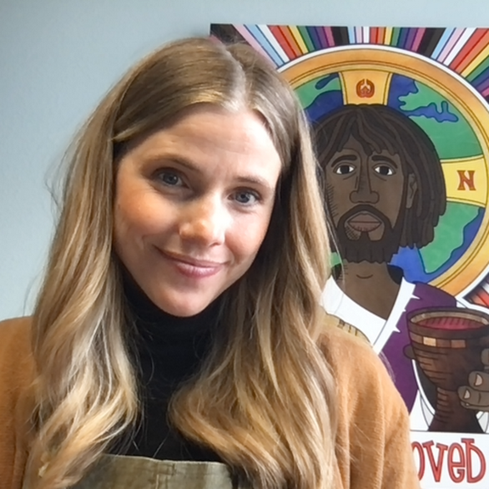

Green Blades Preaching Roundtable

Reflections on the texts
September 17th, 2023 sixteenth Sunday after Pentecost, Year A

Texts: Matthew 20:1-16, Philippians 1:21-30, Psalm 145:1-8, Jonah 3:1—4:11

Lisa Buchanen, Grand Rapids, Minnesota
Bethany Lutheran, Deer River

Genesis 50:15-21; Psalm 103: [1-7] 8-13; Romans 14:1-12; Matthew 18:21-35

What continues to hold my interest as I consider these passages is the connection between forgiveness and freedom. Joseph’s brothers are trapped (so to speak) in their fear and projections of how Joseph would punish them or continue to trap them in unforgiveness. The brothers confess, “we are here as your slaves” (Gen. 50:18b), suggesting they will do whatever Joseph wants them to do, without thought of their own desires, personhood or dreams, since that is what slavery kills in a person. Joseph, who knows a thing or two about dreams (wink) does not keep them bound as slaves but forgives them and restored them to the status of brothers, citing his faith in God (50:19) as the means by which he can forgive.

I know that I need to watch myself when forgiveness becomes a piece of performance art rather than a means of restoring a relationship. I can feel the performance beginning to happen when I consider how generous I am that I could forgive my husband for how loudly he snored last night. Very gracious of me and my forgiveness.

The readings presented today suggest that we can practice forgiveness freely because we have been given God’s expansive mercy. It is not a commodity we give out when we feel like it or when someone deserves it, although I’ll still take it. The readings give us a vision for living so closely with God that forgiveness is an expected part of our everyday, like breathing or digesting.

Despite Jesus speaking in parables to begin his teaching on forgiveness, Matthew’s Jesus pulls no punches by the end of the passage – torture for all who do not forgive! This is a problematic section to consider since Jesus says the heavenly Father would be responsible for such recompense. I can appreciate how Jesus wants to teach about compassionate forgiveness, but the methods are certainly challenging for me, and I would guess for many others.

The parable does make me consider my debts to others, to the world and how much I cannot pay back. I cannot give the sun back all the warmth and energy it has provided me, nor can I give the air back the oxygen I’ve used to breathe and survive. I am in debt to the environment just by existing. But that seems to be the agreed upon deal with living on earth. The debt only starts to get troublesome or unforgiveable when we take too much or destroy too much; when we forget how much has already been given to us, and out of boredom or greed, we want more…just like the slave who squanders the king’s mercy.

My kids went to “farm camp” for a week this summer and had an amazing time learning how flowers grow and what chia seeds taste like. They also came home with Mr. Barley Head, which is a small plastic cup filled with dirt and barley seeds. There are two googly eyeballs on the side of the cup so that as the barley grows, it looks like Mr. Barley Head is growing hair! The kids can give him haircuts! As you can imagine, my littles forget to water Mr. Barley Head on several occasions. But a little sip of water often brings Mr. B.H. right back from the brink of death and it also reminds me how forgiving nature can be. A little time, a little water, a little sunlight and many living things can repair themselves. I don’t want to minimize the debt we have accumulated with our planet, but I must remain hopeful that our planet can continue to forgive us until we can finally not squander such mercy.

I think the world is finally starting to collectively see the unfreedom of climate change through severe storms, unrelenting heat, and flooding. The question remains if we want to stay bound in such a system or if we want to turn toward a future of freedom?

Opening ourselves up to the One who is “full of compassion and mercy, slow to anger and abounding in steadfast love” (Psalm 103:8) provides the interior freedom to be in right relationship with others, with God and with our environment. Such is the fuel of forgiveness.

Lisa Buchanan is pastor at Bethany Lutheran Church in Deer River, Minnesota. She lives with her partner, Ben, in Grand Rapids and their two up-and-coming 2nd graders, Scarlett and Alexander.

Green Blades Preaching Roundtable

Reflections on the texts
Lectionary 25, Year A.
September 24th, 2023 seventeenth Sunday after Pentecost.

Texts: Matthew 20:1-16, Philippians 1:21-30, Psalm 145:1-8, Jonah 3:1—4:11

Luke Pederson, SAM Trinity of Norden and
Good Shepherd Parish. Mondovi, Wisconsin

Wildfires in Maui and Canada. Drought in the Midwest. Heavy rains and flooding in Vermont. Record ocean temperatures. The year 2023 is not over, yet we have already seen the effects of extreme weather exacerbated by rising global temperatures. Indeed, it seems that warnings over the past decades by scientists who have monitored the change in the average global temperature, and who have studied ice cores from the ice caps in Greenland and Antarctica, analyzing the bubbles of ancient air to compare its composition, its percentage of Carbon Dioxide to the present day, are manifesting before our eyes. It is a difficult and uncomfortable truth to face; that our actions have and are altering the climate on a global scale, and that in order to mitigate and reverse the damage, it is imperative that we collectively make significant changes to our lifestyles. The latter can be especially difficult as it means self-examination, repentance-Metanoia, change of heart-and discerning what comforts and luxuries we enjoy, especially in a first-world nation, that come at the expense of our brothers and sisters next door and around the world.

The book of Jonah may be only four chapters, but I think it speaks to us in a profound way as many of us can relate to moments where we felt the prophet’s apprehension at being called to speak truth to power, to be called out of the comfort zone, and perhaps being utterly confounded at God’s mercy and compassion. In fact, Jonah is one of my favorite books in the Old Testament as one can feel Jonah’s emotions of fear and anxiety; the desire to run away when called to go to the last place you’d ever want to go, and his anger and disappointment when God’s way is mercy and compassion on those we consider to be enemies, and holding that in tension with knowing that God is “slow to anger and abounding in steadfast love, and ready to relent from punishing.” (Jonah 4:2). Jonah had experienced God’s mercy and deliverance as God sent a large fish (or a whale?) that rescued Jonah from the stormy sea, after Jonah’s attempt to run from God’s call and the storm at sea that followed, that kept Jonah inside its belly for three days before spitting, or more like vomiting, him back on the beach. When God said to Jonah, “And should I not be concerned about Nineveh, that great city, in which there are more than a hundred and twenty thousand persons who do not know their right hand from their left, and also many animals?”, did Jonah remember the animal sent by God that rescued him?

In the Book of Jonah, we may see an echo of the creation story in Genesis chapter 1; the chaos of the waters and the darkness-darkness covered the deep- like the storm Jonah faced. The great fish recalling the fifth day-“Let the waters bring forth swarms of living creatures, and let birds fly above the earth across the dome of the sky”

And God saw that it was good.

With every act of creation God saw that it was good, indeed very good as God surveyed God’s wondrous creation upon completion. In the reading from Jonah, as well as the Gospel reading, Matthew 20:1-16, we see God’s overflowing compassion and generosity for all life. In Jesus’ parable of the workers in the vineyard, we see God’s care and provision for all, that all are equally deserving of life. Does this invite us to ponder if the care of our Earth, and the plants and animals have been “last”; have they been a secondary concern or ignored all together in the quest for prosperity? How often have the animals been forgotten victims of war? How are the animals suffering from the effects of climate change-from Polar Bears losing hunting grounds due to lack of polar ice, to Moose suffering from loss of habitat as the boral forest retreats north and burning in more frequent fires, and their health suffering from ticks that thrive in warmer summers, to warming streams in the Driftless region, upsetting the delicate balance that the cold-water loving Brook Trout need to survive. As God loves the sparrows of the air, providing all that they need to live and not forgetting one, just as every hair on our heads is known and counted by God (Matthew 10:29-30), may we remember that we are connected with all life on Earth. May we be agents of God’s generosity on Earth, and responsible stewards of the Earth.

Luke Pederson is a syondically Authorized Minister (SAM) in the Northwest Synod of Wisconsin and serves the congregations of Trinity of Norden and Good Shepherd Lutheran churches, located in Mondovi, WI in the rolling hills of the Driftless Region. He enjoys working on prairie restoration and tree planting at his home near Strum, WI., as well as growing a garden and flock of chickens.

