Nurturing New Initiatives in Care of the Creation

EcoFaith Network Micro-Grants

EcoFaith Network, Northeastern Minnesota Synod of the ELCA

Micro-Grant Application

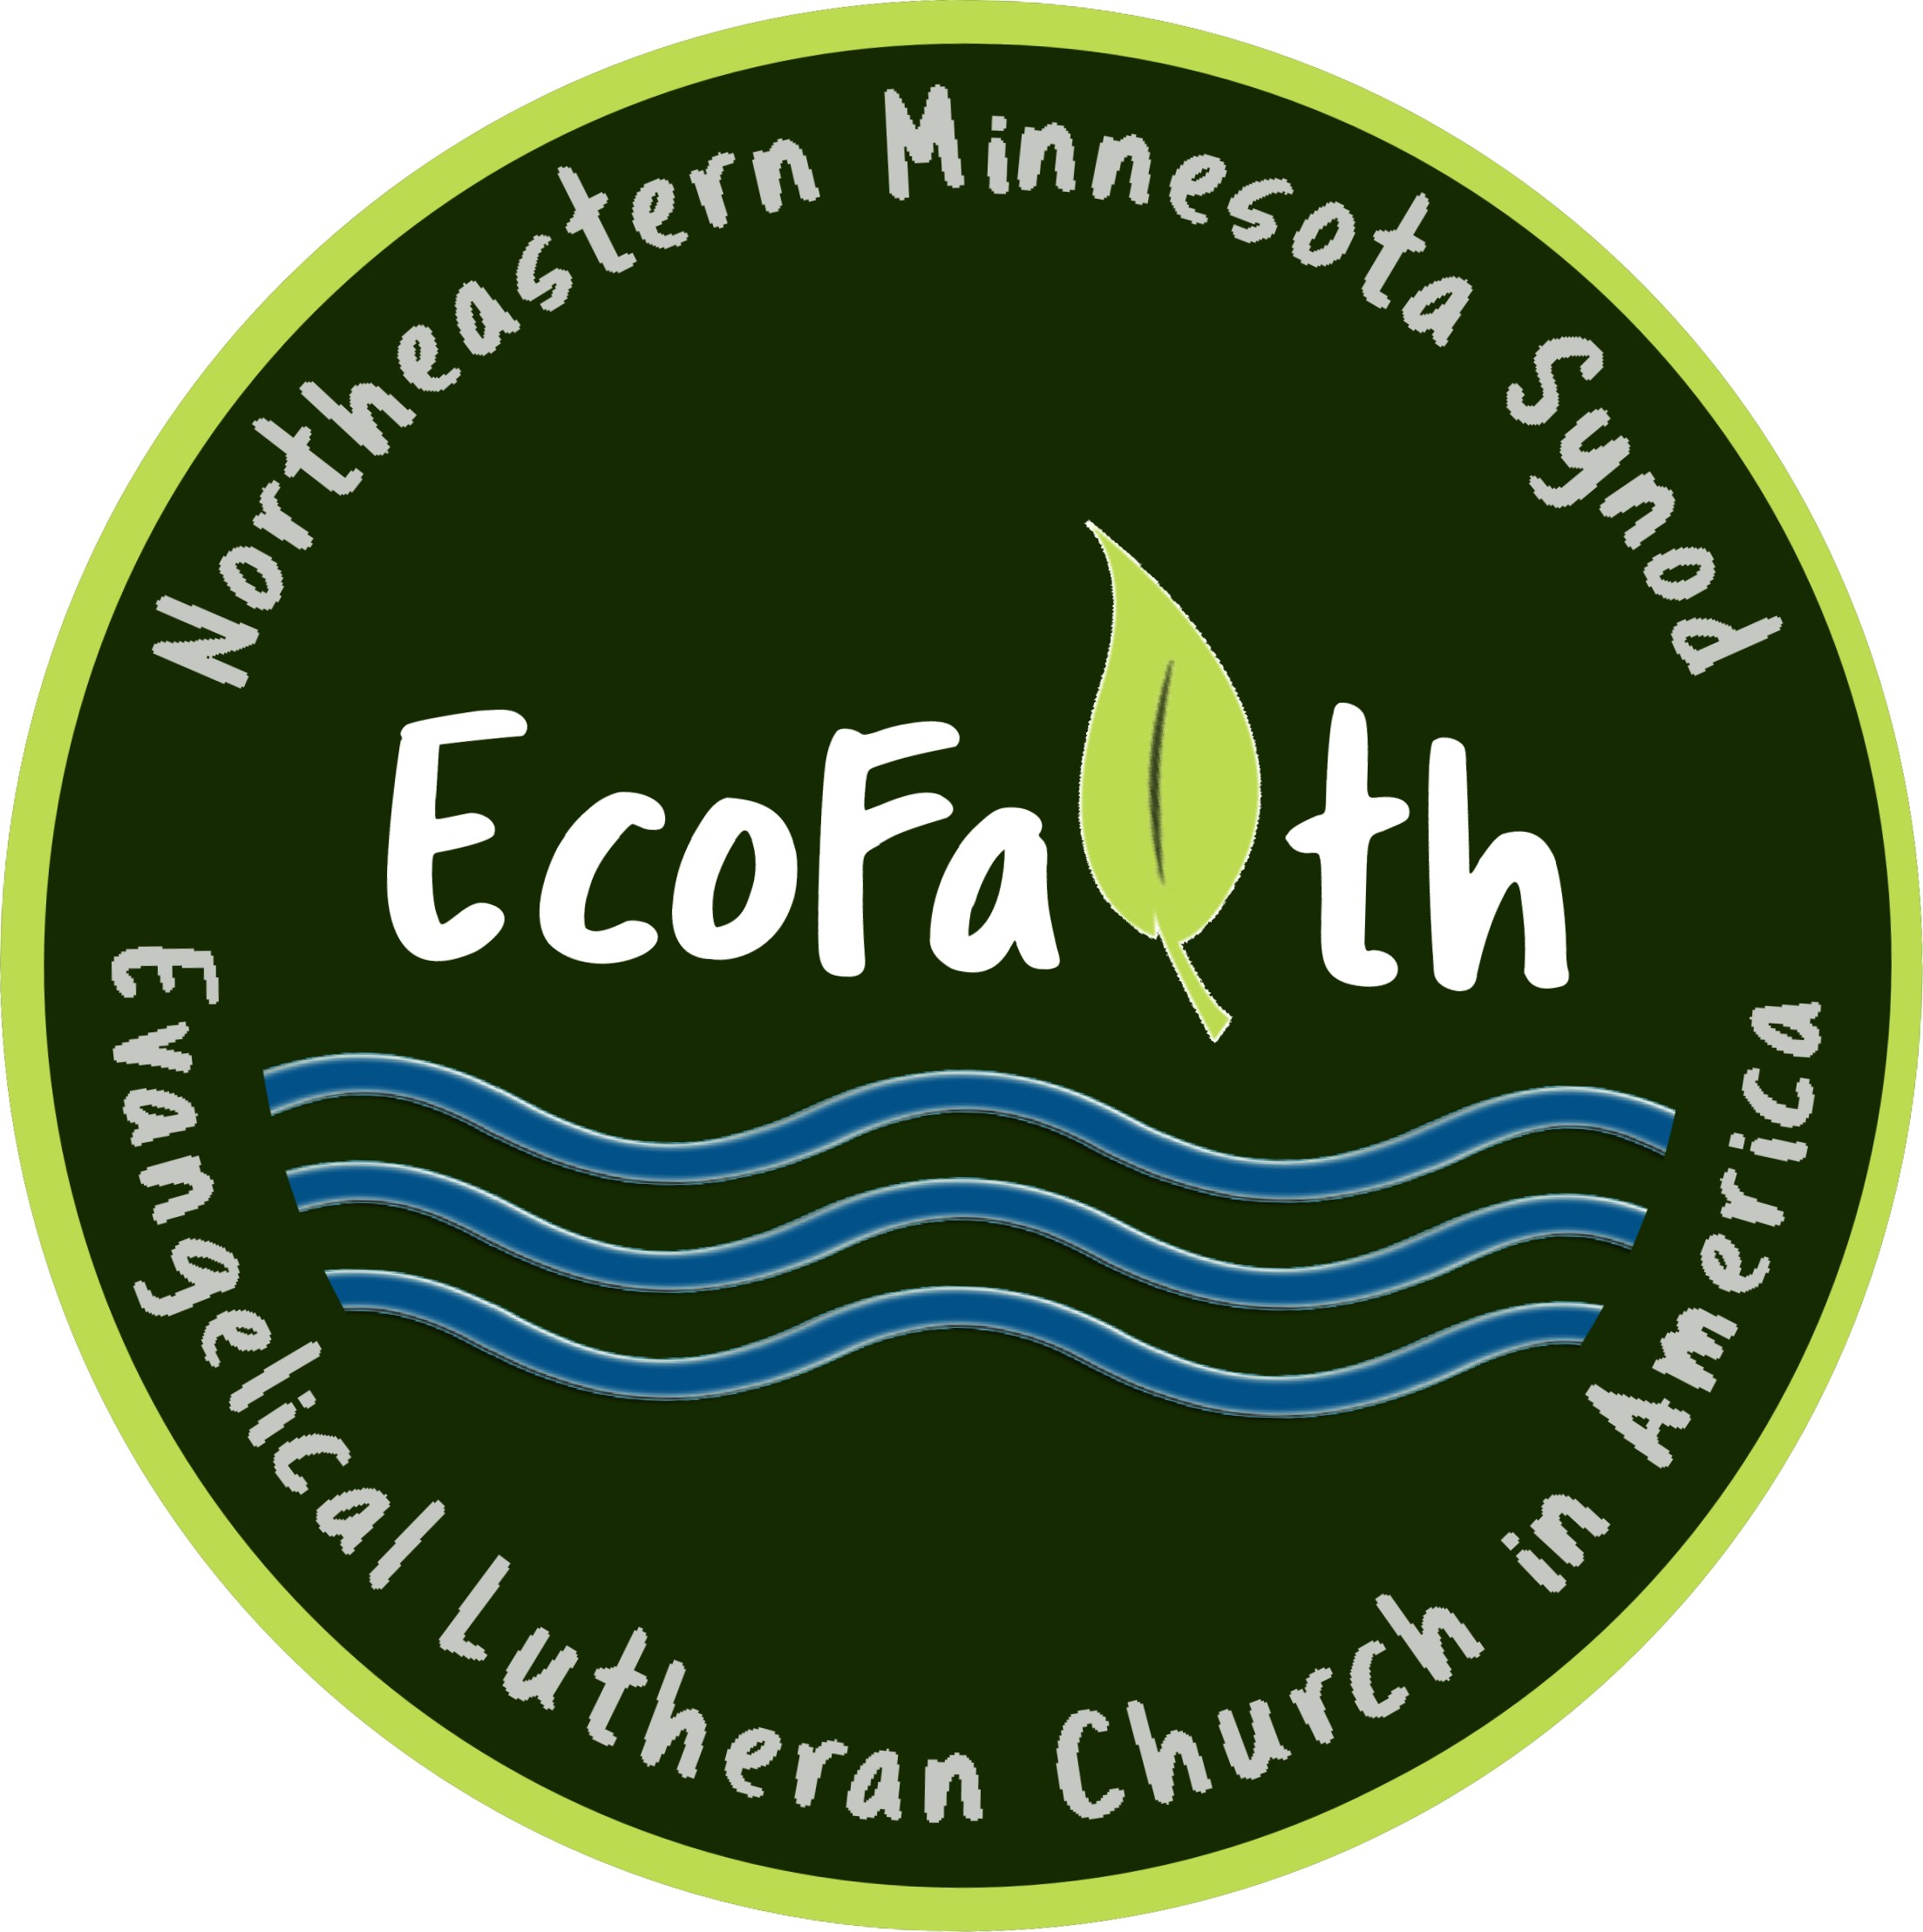

The EcoFaith Network, Northeastern Minnesota Synod of the ELCA is a growing network of congregations and companion partners living out God’s called to be stewards of the earth for the sake of the whole creation.

The EcoFaith Network micro-grant program equips congregations and partners to live into this calling by providing partial funding for specific ministry initiatives.

Grants are available in amounts between $50-$1,000.

Background: Projects in a variety of areas are eligible for funding in pursuit of the following mission goals addressed by EcoFaith Network efforts: worship, education, congregational life, buildings and grounds, community action, and other creation care centered activities. Sample projects might look like but not be limited to the following:

  - Increase community understanding of the relationship between faith in a God of creation and promoting care for creation through worship and biblical/theological reflection;
  - Increase community knowledge of specific ways the congregation/organization can honor creation through environmental education;
  - Develop and implement “green” ways for people to gather that minimize carbon footprints while nourishing relationships;
  - Strengthen congregational/organizational commitment to creation care with policies and practices on their physical site that reflect best practices (e.g. energy audits, recycling, use of solar/wind energy, use of grounds, etc.);
  - Nurture congregational/organizational participants to become more engaged with other entities, agencies, and organizations involved in creation care efforts through events, networking, community action, political advocacy, etc.;
  - Undertake creation care activities in such areas as:
    - Pollinator Projects (including perennial planting, rain gardens, rain barrels)
    - Community gardens
    - Art that promotes creation care
    - Participation in creation care research projects
    - Inter-generational creation care ministry with children and youth
  - Participation in regional environmental events – e.g. conferences, special events, wilderness encounters and youth ministry creation care efforts.

Applications need to be received 30 days prior to the EcoFaith Network Leadership Team monthly meeting to allow for consideration during the upcoming meeting.

We will accompany you throughout your project!

It is a joy to be able to provide micro-grants for creation care efforts.

Before you apply: If you would like help, let us know. The EcoFaith Network Accompaniment Team is available to assist you in developing your project proposal.

When you embark on your project: If/when you receive a microgrant, we will pair you with someone who can support and encourage you as your project unfolds.

Send your request for help or your completed proposal to ecofaith@nemnsynod.org

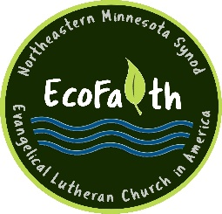
Micro-Grant Application
EcoFaith Network
Northeastern Minnesota Synod of the ELCA

Applicants: Please provide the following information regarding the proposed micro-grant project:

Project title:
Name of project coordinator:
Contact Information: Email - Phone -
Mailing Address:
Creation Care or Organizational Team overseeing the Project:
Requested amount?
On a separate document, please provide the following:
- An overall project description and specific goals.
- A description of how the project aligns with the EcoFaith Network’s mission statement and areas of focus as described above.
  - How will the project serve the healing of a wounded creation?
- A brief description of the implementation process and a timeline of the project.
- Tell us how this project will benefit the congregational/organizational community and the wider community.
- If there are environmental impacts to be addressed, tell us how this will occur.
- What are the potential risks or unknowns involved in this project?
- Please provide an itemized description of project expenses and funding sources.
- Briefly describe the congregational/organizational fiscal host responsible for the financial management of grant funds.

Micro-grants are not just money. They are relationships!
They are forms of companionship, pollinating the care of creation in and beyond our synod. We want to support you. We can meet with you over zoom, or whatever is most helpful. And you will have a story to share! We also want to hear about your project to share your experience with others! Please plan to send pictures and let us know what is happening because of your grant. Together we will be companions in this holy work!

